ADENICSY Apelo Dental Clinic Management System

Project Documentation Submitted to the Faculty of the

School of Computing and Information Technologies

Asia Pacific College

In Partial Fulfillment of the Requirements for

APPLIED PROJECT - SYSTEM PROTOTYPE

SCSPROJ

By

|  |  |
| --- | --- |
| Dahinao, Earl Eufimeah | De Vera, Alfonzo Louise |
| Meltran, Patricia Anne | Pedrola, Janssen |
| Regalado, Guiler Marion |  |

ASIA PACIFIC COLLEGE

Approval Sheet

ADENICSY (Apelo Dental Clinic Management System)

Prepared and Submitted by

Dahinao, Earl Eufimeah

De Vera, Alfonzo Louise

Meltran, Patricia Anne

Pedrola, Janssen

Regalado, Guiler Marion

In Partial Fulfillment of the Requirements for the Degree of

Bachelor of Science in Computer Science

Examined and Recommended for Acceptance and Approval for

Project-Based Learning

___________________________

<Name>, Adviser

Panelists

___________________________

<Name>, Chairperson

|  |  |
| --- | --- |
| ___________________________ | ___________________________ |
| <Name>, Panel Member | <Name>, Panel Member |

Acceptance and Approved in Partial Fulfillment of the Requirements for the Degree of

Bachelor of Science in Computer Science

___________________________

Rhea-Luz R. Valbuena

Executive Director

School of Computing and Information Technologies

# Table of Contents

Table of Contents 4

Abstract i

List of Figures ii

List of Tables iv

I. Introduction 1

1.1 Project Context 1

1.2 Statement of the Problem 2

1.3 Objectives 2

1.4 Significance of the Project 2

1.5 Scope and Limitations 3

II. Review of Related Literature / Systems 2

2.1 Context of Dental Clinics’ System in The Philippines 2

2.2 Similar Dental Clinic System 2

2.3 Management of Patient Information in Dental Clinic System 2

2.4 Queueing Management 3

2.5 Interactive Teeth Model 3

2.6 Synthesis 3

III. Technical Background 5

3.1 Current System 5

3.2 List of Processes 6

3.3 SWOT Analysis 7

3.4 Proposed System 7

3.5 Feasibility 7

3.5.1 Operational Feasibility 7

3.5.2 Economic Feasibility 8

3.5.3 Technical Feasibility 8

IV. Methodology 9

4.1 Requirements Analysis 9

4.1.1 Product Backlog / User Stories 9

4.1.2 Event Tables 11

4.1.3 Use Case Diagrams 13

4.1.4 Use Case Full Description 14

4.2 System Analysis and Design 20

4.2.1 Context Diagram 20

4.2.2 Data Flow Diagrams 21

4.2.3 Entity-Relationship Diagrams 29

4.2.4 Activity Diagrams 32

4.2.5 Object Diagrams 33

4.2.6 Class Diagrams 34

4.2.7 Sequence Diagrams 35

4.2.8 State Machine Diagram 39

4.2.9 Deployment Diagram 41

V. Results and Discussion 42

5.1 Release Plan 42

5.2 Prototype 44

5.2.1 Mobile Prototype for patient’s end 44

5.2.2 Tablet Prototype for Staff’s end 45

5.2.3 Tablet Prototype for Dentist’s end 52

5.2.4 Tablet/Desktop Prototype for Admin’s end 62

5.3 Use Classes and Characteristics 67

VI. Conclusion 68

References 69

Appendices 70

Appendix A: Project Vision 70

1. Business Requirements 1

1.1. Background 1

1.2. Business Opportunity 1

1.3. Business Objectives and Success Criteria 2

1.4. Customer or Market Needs 2

1.5. Business Risks 2

2. Vision of the Solution 1

2.1. Vision Statement 1

2.2. Major Features 1

2.3. Assumptions and Dependencies 1

3. Scope and Limitations 1

3.1. Scope of Initial Release 3

3.2. Scope of Subsequent Releases 3

3.3. Limitations and Exclusions 4

4. Business Context 4

4.1. Stakeholder Profiles 4

4.2. Operating Environment 5

Appendix B: Schedule 6

Appendix C: Product Roadmap 7

Appendix D: Team Meetings 9

Appendix E: Source Code 27

Appendix F: Team’s Curriculum Vitae 28

# Abstract

Asia Pacific College School of Computing and Information Technologies (SoCIT) has it’s Project-Based Learning Program where students experienced to develop a system for a client. It starts from finding a client proposing initial projects, going through design-thinking, developing diagrams for the system, creating a prototype, and developing the actual software.

In this paper, the team Progmatiks have developed a software for their client- Apelo Dental Clinic in which the main goal is to lessen the waiting time of the patients through queueing management, digitalization of patient’s dental records, and automating several manual processes to improve the clinic’s performance. The system is web-based and made using HTML, Bootstrap, PHP, SQL and XAMPP for local hosting and its PhpMyAdmin for the database during the development.

Keyword: Project-Based Learning, Design Thinking, Dental Clinic Software, Queueing Management, Digitalization, Web-based, HTML, Bootstrap, PHP, SQL, XAMPP, PhpMyAdmin

# List of Figures

[Figure 1 Apelo Dental Clinic's file system for patient information 5](https://asiapacificcollege-my.sharepoint.com/personal/jtpedrola_student_apc_edu_ph/Documents/Documents/3rdYearSubjects/Term2/SCSPROJ/Finals%20Required%20Documents/(1)%20SCSPROJ%20Final%20Paper%20-%20Progmatiks.docx#_Toc127305382)

[Figure 2 Use Case Diagram for ADENICSY 13](https://asiapacificcollege-my.sharepoint.com/personal/jtpedrola_student_apc_edu_ph/Documents/Documents/3rdYearSubjects/Term2/SCSPROJ/Finals%20Required%20Documents/(1)%20SCSPROJ%20Final%20Paper%20-%20Progmatiks.docx#_Toc127305383)

[Figure 3 Manage Account Full Use Case Description 14](https://asiapacificcollege-my.sharepoint.com/personal/jtpedrola_student_apc_edu_ph/Documents/Documents/3rdYearSubjects/Term2/SCSPROJ/Finals%20Required%20Documents/(1)%20SCSPROJ%20Final%20Paper%20-%20Progmatiks.docx#_Toc127305384)

[Figure 4 Manage Queueing Full Use Case Description 15](https://asiapacificcollege-my.sharepoint.com/personal/jtpedrola_student_apc_edu_ph/Documents/Documents/3rdYearSubjects/Term2/SCSPROJ/Finals%20Required%20Documents/(1)%20SCSPROJ%20Final%20Paper%20-%20Progmatiks.docx#_Toc127305385)

[Figure 5 Manage Dentist Schedule Full Use Case Description 16](https://asiapacificcollege-my.sharepoint.com/personal/jtpedrola_student_apc_edu_ph/Documents/Documents/3rdYearSubjects/Term2/SCSPROJ/Finals%20Required%20Documents/(1)%20SCSPROJ%20Final%20Paper%20-%20Progmatiks.docx#_Toc127305386)

[Figure 6 Manage Dental Records Full Use Case Description 17](https://asiapacificcollege-my.sharepoint.com/personal/jtpedrola_student_apc_edu_ph/Documents/Documents/3rdYearSubjects/Term2/SCSPROJ/Finals%20Required%20Documents/(1)%20SCSPROJ%20Final%20Paper%20-%20Progmatiks.docx#_Toc127305387)

[Figure 7 Manage Payment Records Full Use Case Description 18](https://asiapacificcollege-my.sharepoint.com/personal/jtpedrola_student_apc_edu_ph/Documents/Documents/3rdYearSubjects/Term2/SCSPROJ/Finals%20Required%20Documents/(1)%20SCSPROJ%20Final%20Paper%20-%20Progmatiks.docx#_Toc127305388)

[Figure 8 Manage Report Full Use Case Description 19](https://asiapacificcollege-my.sharepoint.com/personal/jtpedrola_student_apc_edu_ph/Documents/Documents/3rdYearSubjects/Term2/SCSPROJ/Finals%20Required%20Documents/(1)%20SCSPROJ%20Final%20Paper%20-%20Progmatiks.docx#_Toc127305389)

[Figure 9 Context Diagram for ADENICSY 20](https://asiapacificcollege-my.sharepoint.com/personal/jtpedrola_student_apc_edu_ph/Documents/Documents/3rdYearSubjects/Term2/SCSPROJ/Finals%20Required%20Documents/(1)%20SCSPROJ%20Final%20Paper%20-%20Progmatiks.docx#_Toc127305390)

[Figure 10 Level 0 DFD for ADENICSY 21](https://asiapacificcollege-my.sharepoint.com/personal/jtpedrola_student_apc_edu_ph/Documents/Documents/3rdYearSubjects/Term2/SCSPROJ/Finals%20Required%20Documents/(1)%20SCSPROJ%20Final%20Paper%20-%20Progmatiks.docx#_Toc127305391)

[Figure 11 Level 1 DFD for ADENICSY 22](https://asiapacificcollege-my.sharepoint.com/personal/jtpedrola_student_apc_edu_ph/Documents/Documents/3rdYearSubjects/Term2/SCSPROJ/Finals%20Required%20Documents/(1)%20SCSPROJ%20Final%20Paper%20-%20Progmatiks.docx#_Toc127305392)

[Figure 12 Level 2.1 DFD (Manage Account) for ADENICSY 23](https://asiapacificcollege-my.sharepoint.com/personal/jtpedrola_student_apc_edu_ph/Documents/Documents/3rdYearSubjects/Term2/SCSPROJ/Finals%20Required%20Documents/(1)%20SCSPROJ%20Final%20Paper%20-%20Progmatiks.docx#_Toc127305393)

[Figure 13 Level 2.2 DFD (Manage Queueing List) for ADENICSY 24](https://asiapacificcollege-my.sharepoint.com/personal/jtpedrola_student_apc_edu_ph/Documents/Documents/3rdYearSubjects/Term2/SCSPROJ/Finals%20Required%20Documents/(1)%20SCSPROJ%20Final%20Paper%20-%20Progmatiks.docx#_Toc127305394)

[Figure 14 Level 2.3 DFD (Manage Dentist Schedule) for ADENICSY 25](https://asiapacificcollege-my.sharepoint.com/personal/jtpedrola_student_apc_edu_ph/Documents/Documents/3rdYearSubjects/Term2/SCSPROJ/Finals%20Required%20Documents/(1)%20SCSPROJ%20Final%20Paper%20-%20Progmatiks.docx#_Toc127305395)

[Figure 15 Level 2.4 DFD (Manage Dental Records) for ADENICSY 26](https://asiapacificcollege-my.sharepoint.com/personal/jtpedrola_student_apc_edu_ph/Documents/Documents/3rdYearSubjects/Term2/SCSPROJ/Finals%20Required%20Documents/(1)%20SCSPROJ%20Final%20Paper%20-%20Progmatiks.docx#_Toc127305396)

[Figure 16 Level 2.5 DFD (Manage Payment Records) for ADENICSY 27](https://asiapacificcollege-my.sharepoint.com/personal/jtpedrola_student_apc_edu_ph/Documents/Documents/3rdYearSubjects/Term2/SCSPROJ/Finals%20Required%20Documents/(1)%20SCSPROJ%20Final%20Paper%20-%20Progmatiks.docx#_Toc127305397)

[Figure 17 Level 2.6 DFD (Manage Report) for ADENICSY 28](https://asiapacificcollege-my.sharepoint.com/personal/jtpedrola_student_apc_edu_ph/Documents/Documents/3rdYearSubjects/Term2/SCSPROJ/Finals%20Required%20Documents/(1)%20SCSPROJ%20Final%20Paper%20-%20Progmatiks.docx#_Toc127305398)

[Figure 18 Entity Relationship Diagram (ERD) of ADENICSY 29](https://asiapacificcollege-my.sharepoint.com/personal/jtpedrola_student_apc_edu_ph/Documents/Documents/3rdYearSubjects/Term2/SCSPROJ/Finals%20Required%20Documents/(1)%20SCSPROJ%20Final%20Paper%20-%20Progmatiks.docx#_Toc127305399)

[Figure 19 Data Dictionary of ADENICSY's ERD part 1 30](https://asiapacificcollege-my.sharepoint.com/personal/jtpedrola_student_apc_edu_ph/Documents/Documents/3rdYearSubjects/Term2/SCSPROJ/Finals%20Required%20Documents/(1)%20SCSPROJ%20Final%20Paper%20-%20Progmatiks.docx#_Toc127305400)

[Figure 20 Data Dictionary of ADENICSY's ERD part 2 31](https://asiapacificcollege-my.sharepoint.com/personal/jtpedrola_student_apc_edu_ph/Documents/Documents/3rdYearSubjects/Term2/SCSPROJ/Finals%20Required%20Documents/(1)%20SCSPROJ%20Final%20Paper%20-%20Progmatiks.docx#_Toc127305401)

[Figure 21 Activity Diagram for ADENICSY staff 32](https://asiapacificcollege-my.sharepoint.com/personal/jtpedrola_student_apc_edu_ph/Documents/Documents/3rdYearSubjects/Term2/SCSPROJ/Finals%20Required%20Documents/(1)%20SCSPROJ%20Final%20Paper%20-%20Progmatiks.docx#_Toc127305402)

[Figure 22 Activity Diagram for ADENICSY admin 32](https://asiapacificcollege-my.sharepoint.com/personal/jtpedrola_student_apc_edu_ph/Documents/Documents/3rdYearSubjects/Term2/SCSPROJ/Finals%20Required%20Documents/(1)%20SCSPROJ%20Final%20Paper%20-%20Progmatiks.docx#_Toc127305403)

[Figure 23 Activity Diagram for ADENICSY patient 32](https://asiapacificcollege-my.sharepoint.com/personal/jtpedrola_student_apc_edu_ph/Documents/Documents/3rdYearSubjects/Term2/SCSPROJ/Finals%20Required%20Documents/(1)%20SCSPROJ%20Final%20Paper%20-%20Progmatiks.docx#_Toc127305404)

Figure 24 Object Diagram for ADENICSY 33

[Figure 25 Class Diagram for ADENICSY 34](https://asiapacificcollege-my.sharepoint.com/personal/jtpedrola_student_apc_edu_ph/Documents/Documents/3rdYearSubjects/Term2/SCSPROJ/Finals%20Required%20Documents/(1)%20SCSPROJ%20Final%20Paper%20-%20Progmatiks.docx#_Toc127305406)

[Figure 26 Sequence Diagram for Patient and Employee Login 35](https://asiapacificcollege-my.sharepoint.com/personal/jtpedrola_student_apc_edu_ph/Documents/Documents/3rdYearSubjects/Term2/SCSPROJ/Finals%20Required%20Documents/(1)%20SCSPROJ%20Final%20Paper%20-%20Progmatiks.docx#_Toc127305407)

[Figure 27 Sequence Diagram for Managing Queueing 36](https://asiapacificcollege-my.sharepoint.com/personal/jtpedrola_student_apc_edu_ph/Documents/Documents/3rdYearSubjects/Term2/SCSPROJ/Finals%20Required%20Documents/(1)%20SCSPROJ%20Final%20Paper%20-%20Progmatiks.docx#_Toc127305408)

[Figure 28 Sequence Diagram for Managing Dental Records 37](https://asiapacificcollege-my.sharepoint.com/personal/jtpedrola_student_apc_edu_ph/Documents/Documents/3rdYearSubjects/Term2/SCSPROJ/Finals%20Required%20Documents/(1)%20SCSPROJ%20Final%20Paper%20-%20Progmatiks.docx#_Toc127305409)

[Figure 29 Sequence Diagram for Managing Reports 38](https://asiapacificcollege-my.sharepoint.com/personal/jtpedrola_student_apc_edu_ph/Documents/Documents/3rdYearSubjects/Term2/SCSPROJ/Finals%20Required%20Documents/(1)%20SCSPROJ%20Final%20Paper%20-%20Progmatiks.docx#_Toc127305410)

[Figure 30 State Machine Diagram for Apelo Dental Clinic 39](https://asiapacificcollege-my.sharepoint.com/personal/jtpedrola_student_apc_edu_ph/Documents/Documents/3rdYearSubjects/Term2/SCSPROJ/Finals%20Required%20Documents/(1)%20SCSPROJ%20Final%20Paper%20-%20Progmatiks.docx#_Toc127305411)

[Figure 31 State Machine Diagram for ADC's Patient 40](https://asiapacificcollege-my.sharepoint.com/personal/jtpedrola_student_apc_edu_ph/Documents/Documents/3rdYearSubjects/Term2/SCSPROJ/Finals%20Required%20Documents/(1)%20SCSPROJ%20Final%20Paper%20-%20Progmatiks.docx#_Toc127305412)

[Figure 32 Deployment Diagram for ADENICSY 41](https://asiapacificcollege-my.sharepoint.com/personal/jtpedrola_student_apc_edu_ph/Documents/Documents/3rdYearSubjects/Term2/SCSPROJ/Finals%20Required%20Documents/(1)%20SCSPROJ%20Final%20Paper%20-%20Progmatiks.docx#_Toc127305413)

[Figure 33 ADENICSY Mobile View Prototype for Patient Signup and Login 44](https://asiapacificcollege-my.sharepoint.com/personal/jtpedrola_student_apc_edu_ph/Documents/Documents/3rdYearSubjects/Term2/SCSPROJ/Finals%20Required%20Documents/(1)%20SCSPROJ%20Final%20Paper%20-%20Progmatiks.docx#_Toc127305414)

[Figure 34 ADENICSY Mobile View for Getting a Queueing Number 44](https://asiapacificcollege-my.sharepoint.com/personal/jtpedrola_student_apc_edu_ph/Documents/Documents/3rdYearSubjects/Term2/SCSPROJ/Finals%20Required%20Documents/(1)%20SCSPROJ%20Final%20Paper%20-%20Progmatiks.docx#_Toc127305415)

[Figure 35 ADENICSY Mobile View on Notifications, Payment Records, Feedback and Profile 45](https://asiapacificcollege-my.sharepoint.com/personal/jtpedrola_student_apc_edu_ph/Documents/Documents/3rdYearSubjects/Term2/SCSPROJ/Finals%20Required%20Documents/(1)%20SCSPROJ%20Final%20Paper%20-%20Progmatiks.docx#_Toc127305416)

[Figure 36 ADENICSY Tablet View for Staff's Welcome Page 45](https://asiapacificcollege-my.sharepoint.com/personal/jtpedrola_student_apc_edu_ph/Documents/Documents/3rdYearSubjects/Term2/SCSPROJ/Finals%20Required%20Documents/(1)%20SCSPROJ%20Final%20Paper%20-%20Progmatiks.docx#_Toc127305417)

[Figure 37 ADENICSY Tablet View for Searching Payment Records 46](https://asiapacificcollege-my.sharepoint.com/personal/jtpedrola_student_apc_edu_ph/Documents/Documents/3rdYearSubjects/Term2/SCSPROJ/Finals%20Required%20Documents/(1)%20SCSPROJ%20Final%20Paper%20-%20Progmatiks.docx#_Toc127305418)

[Figure 38 ADENICSY Search Result for Payment Records 47](https://asiapacificcollege-my.sharepoint.com/personal/jtpedrola_student_apc_edu_ph/Documents/Documents/3rdYearSubjects/Term2/SCSPROJ/Finals%20Required%20Documents/(1)%20SCSPROJ%20Final%20Paper%20-%20Progmatiks.docx#_Toc127305419)

[Figure 39 ADENICSY Payment Transaction Records of Patient 48](https://asiapacificcollege-my.sharepoint.com/personal/jtpedrola_student_apc_edu_ph/Documents/Documents/3rdYearSubjects/Term2/SCSPROJ/Finals%20Required%20Documents/(1)%20SCSPROJ%20Final%20Paper%20-%20Progmatiks.docx#_Toc127305420)

[Figure 40 ADENICSY Dentist Schedule in Staff's end 49](https://asiapacificcollege-my.sharepoint.com/personal/jtpedrola_student_apc_edu_ph/Documents/Documents/3rdYearSubjects/Term2/SCSPROJ/Finals%20Required%20Documents/(1)%20SCSPROJ%20Final%20Paper%20-%20Progmatiks.docx#_Toc127305421)

[Figure 41 ADENICSY Modifying Dentist Schedule and Available Queueing Numbers 50](https://asiapacificcollege-my.sharepoint.com/personal/jtpedrola_student_apc_edu_ph/Documents/Documents/3rdYearSubjects/Term2/SCSPROJ/Finals%20Required%20Documents/(1)%20SCSPROJ%20Final%20Paper%20-%20Progmatiks.docx#_Toc127305422)

[Figure 42 ADENICSY Queueing List 51](https://asiapacificcollege-my.sharepoint.com/personal/jtpedrola_student_apc_edu_ph/Documents/Documents/3rdYearSubjects/Term2/SCSPROJ/Finals%20Required%20Documents/(1)%20SCSPROJ%20Final%20Paper%20-%20Progmatiks.docx#_Toc127305423)

[Figure 43 ADENICSY Search Page for Patient's Dental Records 52](https://asiapacificcollege-my.sharepoint.com/personal/jtpedrola_student_apc_edu_ph/Documents/Documents/3rdYearSubjects/Term2/SCSPROJ/Finals%20Required%20Documents/(1)%20SCSPROJ%20Final%20Paper%20-%20Progmatiks.docx#_Toc127305424)

[Figure 44 ADENICSY Search Result for Patient's Dental Record 53](https://asiapacificcollege-my.sharepoint.com/personal/jtpedrola_student_apc_edu_ph/Documents/Documents/3rdYearSubjects/Term2/SCSPROJ/Finals%20Required%20Documents/(1)%20SCSPROJ%20Final%20Paper%20-%20Progmatiks.docx#_Toc127305425)

[Figure 45 Patient's Dental Record Overview 54](https://asiapacificcollege-my.sharepoint.com/personal/jtpedrola_student_apc_edu_ph/Documents/Documents/3rdYearSubjects/Term2/SCSPROJ/Finals%20Required%20Documents/(1)%20SCSPROJ%20Final%20Paper%20-%20Progmatiks.docx#_Toc127305426)

[Figure 46 Patient's Teeth Picture 55](https://asiapacificcollege-my.sharepoint.com/personal/jtpedrola_student_apc_edu_ph/Documents/Documents/3rdYearSubjects/Term2/SCSPROJ/Finals%20Required%20Documents/(1)%20SCSPROJ%20Final%20Paper%20-%20Progmatiks.docx#_Toc127305427)

[Figure 47 Patient's Xray File 56](https://asiapacificcollege-my.sharepoint.com/personal/jtpedrola_student_apc_edu_ph/Documents/Documents/3rdYearSubjects/Term2/SCSPROJ/Finals%20Required%20Documents/(1)%20SCSPROJ%20Final%20Paper%20-%20Progmatiks.docx#_Toc127305428)

Figure 48 Patient's Teeth Model 57

[Figure 49 Patient's Dental Procedures 58](https://asiapacificcollege-my.sharepoint.com/personal/jtpedrola_student_apc_edu_ph/Documents/Documents/3rdYearSubjects/Term2/SCSPROJ/Finals%20Required%20Documents/(1)%20SCSPROJ%20Final%20Paper%20-%20Progmatiks.docx#_Toc127305430)

Figure 50 Adding New Record in Dental Procedure 59

[Figure 51 Recent Payment Transaction of Patient in Dentist's end 60](https://asiapacificcollege-my.sharepoint.com/personal/jtpedrola_student_apc_edu_ph/Documents/Documents/3rdYearSubjects/Term2/SCSPROJ/Finals%20Required%20Documents/(1)%20SCSPROJ%20Final%20Paper%20-%20Progmatiks.docx#_Toc127305432)

Figure 52 Adding New Payment Information and Cost 61

[Figure 53 Admin Login 62](https://asiapacificcollege-my.sharepoint.com/personal/jtpedrola_student_apc_edu_ph/Documents/Documents/3rdYearSubjects/Term2/SCSPROJ/Finals%20Required%20Documents/(1)%20SCSPROJ%20Final%20Paper%20-%20Progmatiks.docx#_Toc127305434)

[Figure 54 Dashboard of Summarize KPI 63](https://asiapacificcollege-my.sharepoint.com/personal/jtpedrola_student_apc_edu_ph/Documents/Documents/3rdYearSubjects/Term2/SCSPROJ/Finals%20Required%20Documents/(1)%20SCSPROJ%20Final%20Paper%20-%20Progmatiks.docx#_Toc127305435)

[Figure 55 View of Employee List 64](https://asiapacificcollege-my.sharepoint.com/personal/jtpedrola_student_apc_edu_ph/Documents/Documents/3rdYearSubjects/Term2/SCSPROJ/Finals%20Required%20Documents/(1)%20SCSPROJ%20Final%20Paper%20-%20Progmatiks.docx#_Toc127305436)

Figure 56 Adding New Employee 65

Figure 57 Confirmation of Successful Adding of Employee 66

# List of Tables

Table 1 List of Processes in the Current System 6

[Table 2 SWOT Analysis for Apelo Dental Clinic 7](https://asiapacificcollege-my.sharepoint.com/personal/jtpedrola_student_apc_edu_ph/Documents/Documents/3rdYearSubjects/Term2/SCSPROJ/Finals%20Required%20Documents/(1)%20SCSPROJ%20Final%20Paper%20-%20Progmatiks.docx#_Toc127304406)

Table 3 Updated Product Backlog for ADENICSY 9

Table 4 Event's Table for ADENICSY 11

Table 5 Users and their Description in ADENICSY 67

# Introduction

A pleasant smile is one of a person's most valuable qualities. It makes a significant impact as it is the first thing that people notice. Most people's hearts are captivated by that unspoken language. To acquire and maintain one such smile, proper oral health is required. This should not be overlooked or ignored because it is the gateway towards the body's general wellness. Hence, effective dental hygiene is essential for maintaining a healthy grin.

Dentists are companions in dental health. Professionals have the training and license to work in dentistry facilities, hospitals, and medical clinics. They are acknowledged to conduct a thorough oral assessment of the patient and to formulate treatment options based on the results. Moreover, a dentist's primary responsibility is to provide high quality patient care. However, most dental clinics are still associated with manual processes to manage their businesses, such as putting all their records in a desk drawer that when it comes to maintaining and updating records, there is a lot of room for error. Additionally, keeping track of dentists and business’ performance is also difficult.

The developers are challenged to develop a dental clinic management software for Apelo Dental Clinic (ADC) since this clinic has no existing computerized system yet. This will help in storing patient information/records, medical history, payment records and other patient data. Moreover, it will also include features such as queueing management with Short Messaging Service (SMS) notification and other features necessary. The said software will help them to focus on other areas that needs attention.

## Project Context

Apelo Dental Clinic (ADC) is the chosen client of the developers. It’s owned by Dr. Denroe Apelo, located in Dr Arcadio Santos Ave, Parañaque City, established since 2001. Their mission is to provide quality service with affordable price, so no one is deprived of good oral health care and their vision is to continuously upgrade to deliver highest dental care in safe environment for life-long. However, ADC’s current processes such as queueing of patients and recording patient information still relies on traditional or manual process.

The technique of patient’s queuing has been changed for several times to find the best way to handle numerous patients. Their latest technique is with combination of listing names and time of arrival in a paper as early as 4 am in the morning and giving a numbered card to patients at 8:30 am before the clinic operates from 9 am – 5pm. This results in long waiting time for the patient because they will not know the current number being served so they might come back too early or too late that they might cut others in line. Aside from that, the patient’s duration of procedure is very indefinite as well, because the time will only be based on the dentist’s findings on what procedure should be done for a certain patient (which means, this factor that also cause the long waiting time is out of control by the clinic or the developers).

There were certain weeks in a month where patients are less and other weeks where the number of patients is overwhelming. One of the reasons for this is the salary period of the patients where they tend to visit the clinic more on the day that they have money.

The clinic allows minimal balances for patients with existing records. Having said that, if we can spread the number of patients throughout the day in a month since most of the procedures done in a day are still orthodontics which means that these patients will still come back and can be allowed to have a minimal balance, they can be assigned on weeks with a smaller number of patients instead of heaping on a certain week.

Aside from the concern on long waiting time, patient’s information such as personal information, medical history and payment records are manually written in an index card. This is prone to long time of retrieval or sometimes the index card gets lost because of too many records since 2001.

Manual filing system also slows the day-to-day process of the business. When patients are about to be served, their index card will be retrieved by the front-desk staff, if the staff found it, she will prepare it with all the other files needed by the patient, but when it’s lost, the patient is required to fill another index card that cause problems like due to lost records. During the treatment, the index card will be handed to the dentist where he/she will put information like what he did, how the tooth looks like by putting marks on the teeth model, and putting the procedures done on that session with the total amount on a piece of paper that is clipped in the index card. The patient will then go to the accounting staff where they will pay the amount which sometimes incur some balance that is why the accounting staff should be the one to enter the total money paid by the patient in the index card.

The accounting staff will also need to write all the payment in piece of paper that she receives which at the end of the day she will forward to Dr. Denroe. While the index card will be put back to where it should be placed based on alphabetical order of names.

## Statement of the Problem

Apelo Dental Clinic has no website nor application that they can use in their business processes. Hence, it causes the following problems:

1. Queueing causes delay.
2. The manual retrieval of patient records is significantly slow.
3. Patients must get a queue number early in the morning and they don’t know the queue in the clinic.

## Objectives

The main objective of this project is to develop a website/ system for Apelo Dental Clinic that will improve their business processes. Thus, the developer wants to achieve the following:

1. Aim to make the waiting time from 4 hours to 1 hour.
2. Provide a search function that will show the recent medical information of a certain patient.
3. Make queueing number online so that patients can get the number through their smart phones and see the current number in the clinic website as it updates.

## Significance of the Project

This project will help the Apelo Dental Clinic (ADC) to have a dental clinic management system that will allow them to reduce the waiting time of the customer through queueing management that allows patient to get a queueing number through their mobile phones and see the current number being served in the clinic as the staff updates it, store patient’s medical information in digital format and record their payments that will make retrieval and related processes easier. Hence, this project will benefit the following:

* Owner- Can add or delete employees where there are new employees in the clinic.
* Dentists – Storing and navigating medical history and other patient information will be easier which can improve the quality and time of making a diagnosis.
* Staff – There will be fewer physical records to be managed and stored and she will be able to manage the queueing better and accommodate patients. Also, recording of payment and generating sales report can be done in easily a supported by the system.
* Patients – Waiting time will be reduced and records don’t have to be filled out multiple times when they get lost. They will also be able to see their payment records and balance.

Future Developers - This project will help future developers since it may be used as a reference for any related projects.

## Scope and Limitations

This study aims to determine the problems in Apelo Dental Clinic’s (ADC) current system and provide possible solutions that will address it.

Scope:

The focus of this project is to lessen the waiting time of the patients of ADC and digitalize the manual processing of patient’s information. This will include features such as user login, inputting patient information from different users, queueing management, SMS notification, search function and recording payments of the patient.

Limitations:

In the software, inventory management of clinic supplies will not be included that is common in most dental clinic management software that has been developed. Payment records will be manually inputted by the staff, hence, there will be no other mode of payment or connected Point of Sales (POS) for payment records. Data migration of the clinic’s patient information from their index card will also not be included in the system to be developed.

# Review of Related Literature / Systems

(

This chapter will discuss the related studies and systems developed for dental clinic and other health care facilities. Specifically, we will go to the context of how manual dental clinic systems in the Philippines works and its implications and how computerized dental clinic system in different countries works and what are their implemented features. The sources in discussion below are found on the internet that consists of studies, publication, and software where we go over on the features they implement and how it addresses key-problems in dental clinic systems.

1. Context of Dental Clinics’ System in The Philippines

Dental clinics around the Philippines are coping with the technology to provide better services to their patients, however, most of the improvement are just limited to reaching the dental clinic through social media for booking an appointment and having general inquiry. Patient’s queueing in clinics that caters greater number of patients still relies on manual way of writing down one’s name in a paper then they will be given a numbered card that will be the basis for the queueing.

In a study conducted in Wesleyan University Philippines in Nueva Ecija, they found out problems in a dental clinic that they are developing a system for such as storing of patient’s information manually that results to several problems such as loss patient data, redundant data and slow retrieval of data that is also a problem of most dental clinics in the Philippines [1]. These lapses in availability of patient information could also affect diagnoses’ accuracy. On the other hand, accessibility of important data that are poorly formatted in the index card like the teeth model and procedures done on each tooth can improve doctor’s diagnosis [2].

1. Similar Dental Clinic System

There have been various dental clinic systems implemented around the world. Some of the systems available are My Dental Clinic, Plato Dental Clinic, Klinika.ph, Dental4Windows and Doctor Assist that provides an automated system for dental clinics from registration of patients, appointment scheduling, information management, graphical model of teeth, medical notes, and other features to improve the dental clinic system such as payment processing and inventory management [3], [4], [5], [6], [7]. Some of these systems have implemented other features that separate them from their competitors. In Plato Dental Clinic, they reduce waiting time of the patient by providing a feature in the appointment system where patient can receive a Short Messaging Service (SMS) when they are near the queue [8]. Similarly, Dental4Windows implement messaging and calls for other reminders such as monthly visit date for orthodontics procedure [7]. While most of these systems implement a visual teeth model that is vital in dentistry, they have different charting methods that vary from 3d or 2d, color-coding and more, that will depend on the dentist’s preference.

1. Management of Patient Information in Dental Clinic System

Information plays a significant role in a dental clinic system. From formatting of data on how it will be viewed by the doctors, what information should be available to which user, syncing of information in different devices and more.

Most dental clinic systems mentioned above implements a registration of the patient prior from going to the clinic that helps reduce workload for front-desk and reduce the use of papers [8]. However, patient’s personal information is not the only data that is needed to be inputted in the system, medical records are also needed to be recorded that is inputted by the doctors and data should sync to other devices [9] just like when the doctor will input the total cost of the procedure and the accounting will be able to see it. This concept is supported in Plato Dental Clinic, where real-time data syncing is implemented so that sharing of data from doctors and staff will be more effective that can result to increase in productivity and make room for other improvements [5].

1. Queueing Management

Queueing management is an important aspect of service operations, as it affects customer satisfaction and service efficiency. The use of IoT technology and real-time tracking can improve the efficiency of queue management. This study discusses how smartphones can be used as an IOT to join a queue instead of going to a desk to get a physical number. The idea of this study is self-service enlisting in a queue of a customer while accessing the movement of queue numbers remotely [10]. Similar to the system that we will develop, this will omit the process where patients need to go to a staff, but the difference is that in our system, patients can get a number to get in the queue wherever they are.

This study found that the use of IoT devices can improve the accuracy of real-time queue tracking and management, leading to reduced customer wait times and improved service efficiency. Another study by Li et al. (2020) found that the use of IoT-enabled queue management systems can improve customer satisfaction by providing real-time information on wait times and service availability. Other studies have explored the use of IoT-enabled queue management systems in various service industries, such as healthcare and retail. For example, a study by Wang et al. (2016) found that the use of IoT-enabled queue management systems in healthcare clinics can improve patient flow and reduce wait times.

In conclusion, the literature suggests that IoT-enabled queue management systems with real-time queue tracking can improve the efficiency of queue management in service operations.

1. Interactive Teeth Model

One of the fundamental components in patient’s information in dental clinics is the teeth model that represents the current situation of a patient’s teeth. This model will be very useful in determining diagnosis and giving the doctors the idea on what should they suggest based on their patient’s current situation. Several dental clinic software such as “My Dental Clinic” and “Plato Dental Clinic” supports this kind of feature [3, 8]. The difference in the two software being referred to is that the Plato’s feature has more precise representation as each tooth is divided into quadrant which can help to make a more detailed analysis of a certain problem. Each quadrant will be colored specifically based on the classification of what disease is associated within and extracted tooth will be colored black. Doctors can input information in a specific tooth quadrant which, when clicked, can be viewed for a more detailed information.

1. Synthesis

The systems and related studies gathered above are crucial to the development of the project. It gives the developers the base knowledge in the fundamentals of Dental Clinic Systems. Features such as registration of patients, appointment scheduling, information management, graphical model of teeth, medical notes and payment processing will be implemented in the system that will be developed by the developer. However, other aspects such as inventory management will still be decided to whether be implement or not as the developer progress on doing the system. Furthermore, SMS update, data syncing to other devices optimized even there’s no Wi-Fi connectivity will be implemented as well.

Some other differences from the features of the systems mentioned above to the system that will be developed are implemented just on modification to tailor-fit the current business process of Apelo Dental Clinic. For example, in patient registration, patient’s initial information that they registered in the system themselves will still be verified in the front desk and doctors, this can help ensure the validity of data they input that can also be used in allowing later payments which is one of the causes why patients are peak on some time of the month. Through this, number of patients can be spread throughout the month allowing for less waiting time and overwhelming day for the clinic.

In the appointment system, the concept of having one doctor to be not available in the appointment will be implemented too but we are eyeing on modifying it because patients have preference of which doctor will treat them, thus, making all the doctors available on their schedule is important too.

The developer also thinks of providing dashboard that will also differentiate the system from other mentioned above. This will provide overview of key performance of the clinic such as number of patient’s served, number of each procedures done, how many patients does each doctor finished and what procedures have they done. This data will be very useful in introducing new approach that will improve the clinic such as providing incentives and making strategies for increasing sales.

There will still be prior modifications on the systems that will be developed. Nevertheless, this chapter was able to discuss the features that is crucial in a Dental Clinic System.

)

# Technical Background

ADENICSY will be automating the process of queueing for the patients within a day and the storage of patient information, and the process related to it such as inputting additional dental records, adding payment records, etc. This will result to increase efficiency, minimize the risk of data loss, and less physical storage consumed by the records.

This section will discuss the current system and the proposed system for the clinic. Software, hardware, and network requirements will also be discussed as well as the feasibility aspect of the system.

## Current System

Apelo Dental Clinic still uses physical storage and uses index cards for their patients. Patients queue up starting at 4 am to be given a number that would determine their place in line to be served. A secretary organizes the index card and other files like dental x-ray which she will hand to the dentist when it’s the patients turn in the operating room. Whenever a dentist needs to take pictures or videos, the dentists’ transfer and save it on iCloud.

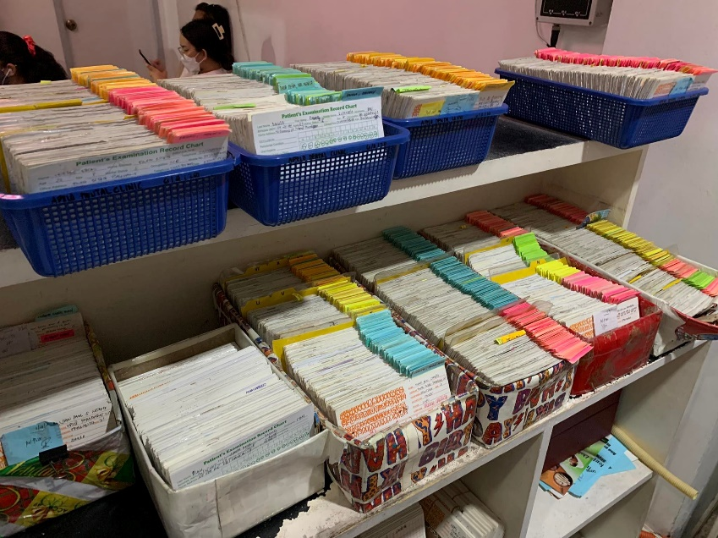

Figure 1 Apelo Dental Clinic's file system for patient information

## 3.2 List of Processes

To understand it better, below is the chronological day to day business process of Apelo Dental Clinic.

Table 1 List of Processes in the Current System

|  |  |  |
| --- | --- | --- |
| Process ID | Process Name | Process Details |
| P001 | Patients list their name in a paper | Patient queues up as early as 5 am to list their name, procedure, and date of arrival in a sheet of paper which will be the basis of numbered card. |
| P002 | Getting numbered card | At 8:30 am, the front-desk staff will give all the patients their numbered card based on date of arrival. |
| P003 | Waiting at the lobby | Patients who get smaller number will wait at the lobby while some patients leave the clinic for a while and comes back at a later hour |
| P004 | Retrieval of index card | Front-desk staff will retrieve the patient’s index card that contains all the patient’s information. If not found, the patient will fill another index card. |
| P005 | Fill-up an index card | New patient or those who haven’t found a record (lost) will fill another index car |
| P006 | Looking at the index card | Dentist will look at the index card to see all the needed information such as recent procedure done, visual teeth model etc. |
| P007 | Procedure starts | Once diagnosis is made, all the necessary procedure will be made or depends will be agreed upon |
| P008 | Procedure done | When the procedure is done, the dentist will write the payment cost in a small piece of paper clipped in the index card. |
| P009 | Paying the procedure | The patient will go to the accounting staff to pay the amount, when their money is not enough, the clinic allows balances to be paid on the next visitation. |
| P010 | Record the payment | Accounting staff will record all the payment made in that day in a paper and records the payment info in the index card |
| P011 | Putting back the index card | At the end of the day, all the index cards will then be rearranged again to its tray holder. |
| This table shows the chronological day to day process of the clinic from the moment that patient queues to list their name in a paper to getting their number, finishing their procedure, paying, and leaving the clinic. | | |

## SWOT Analysis

Table 2 SWOT Analysis for Apelo Dental Clinic



## Proposed System

The software will be developed as a responsive web application using HTML, Bootstrap and Laravel and the developers will collaborate in Visual Studio Code. For the peopleware, the required staff as well as the owner will be taught about the application or be provided with documentation to avoid errors and confusion. For the network, the developers would like the files, pictures, videos, and other documents to be transferrable via WIFI, Bluetooth, USB, and even downloading through internet storages such as Google Drive and iCloud. In terms of data syncing in all the devices, information should be consistent via the devices used in the clinic through routers while available data on the website from the patient’s side accessing it remotely should be syncing as there is an internet connection available.

## Feasibility

### Operational Feasibility

Apelo Dental Clinic's (ADC) patient information are stored in the index card that are filed in a box. As the team propose to Doctor Denroe the initial plan to implement a website with the main feature to address the appointment system, he declines to it due to the reason that there's no fix time for each patient's procedure. He rather suggests having a database for patient's information due to several problems that the traditional file system is causing. Hence, the support of the management to the project is certain.

Soon as the clinic will transition from index card file system to computerized, there would be a need for testing and brief training for navigation and how-to of the system.

The secretary and staff in payment section has the knowledge of using computer programs, while the dentist have no problem in transitioning to tablet-based information retrieval as they all agreed in implementing the application and are using smartphones.

Documentation will also be available to the development of the application so that the future IT who will maintain the program will not have a hard time to make modifications on it.

### Economic Feasibility

ADC's facility is already equipped with desktop computer, Wi-Fi and printer which are the initial hardware equipment needed for the project. However, the tablets which are the alternative for index card are still needed to be canvas for estimated price, nevertheless, Doc Denroe was already informed about the possible cost as the idea of tablets are suggested by him.

There will be no need for any software subscription for the development of the system as the language for development will be open-source and the database will be RDBMS of phpMyAdmin via XAMPP.

Although the development of the project will not assure to increase the profit of the clinic, customers’, and employees' satisfaction for faster waiting time due to fast retrieval of information and paperless transaction will outweigh the cost of the project development.

### Technical Feasibility

Tablet is the only hardware that the clinic lacks for the initial assessment of hardware requirements, nonetheless, tablet can be easily purchased today with lower specifications that can support the program to be installed. Since RDBMS is the database needed for the application, the future needs for memory capacity of the program are more likely to be contained in free database software as they offer large memory capacity in terms of clinic-size database.

# Methodology

Scrum is the software development framework that is used in in this project. It is a framework under Agile methodology for managing complex projects and a flexible approach that is designed to respond to changing requirements and deliver valuable software incrementally. This section will also discuss the different requirement analyses and diagrams done to guide the team in developing the software.

## Requirements Analysis

### Product Backlog / User Stories

Table 3 Updated Product Backlog for ADENICSY

|  |  |  |  |  |
| --- | --- | --- | --- | --- |
| ID | **As a…** | **I want to be able to…** | **So that…** | **Priority** |
| 1 | Patient | Register/login in the system | I can view the current number being served, get a number, and access my payment records | Must |
| 2 | Admin | Login in the system | I can add employees | Must |
| 3 | Dentist | Login in the system | I can view/add dental records of patient | Must |
| 4 | Staff | Login in the system | I can modify the dentist’s schedule, change the current number, see the queueing list, and add or update patient’s payment records | Must |
| 5 | Admin | Add employees with their roles | My employees can login and do their job. | Must |
| 6 | Patient | Get a number | I can visit the clinic | Must |
| 7 | Patient | View the current number | I can estimate what time should I go to the clinic | Must |
| 8 | Patient | Be notified when my number is near the current one | I can be reminded incase I’m not looking at the app | Must |
| 9 | Patient | See my payment records | I can verify the payment that reflected on my account. | Should |
| 10 | Patient | Provide feedback to my visitation | I can express my feeling towards the service on my visitation | Should |
| 11 | Dentist | Search for a patient name | I can retrieve their records instantly | Must |
| 12 | Dentist | Add notes and other information of patient teeth or procedure | I and other dentists can have more detailed information about a certain condition | Must |
| 13 | Dentist | Add / Upload teeth picture of my patient | They can see the progress of their teeth | Must |
| 14 | Dentist | Add, view, and examine Xray file in my patient’s medical record | I can see their X-ray file instantly whenever I need it | Must |
| 15 | Dentist | Add payment details after operation | The accounting can see it without the patient bringing a piece of paper | Must |
| 16 | Staff | Update paid amount of patient | The account summary will be exact on patient’s end | Must |
| 17 | Staff | Update dentist schedule | The available number of slots will be updated before the next business day starts | Must |
| 18 | Staff | Update the number of available slots | The clinic can adjust accordingly | Must |
| 19 | Staff | View the queueing list | I can verify the patient in queue. | Must |
| 20 | Staff | Update the current number | Patients can see the current number wherever they are. | Must |
| 21 | Admin | View dashboard | I can track of the progress in my clinic | Should |
| 22 | Admin | Change the variables in the dashboard | I can get insight on certain configurations I want | Should |
| 23 | Admin | Add employee | So that when there’s new hire, they can access the system | Must |
| 24 | Admin | Update employee | So that their privileges or access can be modified as necessary | Must |

### Event Tables

Table 4 Event's Table for ADENICSY

|  |  |  |  |  |  |
| --- | --- | --- | --- | --- | --- |
| ****Event**** | ****Trigger**** | ****Source**** | ****Use Case**** | ****Response**** | ****Destination**** |
| Patient/Employee login to the System | Register/Log in | Patient, Employee | Manage Account | -Account registration details  - Update account information | Patient, System,  Employee |
| Patient gets a queueing number | Queuing | Patient  Staff  System  Staff  Patient | Manage Queuing | -Get/View queueing number  -Fill up queueing information  -Available dentist schedule details  -Update Current Number  -Notify Patient  -Update information in the queueing list  -Provide feedback | Patient, Staff, System  Patient, Staff, System  System, Staff, Dentist  System, Patient, Staff  Patient  System, Staff  System, Staff, Admin |
| Staff modifies dentist schedule and available number | Queuing | Staff | Manage Dentist Schedule | -Add dentist schedule  -Update dentist schedule  -View dentist schedule | Admin, Staff  Admin, Staff  Dentist |
| Dentist inputs new patient/dental record | Medical Records | Dentist | Manage Dental Records | -Search patient dental records  -Show previous dental records  -Add new patient dental records | Dentist  Dentist  Dentist, Admin, System |
| Manage payment | Payment Management | Dentist  Staff | Manage Payment Records | -Add procedure information and cost  -View previous payment records  -Update patient payment records  -Confirmation of the payment | Staff, System  Staff  System, Patient  Patient |
| Examine Dashboard | Dashboard | Admin | Manage Report | - Get data from database  - Show data in Dashboard | Admin |

### Use Case Diagrams

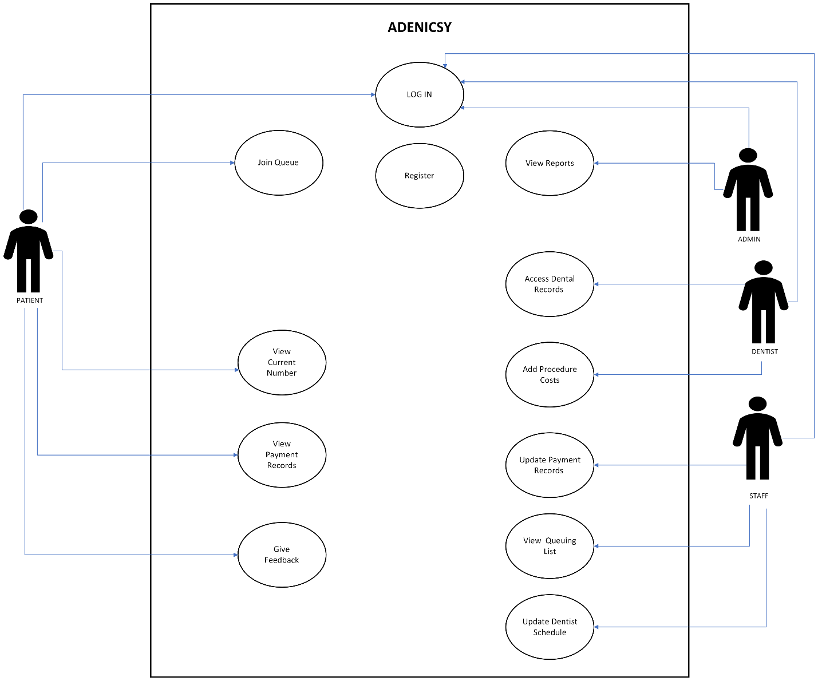

Figure 2 Use Case Diagram for ADENICSY

### Use Case Full Description

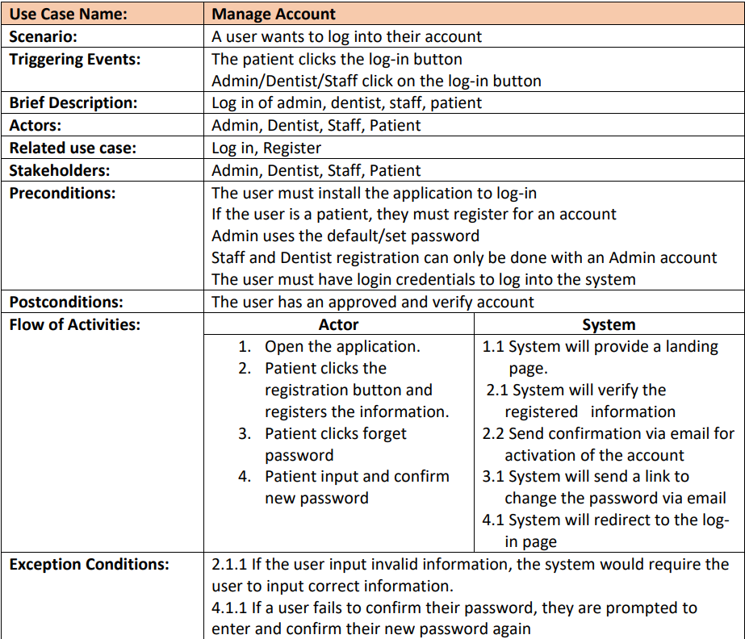

Figure 3 Manage Account Full Use Case Description

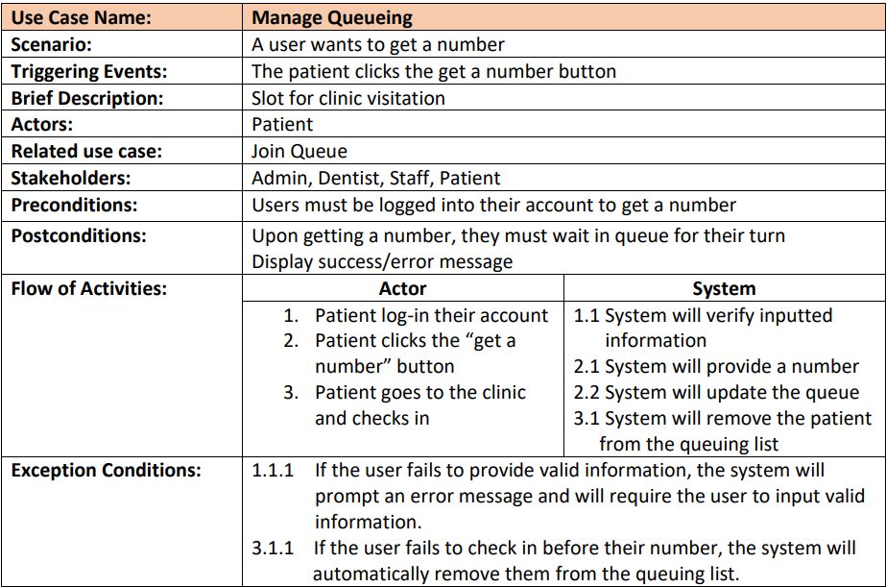

Figure 4 Manage Queueing Full Use Case Description

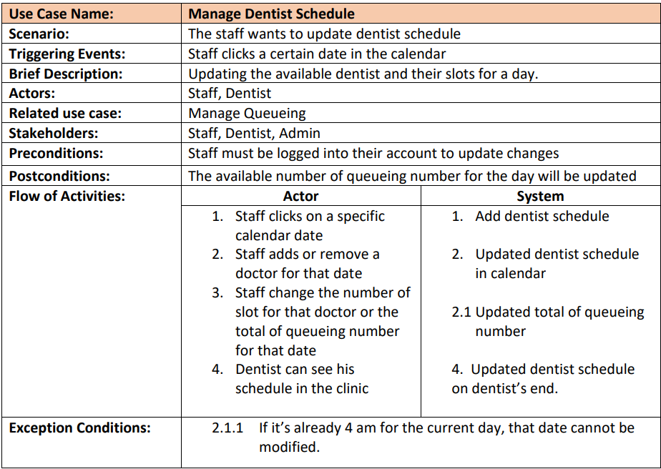

Figure 5 Manage Dentist Schedule Full Use Case Description

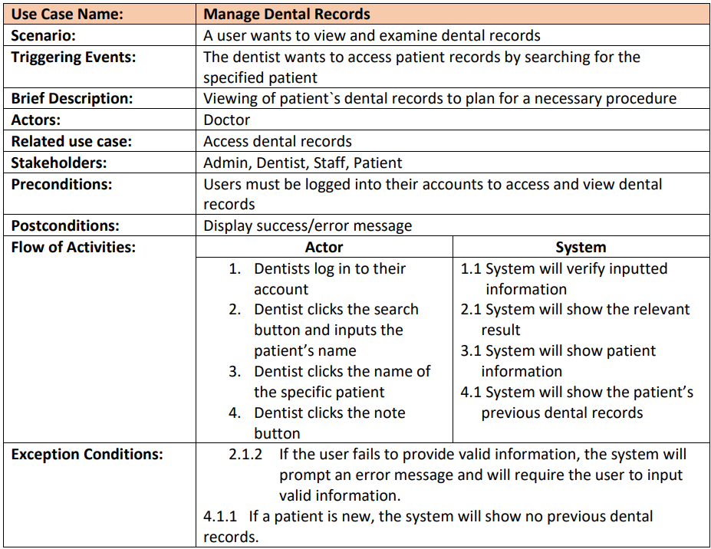

Figure 6 Manage Dental Records Full Use Case Description

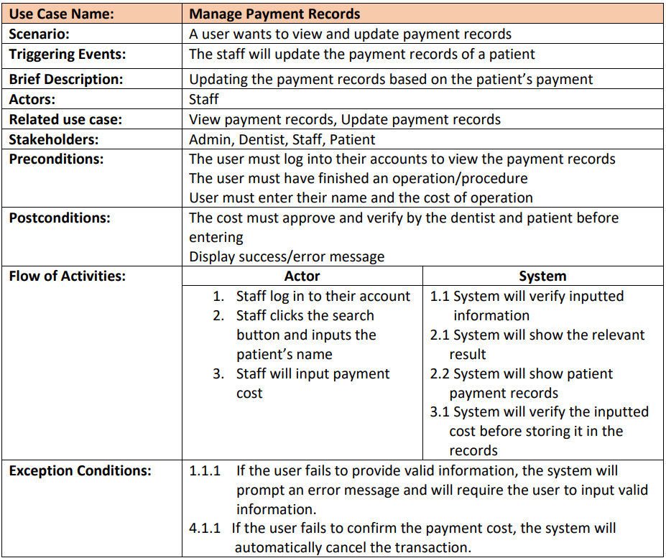

Figure 7 Manage Payment Records Full Use Case Description

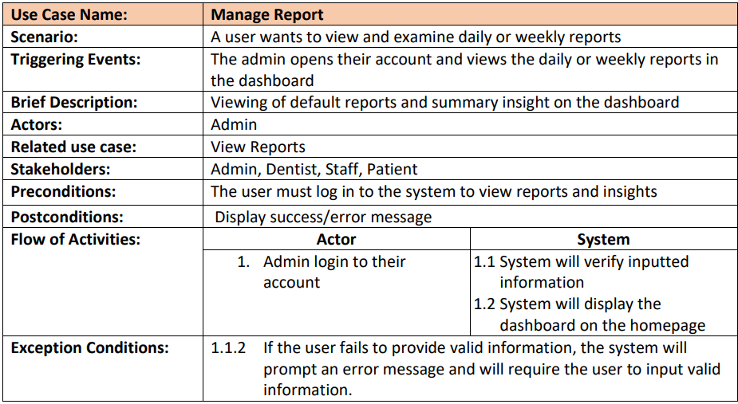

Figure 8 Manage Report Full Use Case Description

## System Analysis and Design

### Diagram Description automatically generatedContext Diagram

Figure 9 Context Diagram for ADENICSY

### Data Flow Diagrams

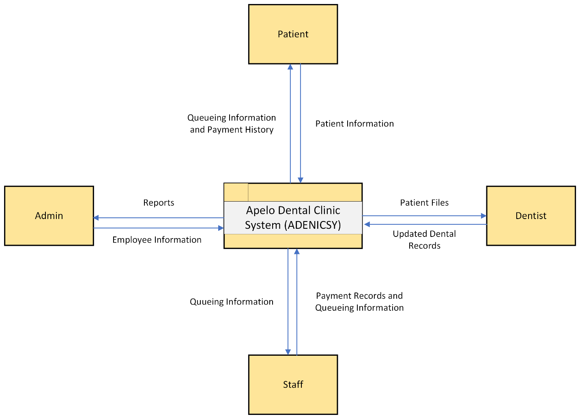

Figure 10 Level 0 DFD for ADENICSY

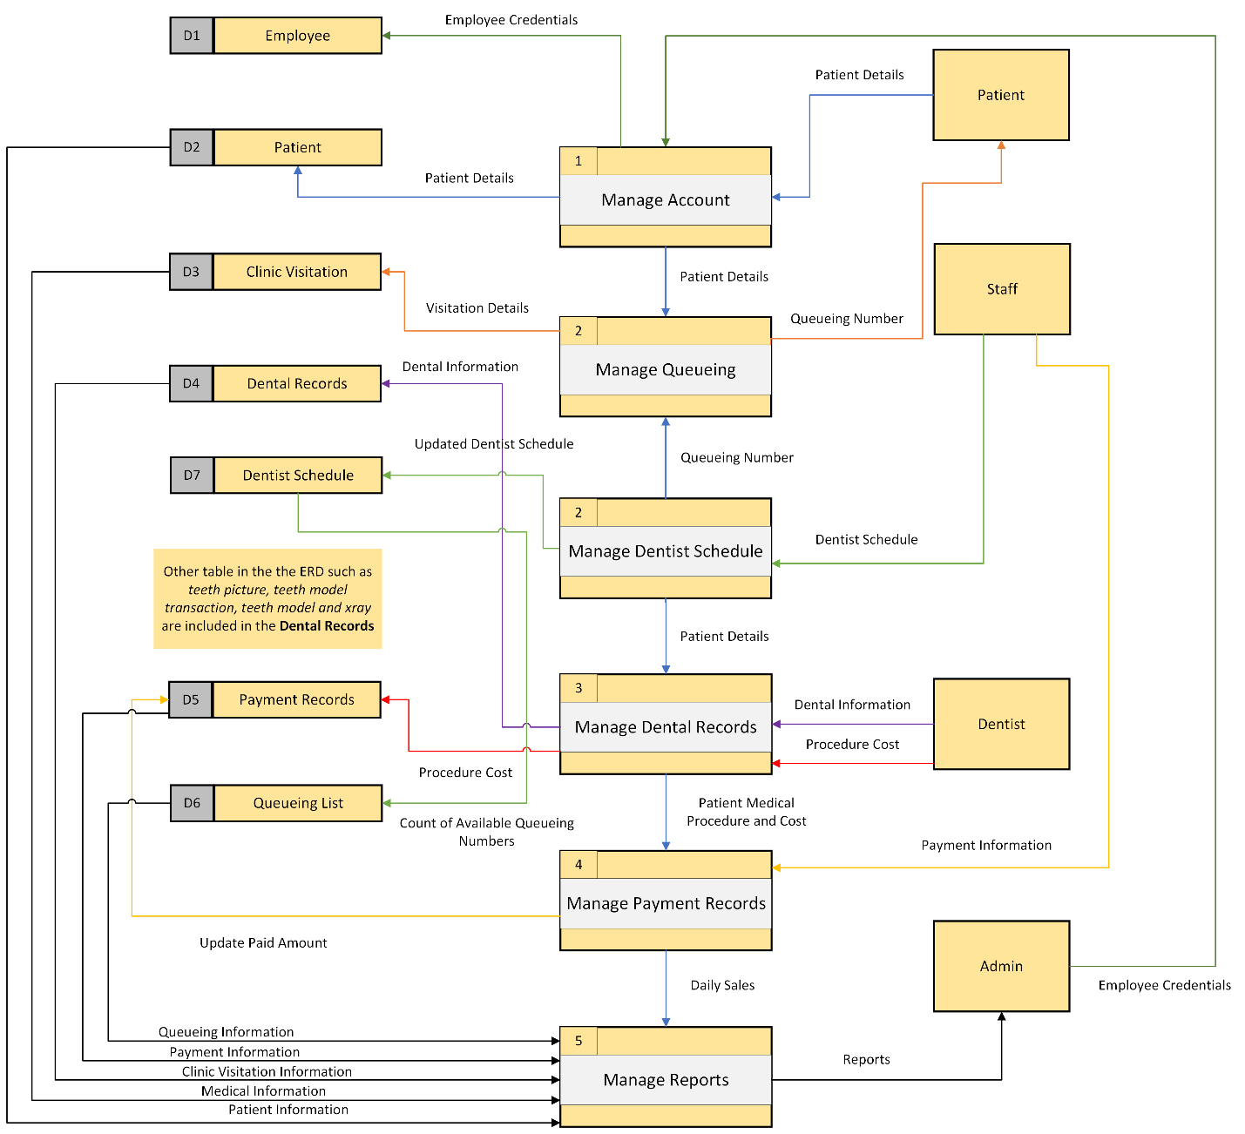

Figure 11 Level 1 DFD for ADENICSY

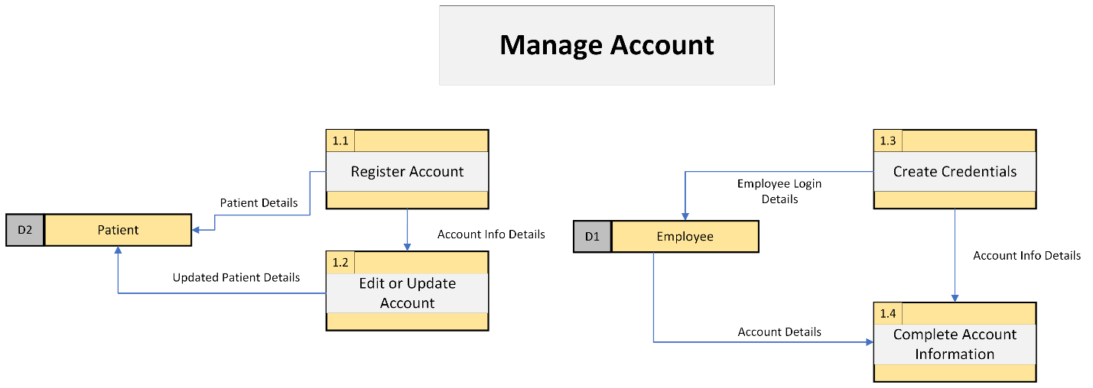

Figure 12 Level 2.1 DFD (Manage Account) for ADENICSY

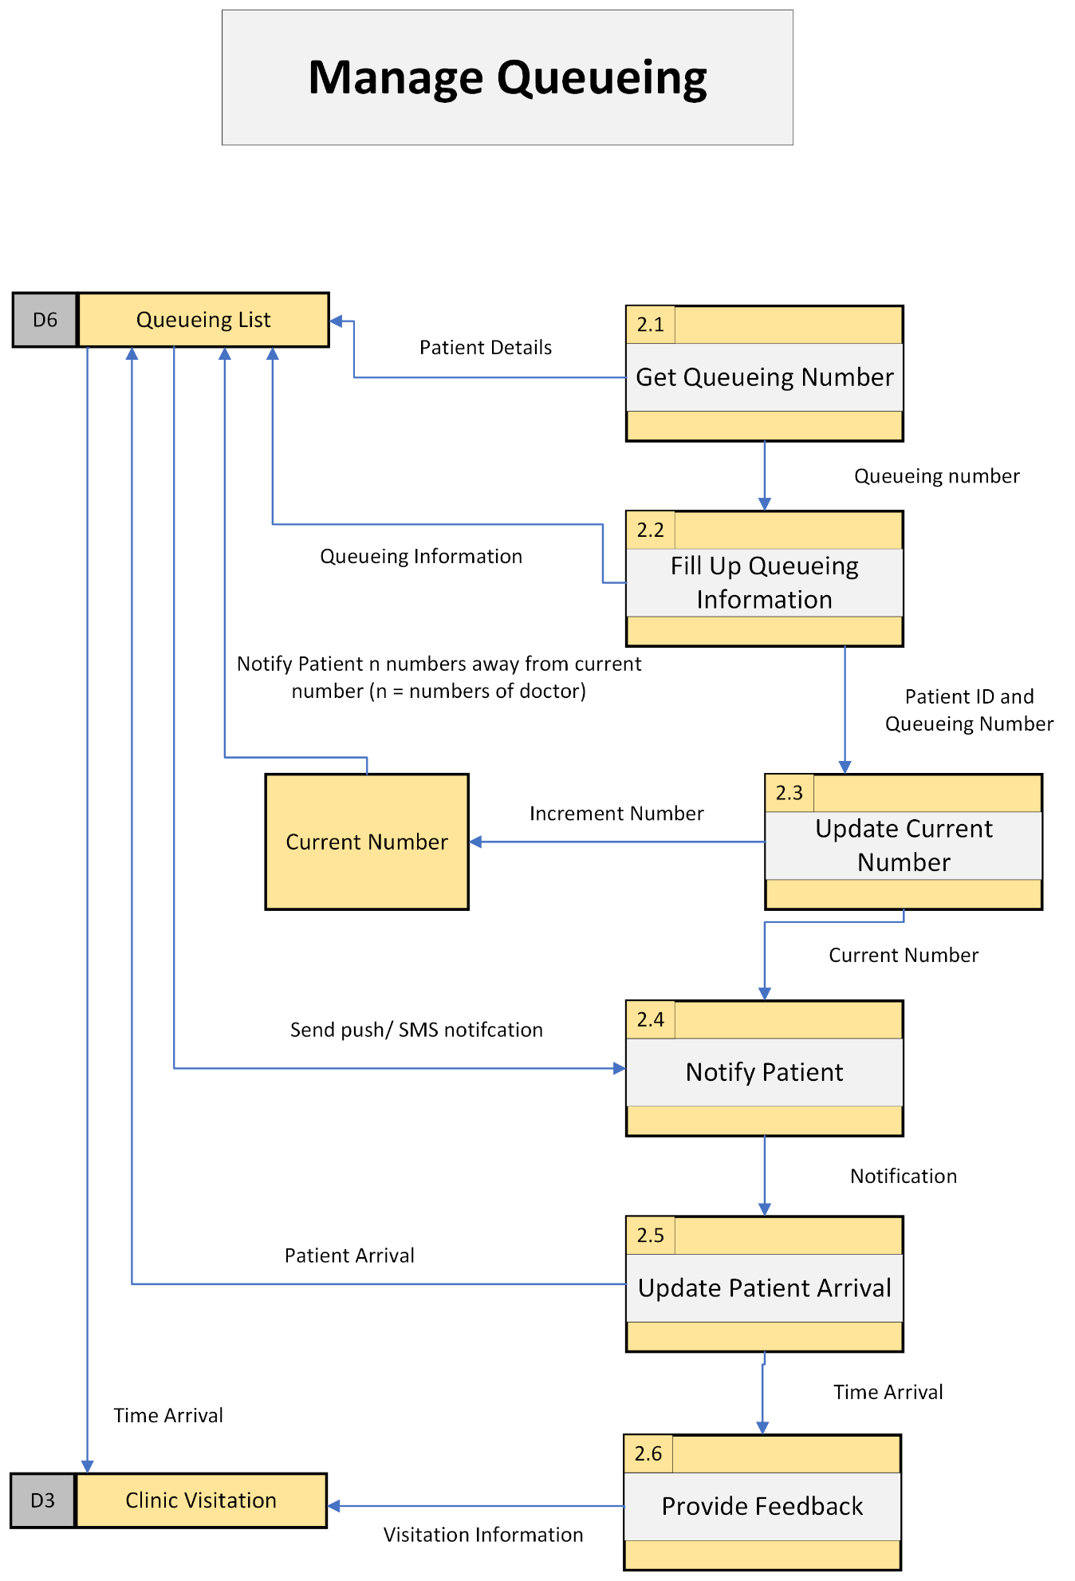

Figure 13 Level 2.2 DFD (Manage Queueing List) for ADENICSY

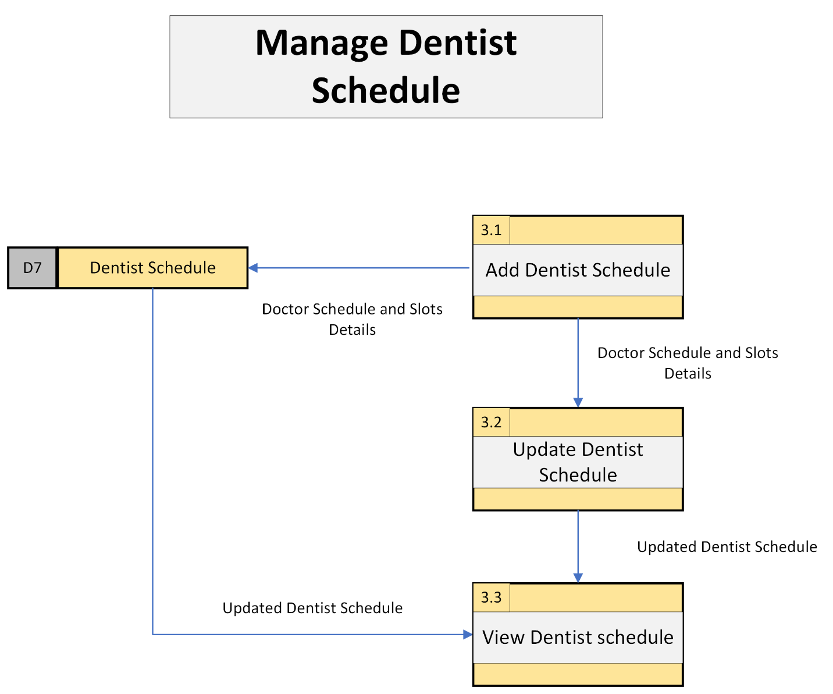

Figure 14 Level 2.3 DFD (Manage Dentist Schedule) for ADENICSY

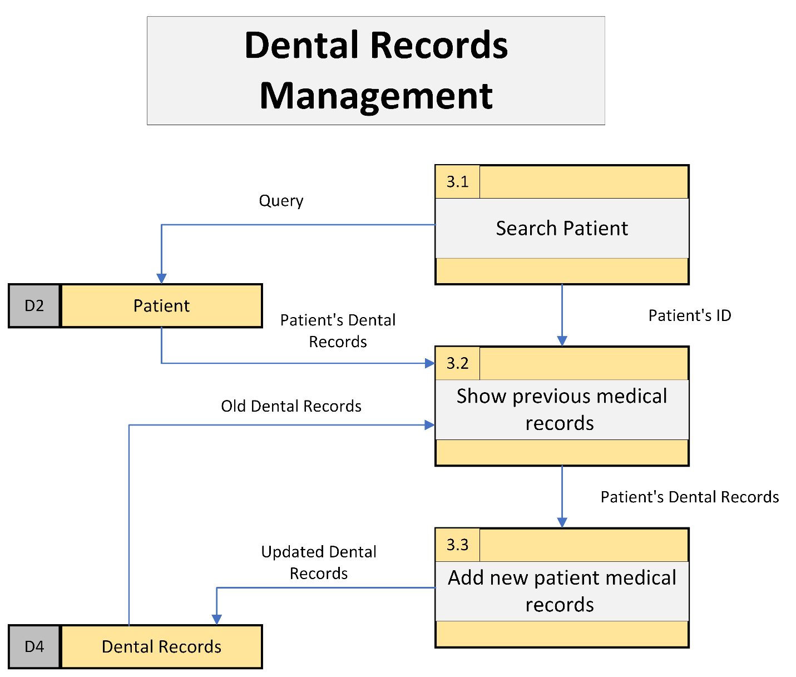

Figure 15 Level 2.4 DFD (Manage Dental Records) for ADENICSY

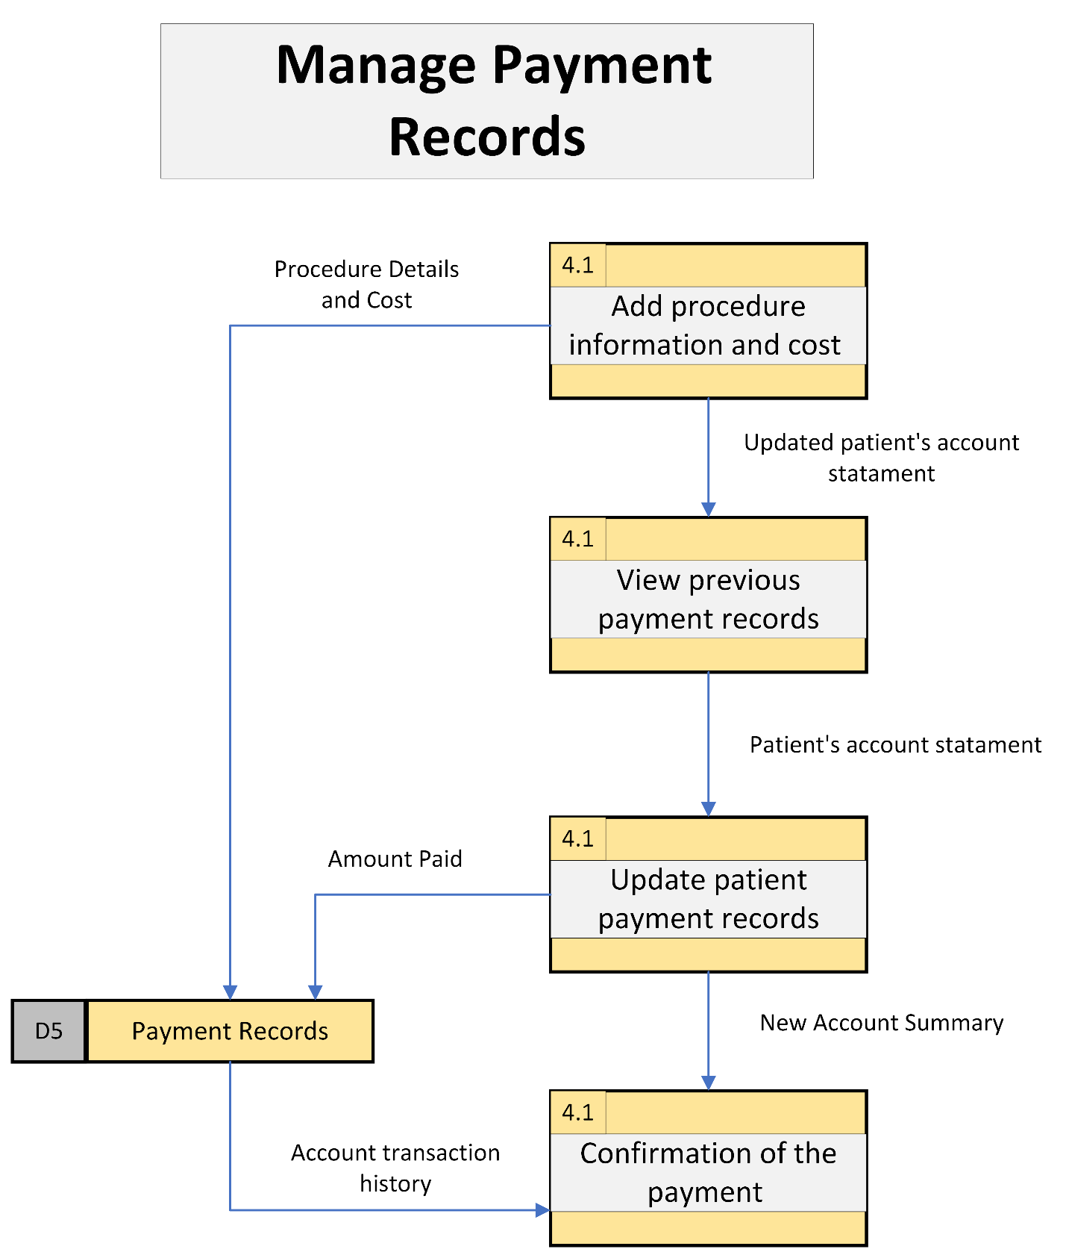

Figure 16 Level 2.5 DFD (Manage Payment Records) for ADENICSY

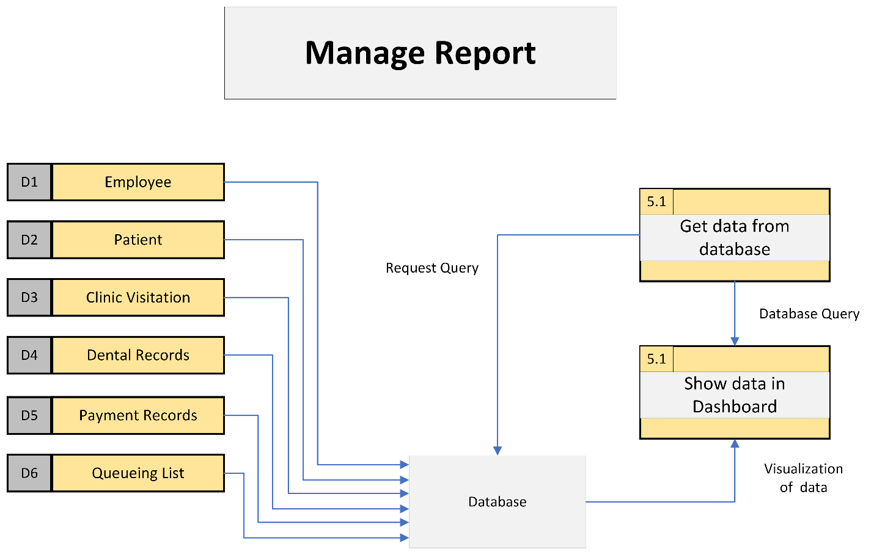

Figure 17 Level 2.6 DFD (Manage Report) for ADENICSY

### Entity-Relationship Diagrams

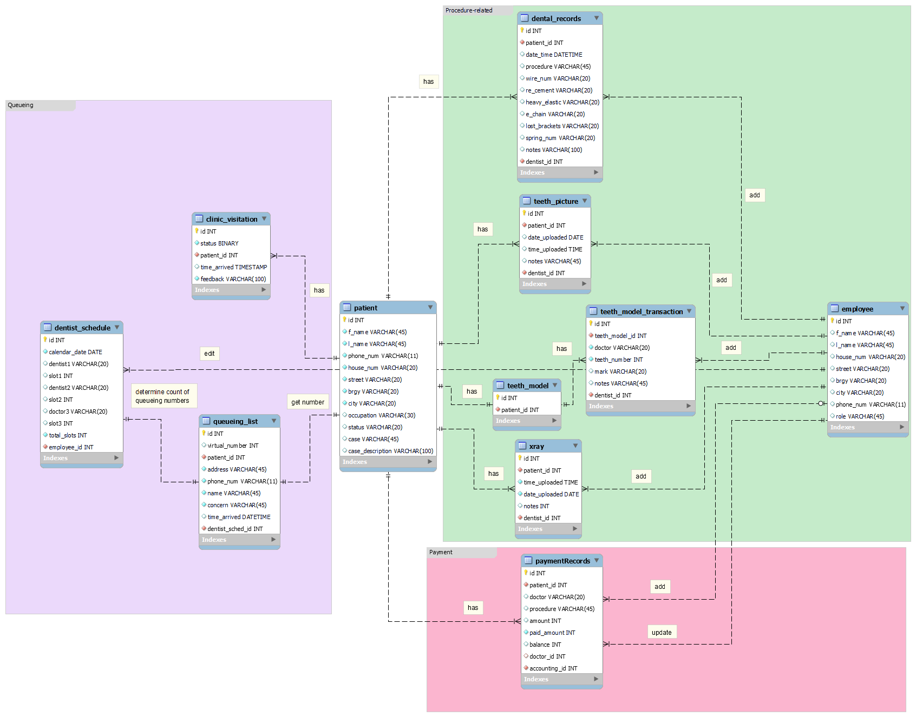

Figure 18 Entity Relationship Diagram (ERD) of ADENICSY

Data Dictionary

Figure 19 Data Dictionary of ADENICSY's ERD part 1



Figure 20 Data Dictionary of ADENICSY's ERD part 2

### Activity Diagrams

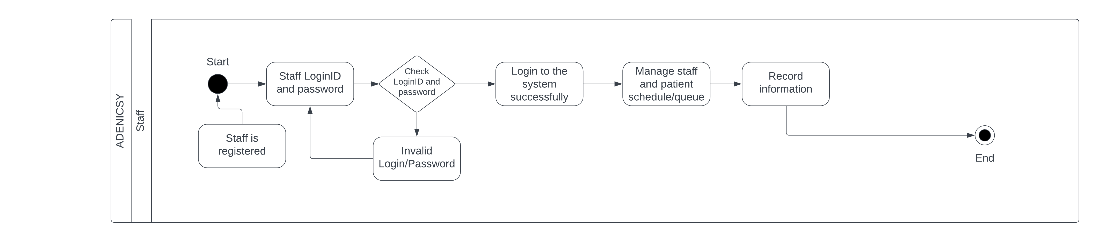

Figure 21 Activity Diagram for ADENICSY staff

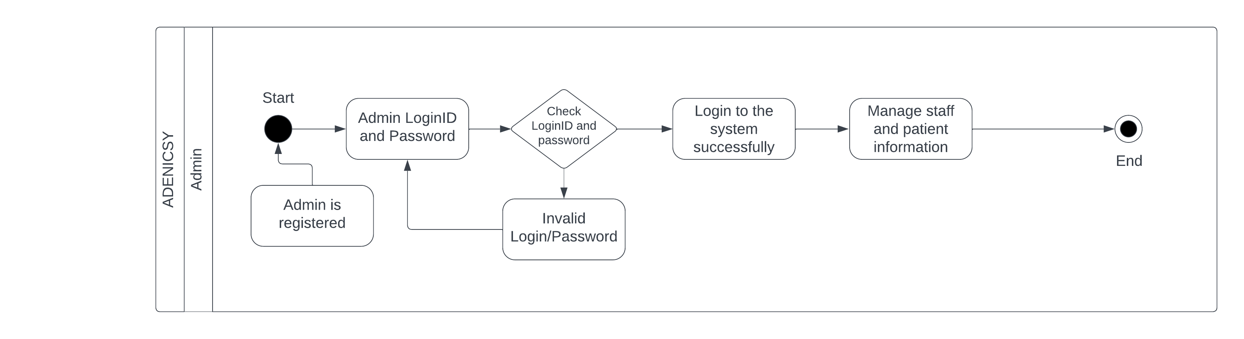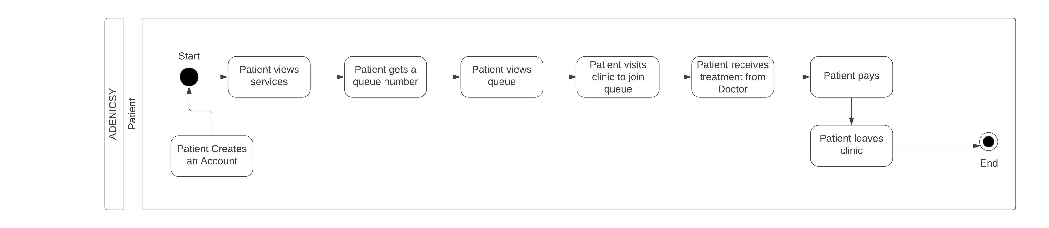

Figure 22 Activity Diagram for ADENICSY admin

Figure 23 Activity Diagram for ADENICSY patient

### Object Diagrams

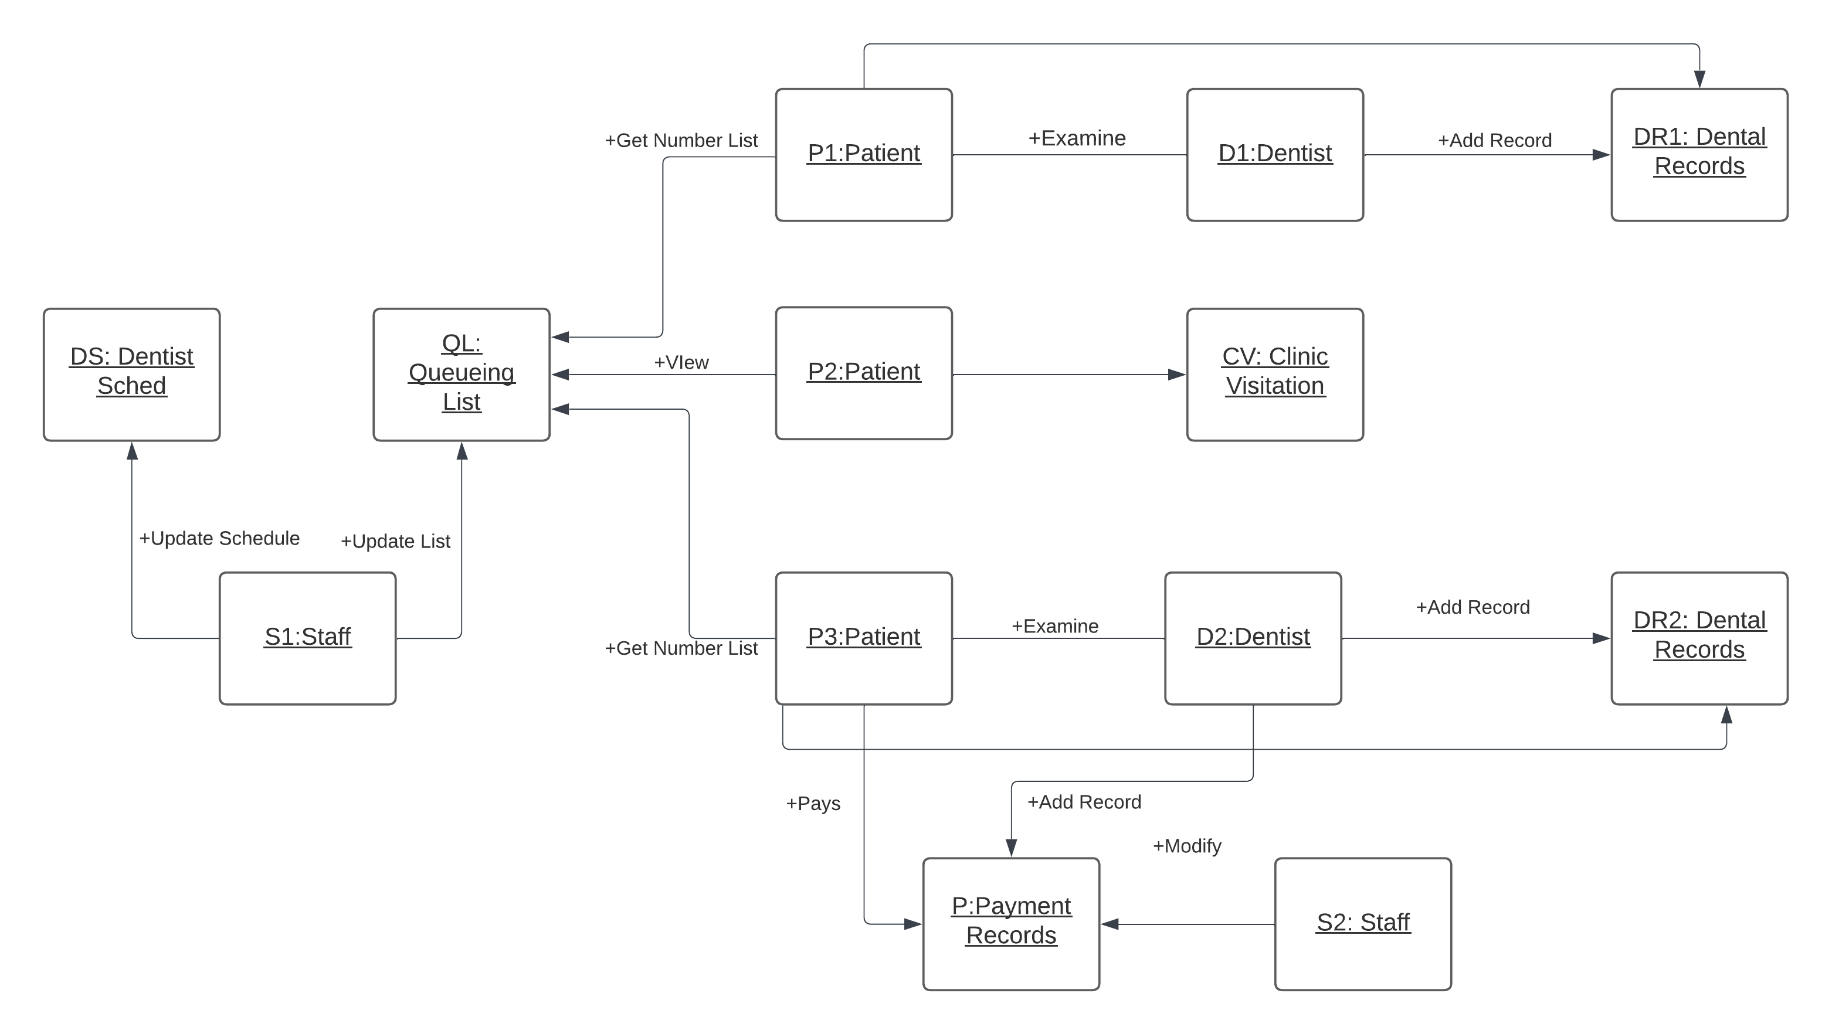

Figure 24 Object Diagram for ADENICSY

### Class Diagrams

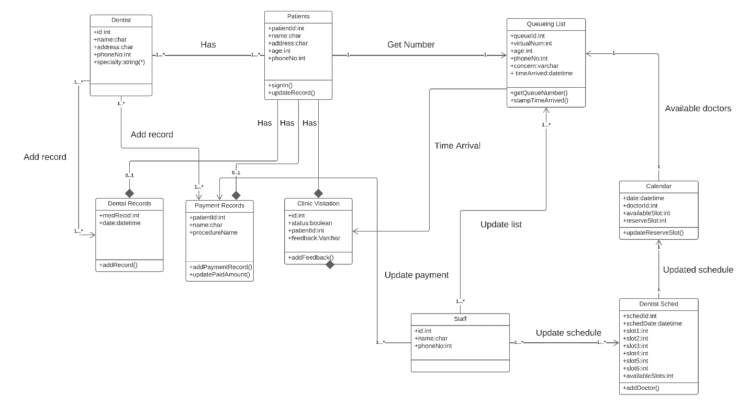

Figure 25 Class Diagram for ADENICSY

### Sequence Diagrams

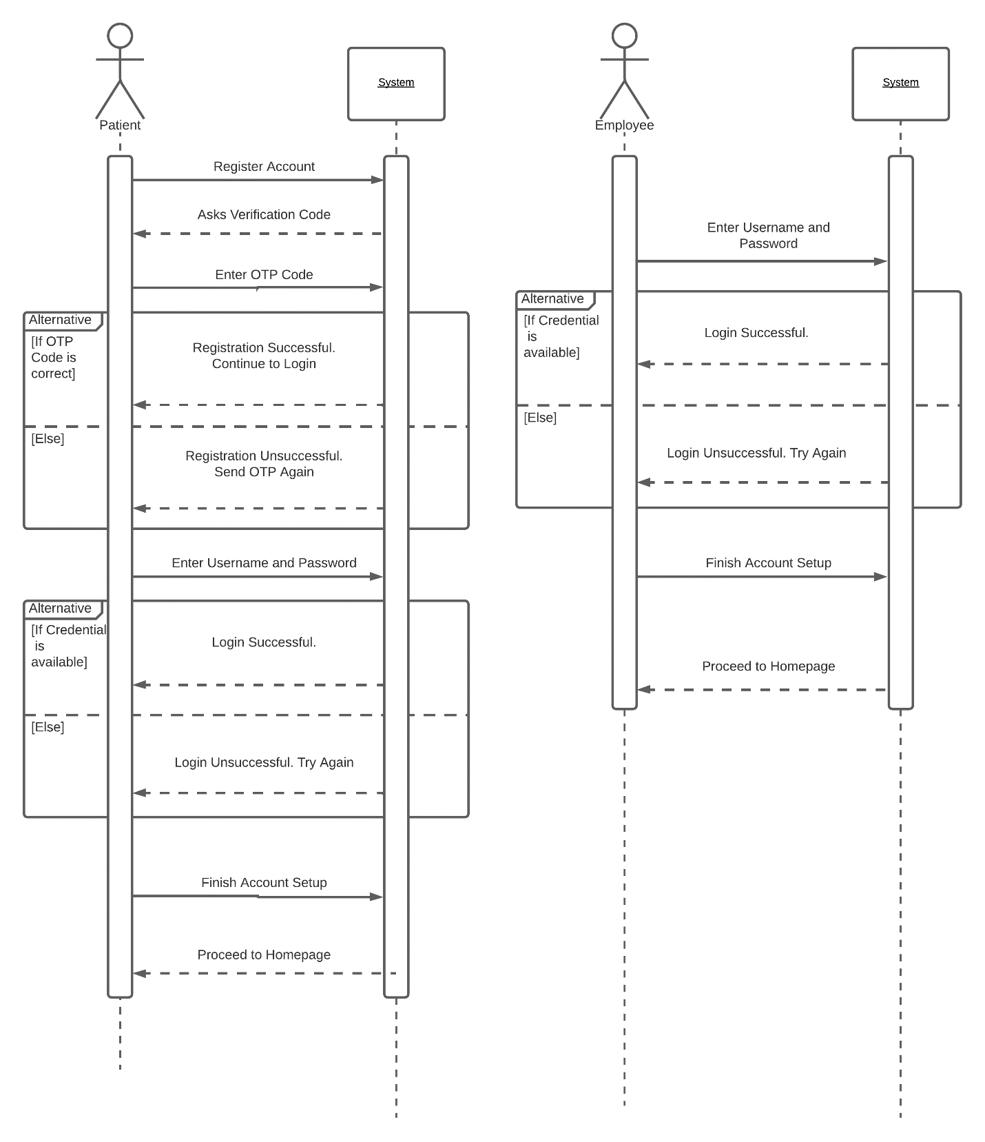

Figure 26 Sequence Diagram for Patient and Employee Login

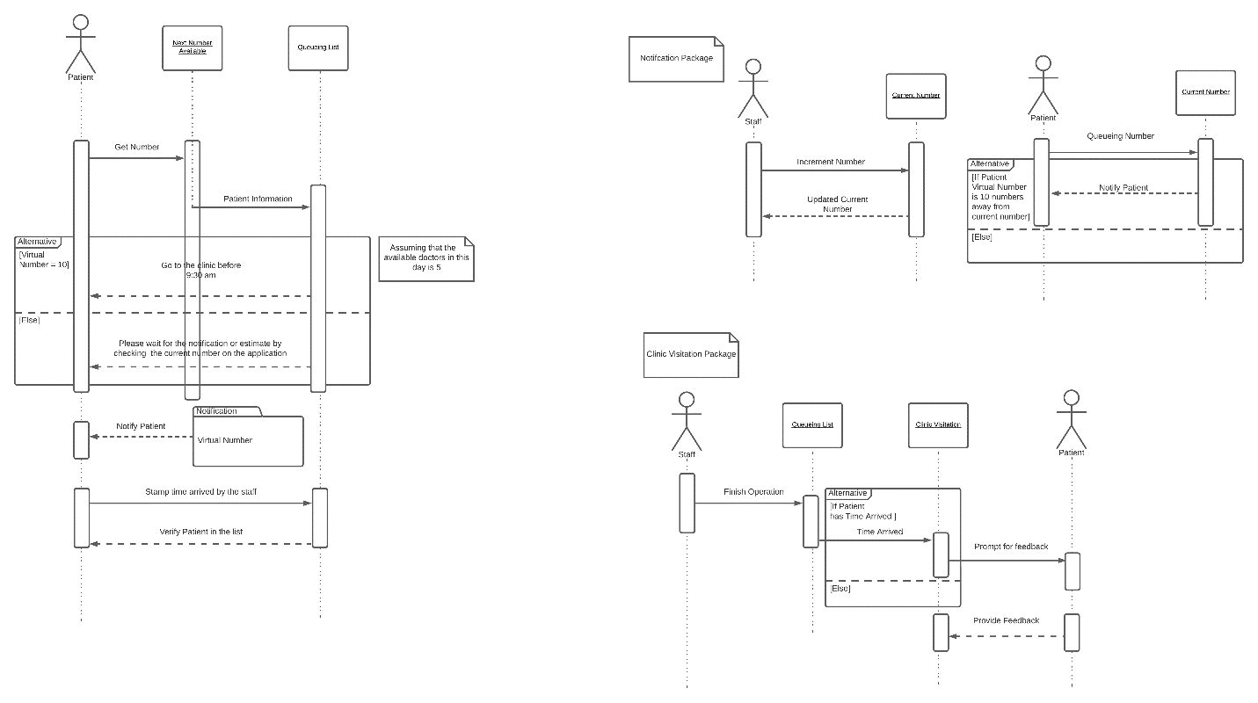

Figure 27 Sequence Diagram for Managing Queueing

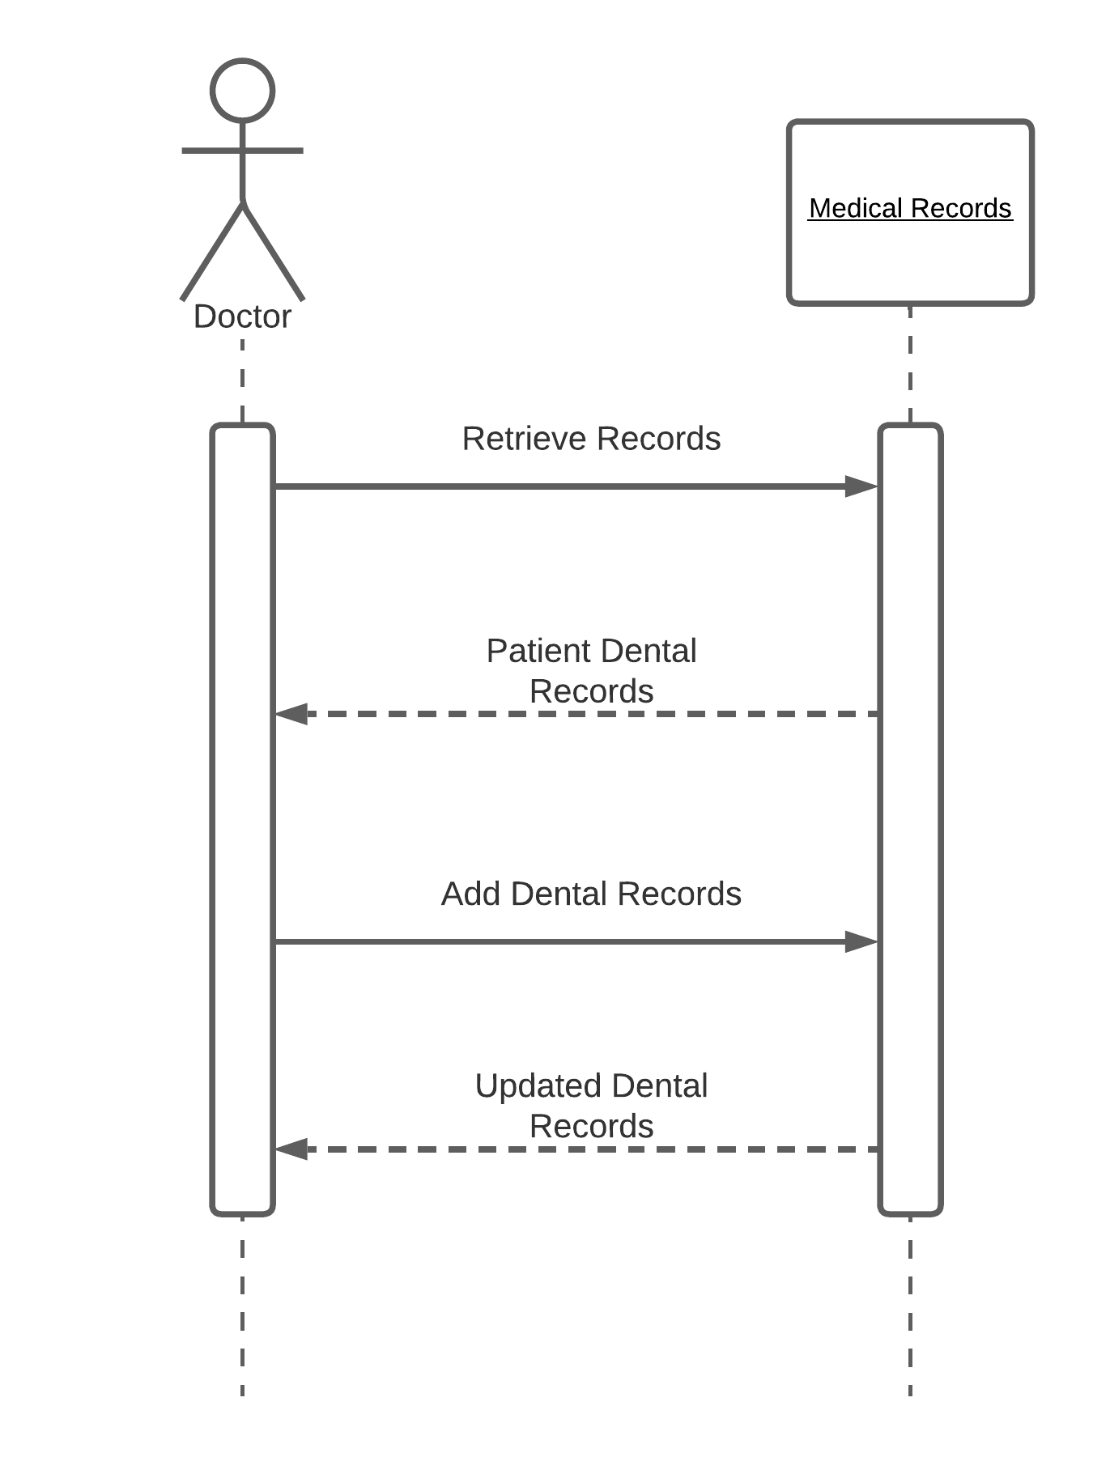

Figure 28 Sequence Diagram for Managing Dental Records

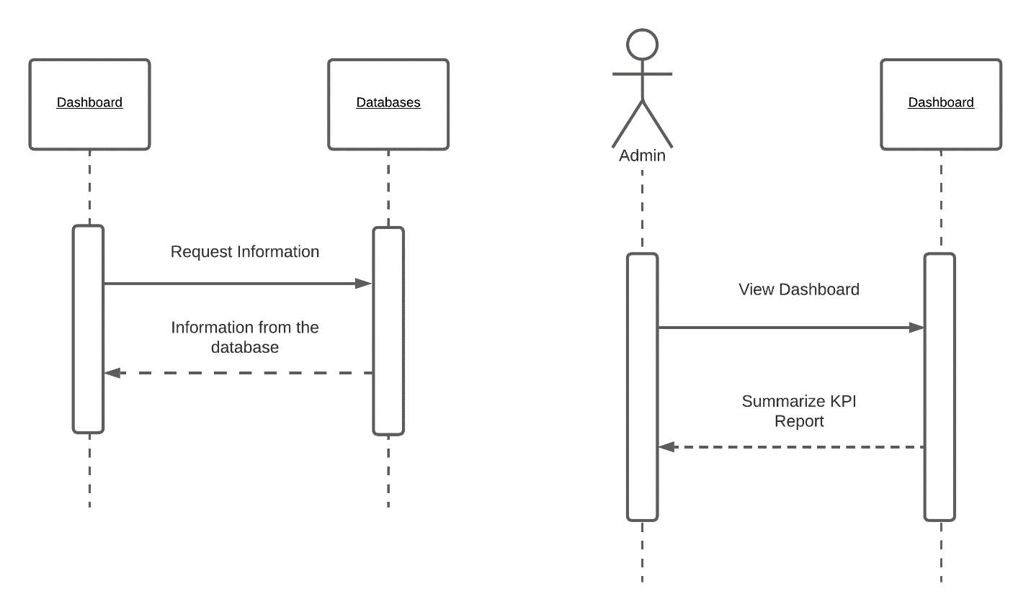

Figure 29 Sequence Diagram for Managing Reports

### State Machine Diagram

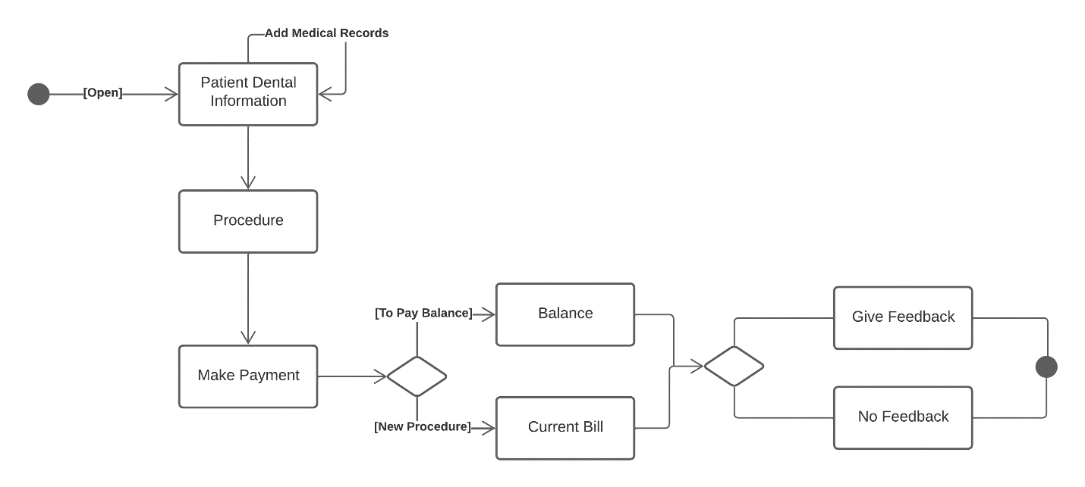

Figure 30 State Machine Diagram for Apelo Dental Clinic

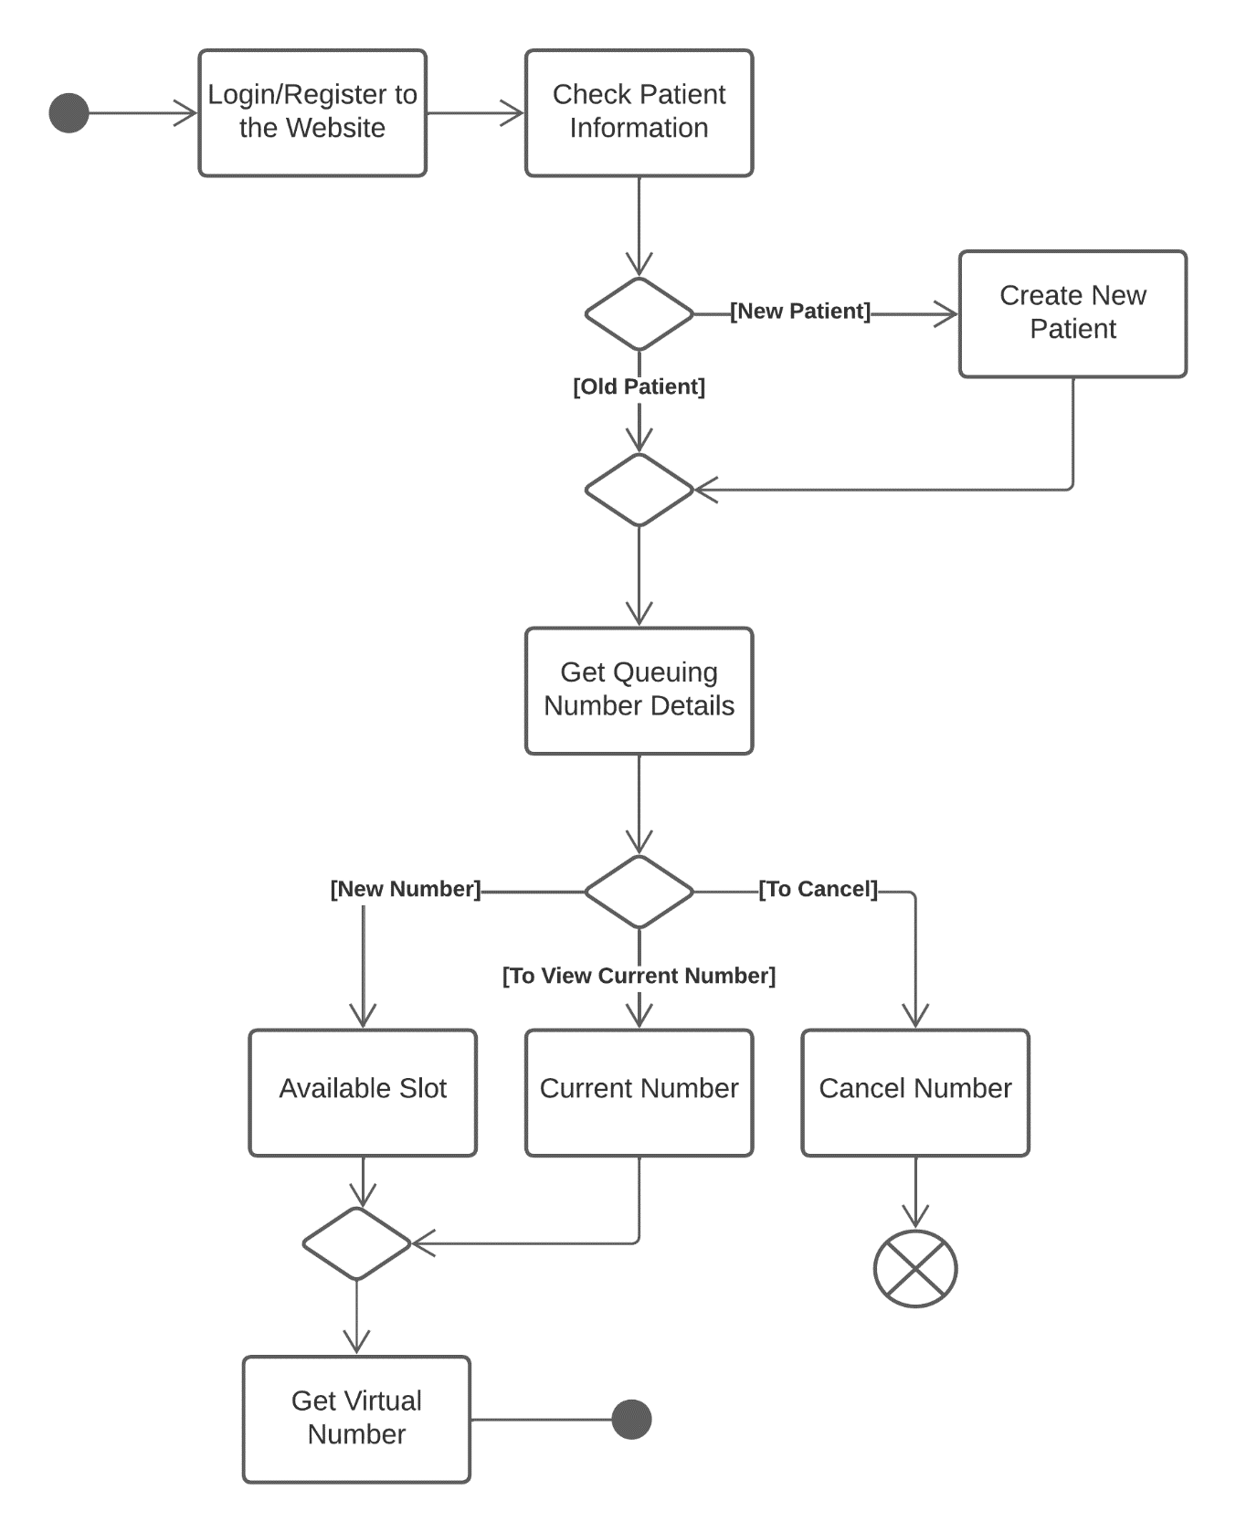

Figure 31 State Machine Diagram for ADC's Patient

### Deployment Diagram

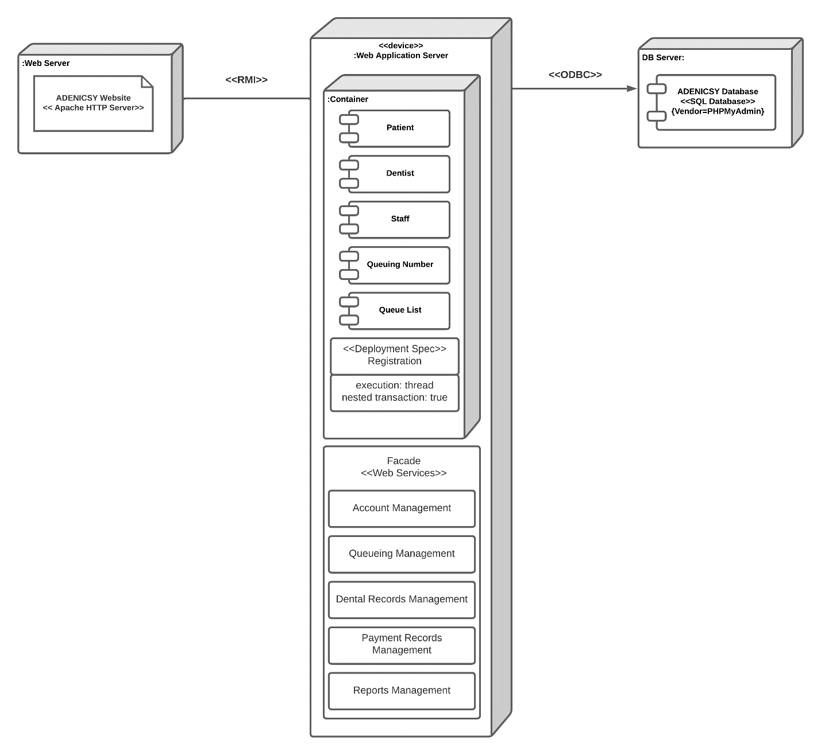

Figure 32 Deployment Diagram for ADENICSY

# Results and Discussion

Making diagrams for the application will make the developer understand their system better. It will make the flow of data and the how different processes will be done and implemented in clear and less erroneous manner. During the development of diagrams several iterations over the design were made and different test and cross examination to multiple artifacts are done to check its correctness. This section will discuss the release plan, prototype and different classes after the finalization of diagrams.

## Release Plan

This is the modified version of the release plan of the developers based on the product backlog at section 4.1.1. As of now, there’s still nothing completed from it, but the developers are planning to do the necessary pages from release 1 before SSYADD1 starts to better plan the more complex features and reiterate fast for testing and refinement.

**Release 1**

Admin can login in the system.

Admin can add employee credentials to the system.

Employees can login in the system.

Patients can visit the website.

Patients can register and login.

Patients can see the mission, vision, services, and other general information of the clinic.

**Release 2**

Dentists can search for a patient information.

Dentists can modify patient information in the storage.

Dentist can view teeth pictures of patients.

Dentist can view Xray of patient’s teeth in the system.

Dentists can input information on each tooth part in the visual teeth model.

Staff can add payment records of the patient.

Staff can search for the patient’s payment record.

Patients can get a queueing number.

**Release 3**

Staff can change dentist’s schedule.

Staff can increment the current number.

Staff can view the queueing list.

Patient can view their payment transaction.

Admin can see performance summary in the dashboard.

)

## Prototype

(The prototype shown here is the high fidelity version made during SSYADD1.

### Mobile Prototype for patient’s end

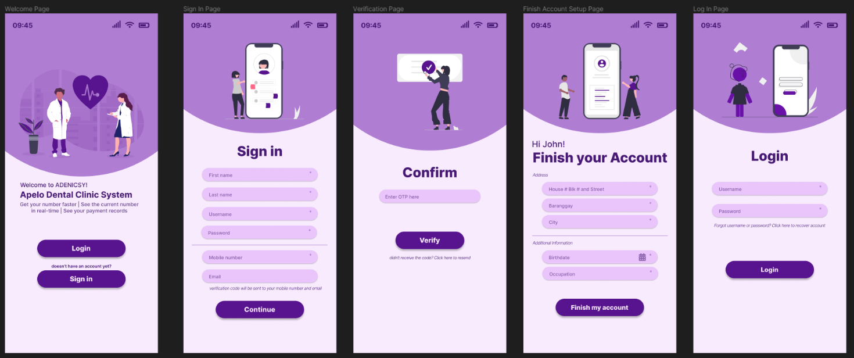

Figure 33 ADENICSY Mobile View Prototype for Patient Signup and Login

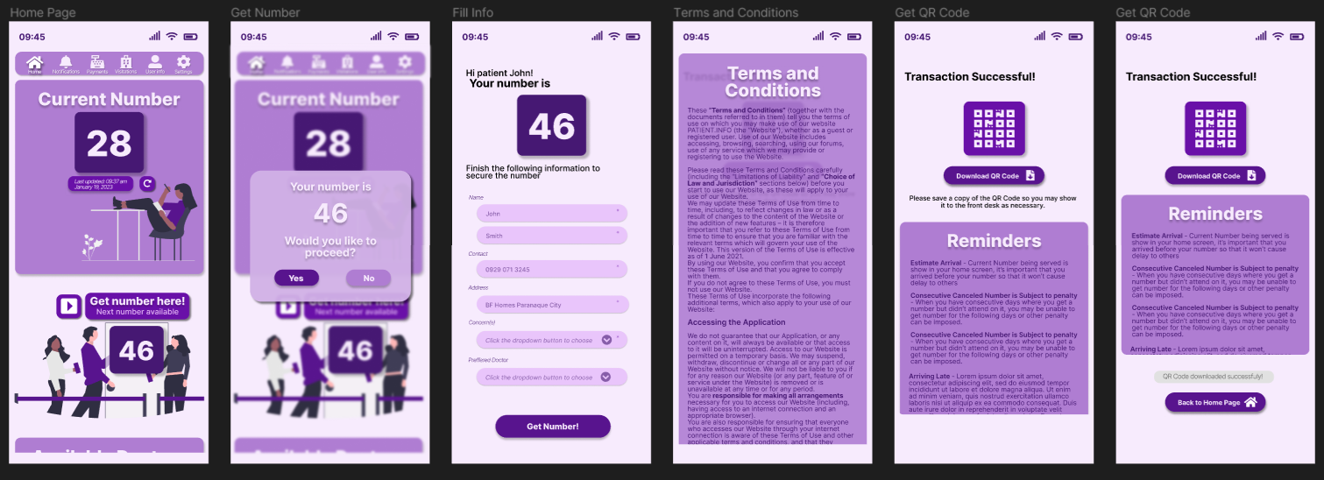

Figure 34 ADENICSY Mobile View for Getting a Queueing Number

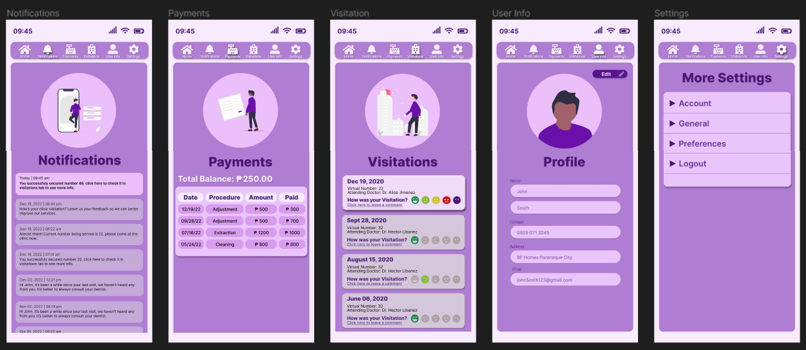

Figure 35 ADENICSY Mobile View on Notifications, Payment Records, Feedback and Profile

### Tablet Prototype for Staff’s end

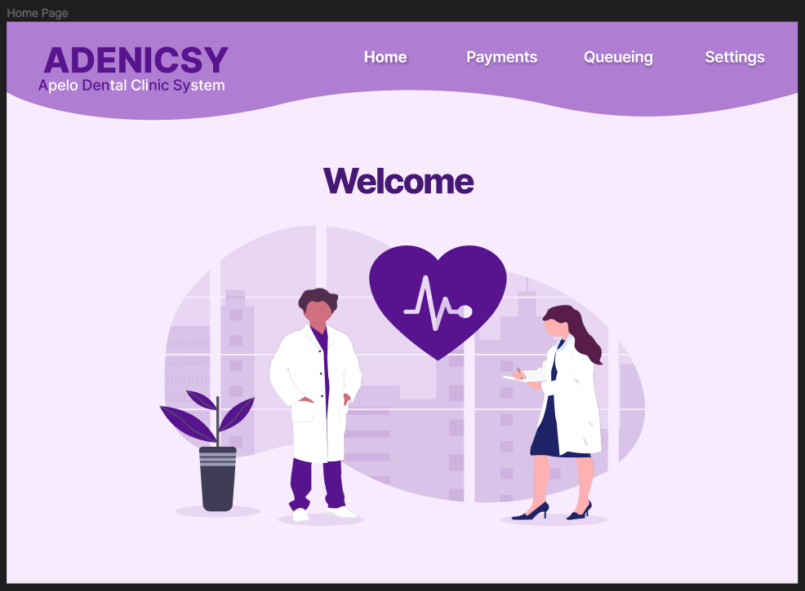

Figure 36 ADENICSY Tablet View for Staff's Welcome Page

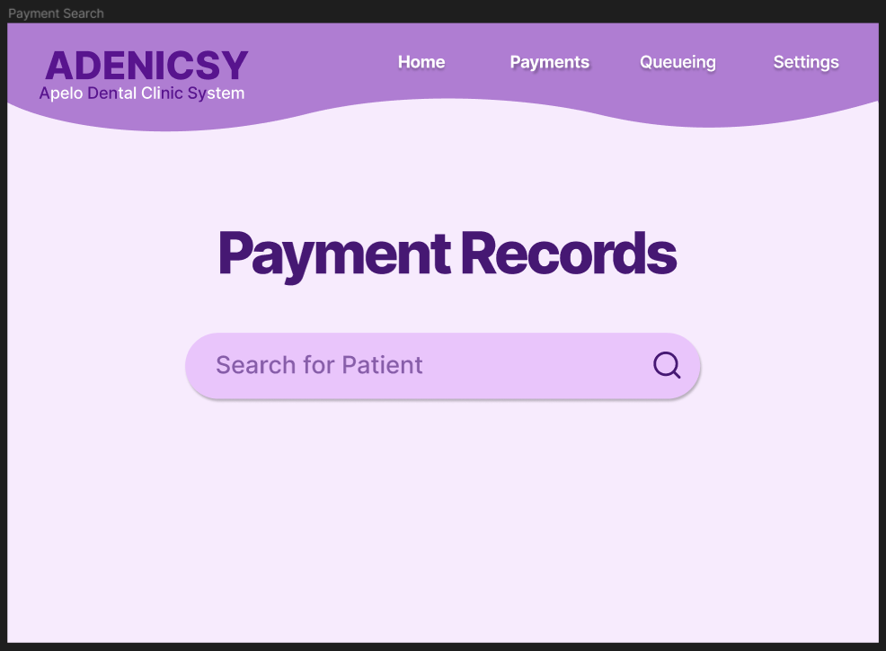

Figure 37 ADENICSY Tablet View for Searching Payment Records

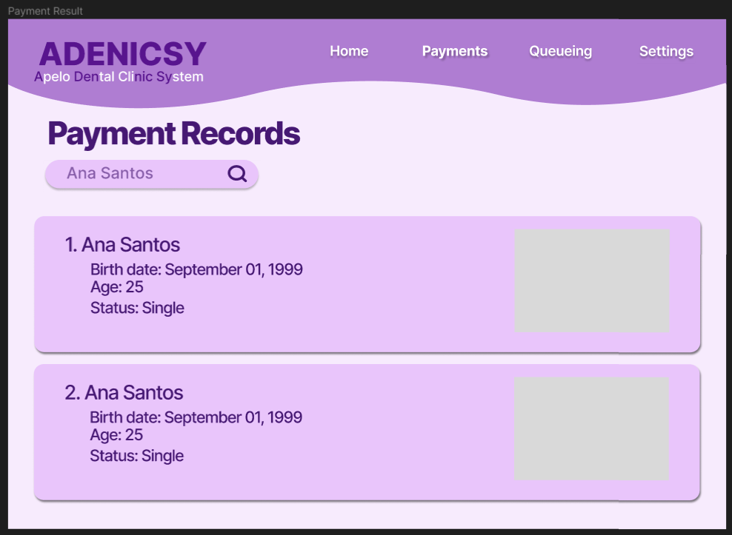

Figure 38 ADENICSY Search Result for Payment Records

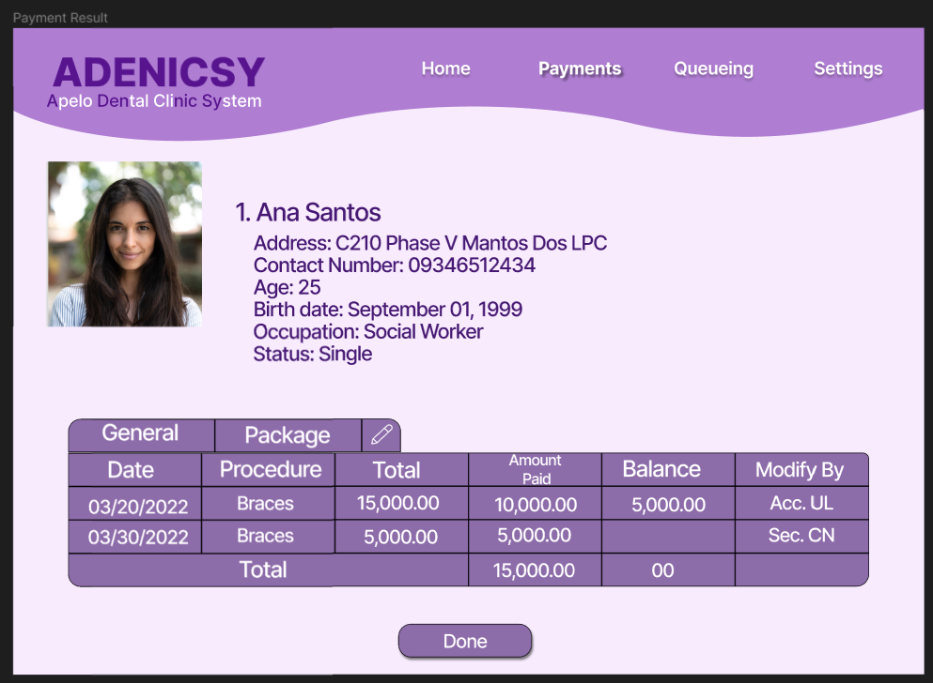

Figure 39 ADENICSY Payment Transaction Records of Patient

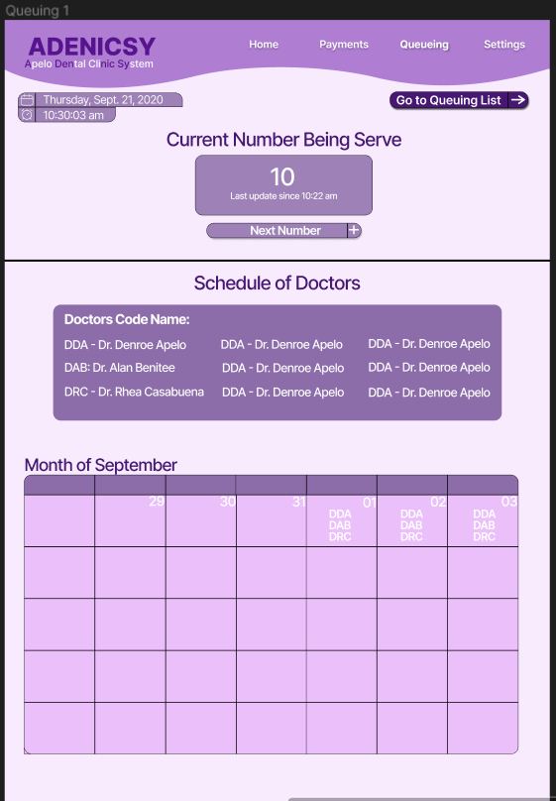

Figure 40 ADENICSY Dentist Schedule in Staff's end

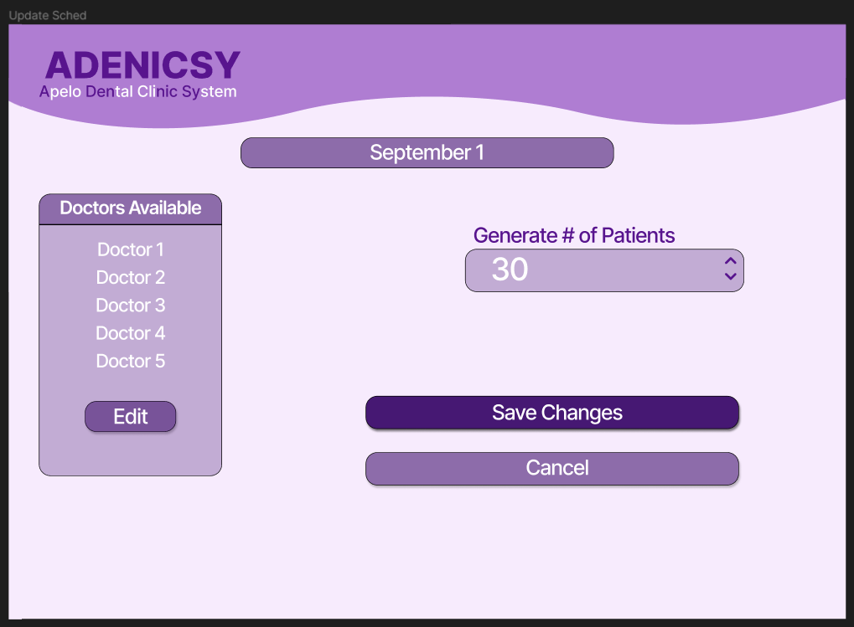

Figure 41 ADENICSY Modifying Dentist Schedule and Available Queueing Numbers

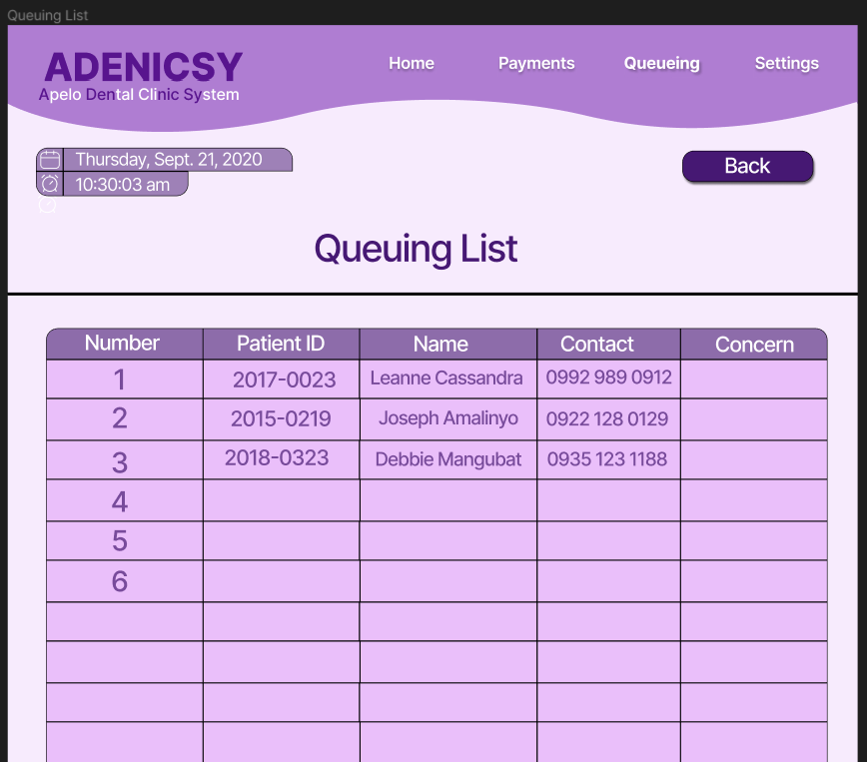

Figure 42 ADENICSY Queueing List

### Graphical user interface, text, application, chat or text message Description automatically generatedTablet Prototype for Dentist’s end

Figure 43 ADENICSY Search Page for Patient's Dental Records

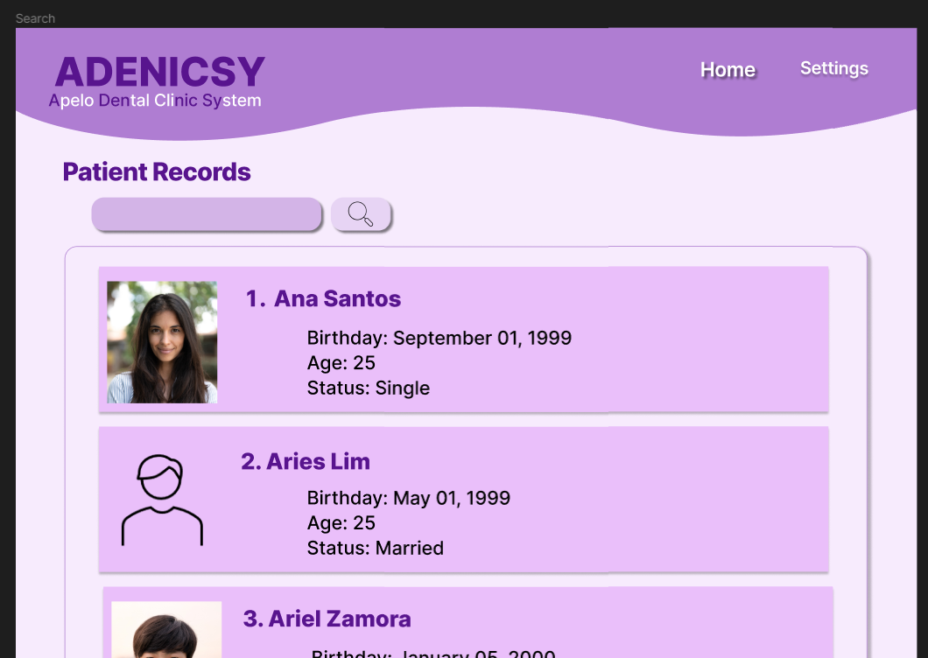

Figure 44 ADENICSY Search Result for Patient's Dental Record

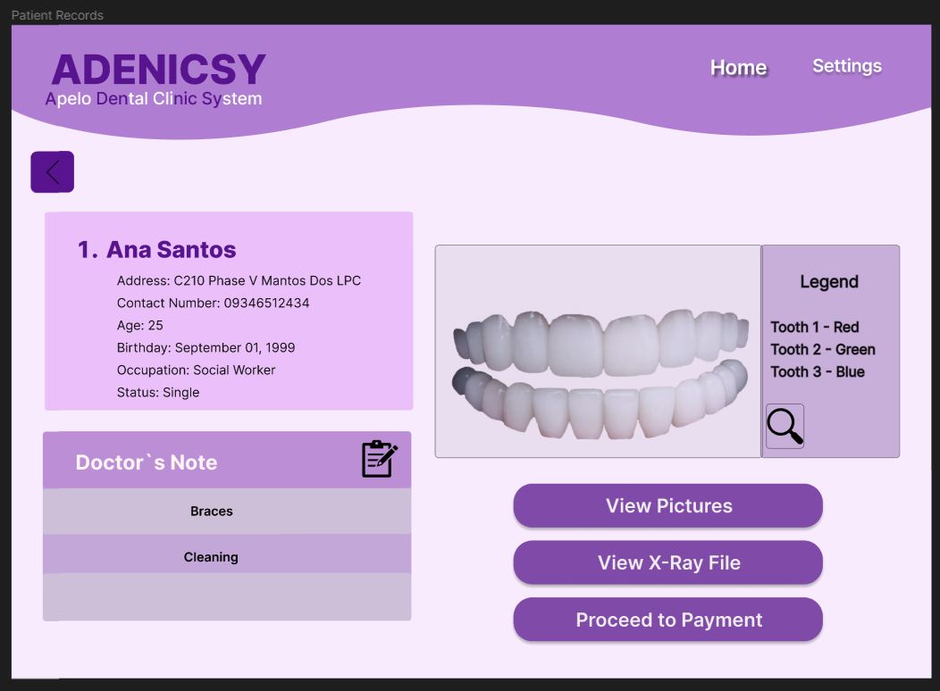

Figure 45 Patient's Dental Record Overview

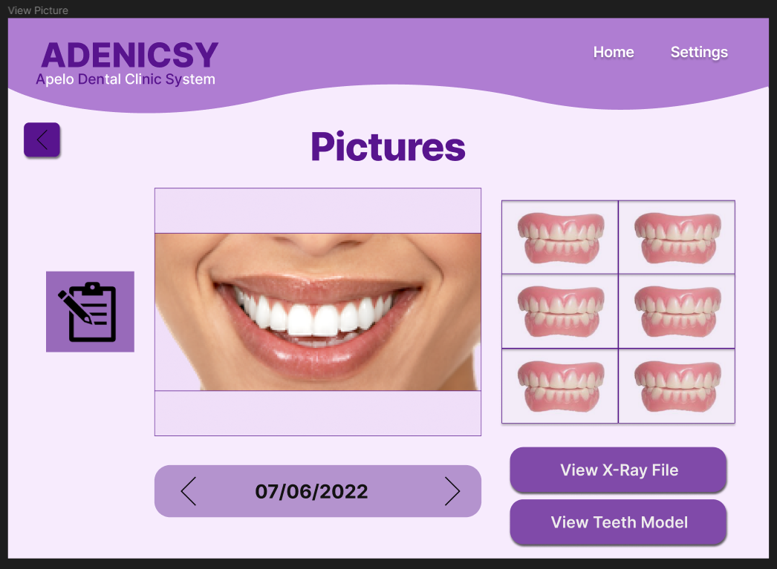

Figure 46 Patient's Teeth Picture

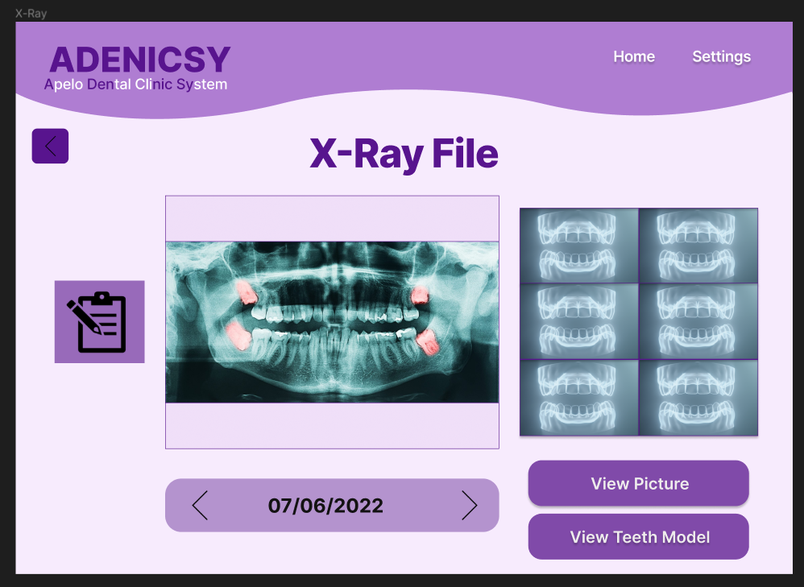

Figure 47 Patient's Xray File

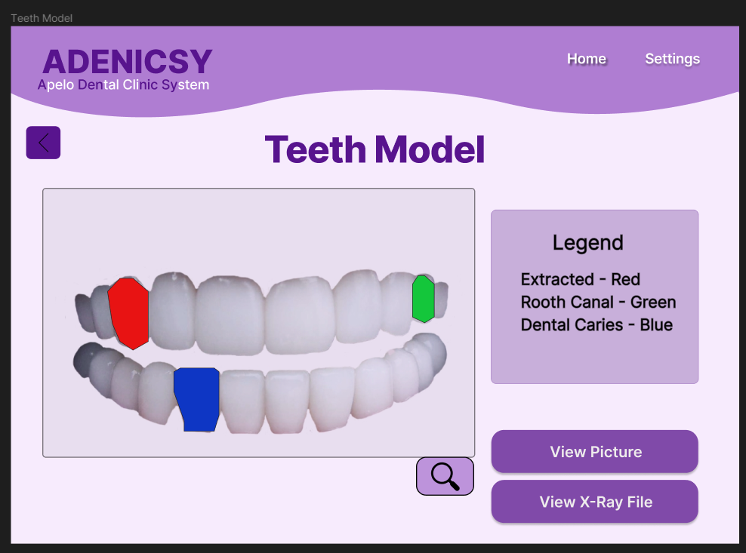

Figure 48 Patient's Teeth Model

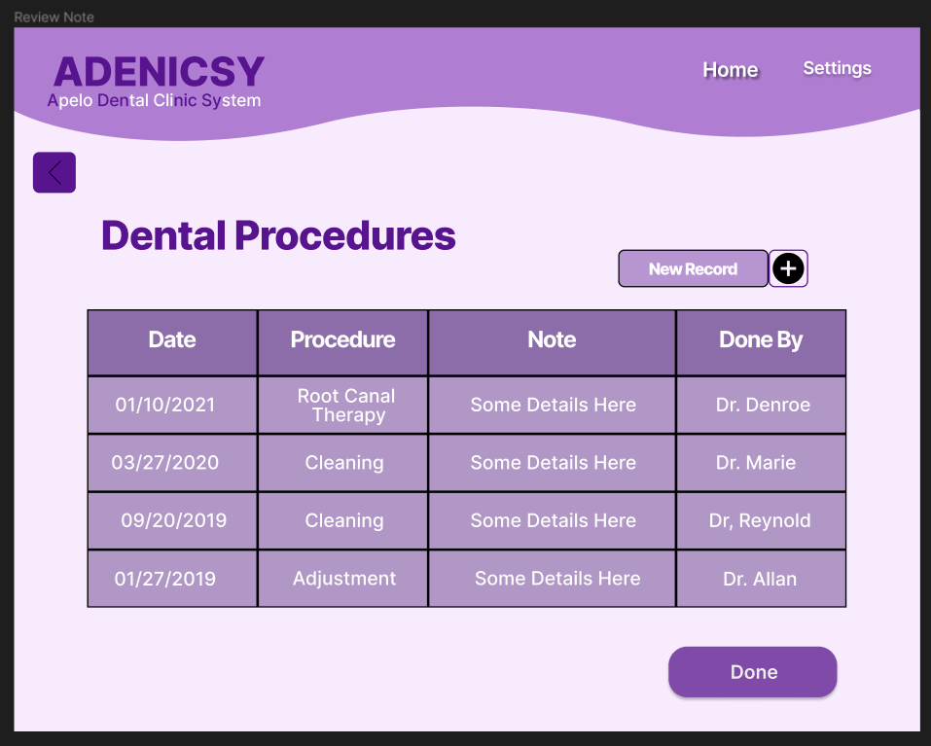

Figure 49 Patient's Dental Procedures

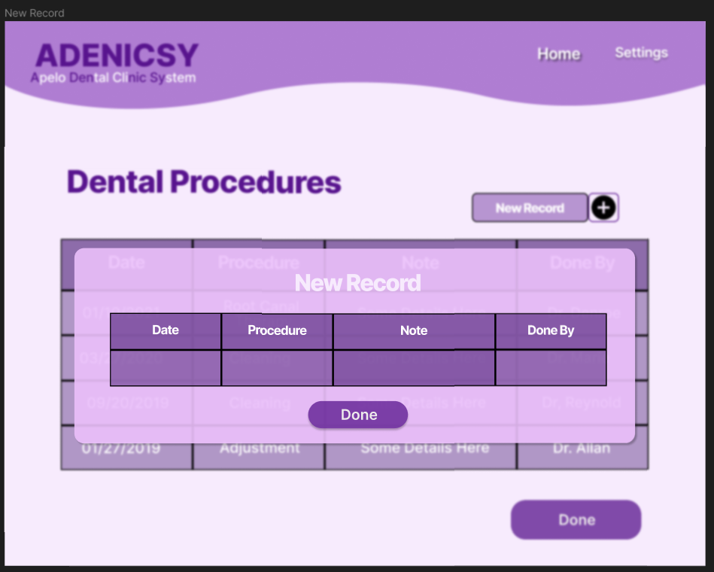

Figure 50 Adding New Record in Dental Procedure

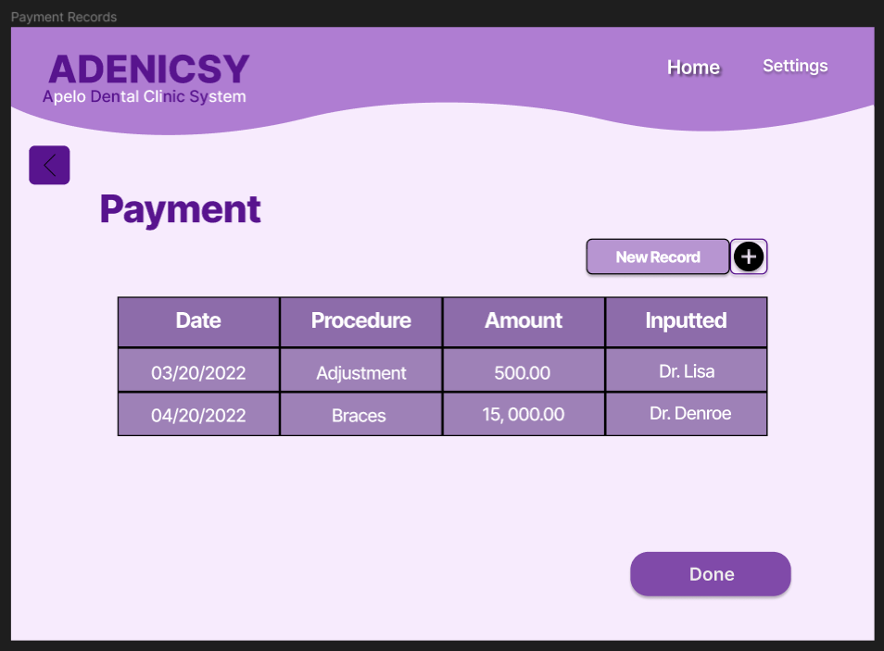

Figure 51 Recent Payment Transaction of Patient in Dentist's end

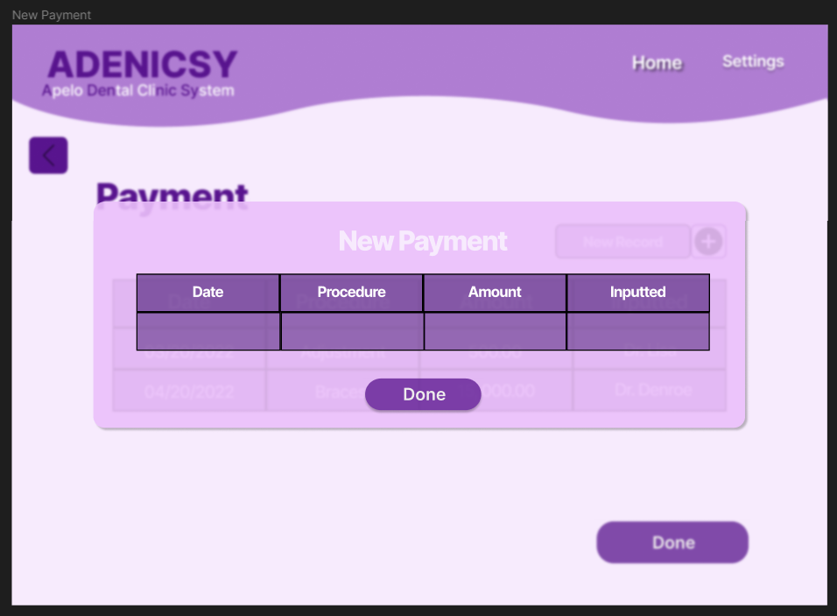

Figure 52 Adding New Payment Information and Cost

### Tablet/Desktop Prototype for Admin’s end

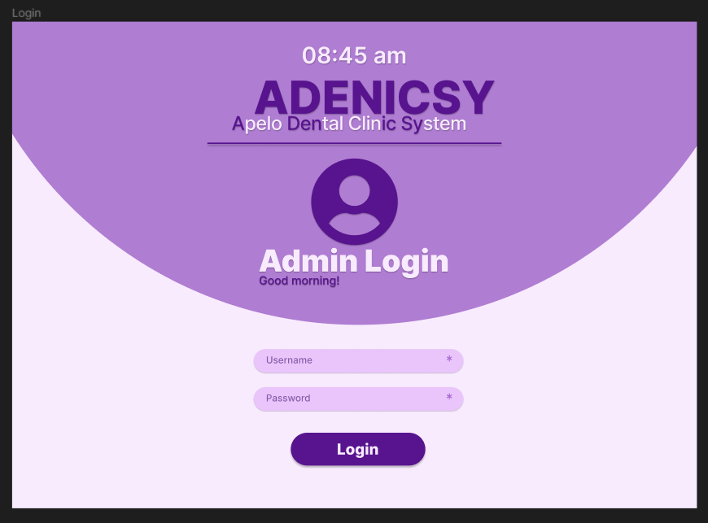

Figure 53 Admin Login

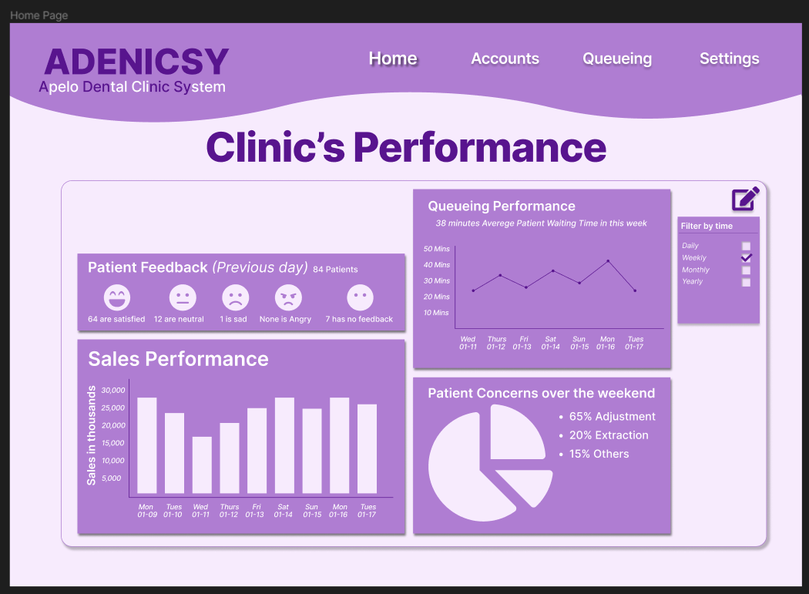

Figure 54 Dashboard of Summarize KPI

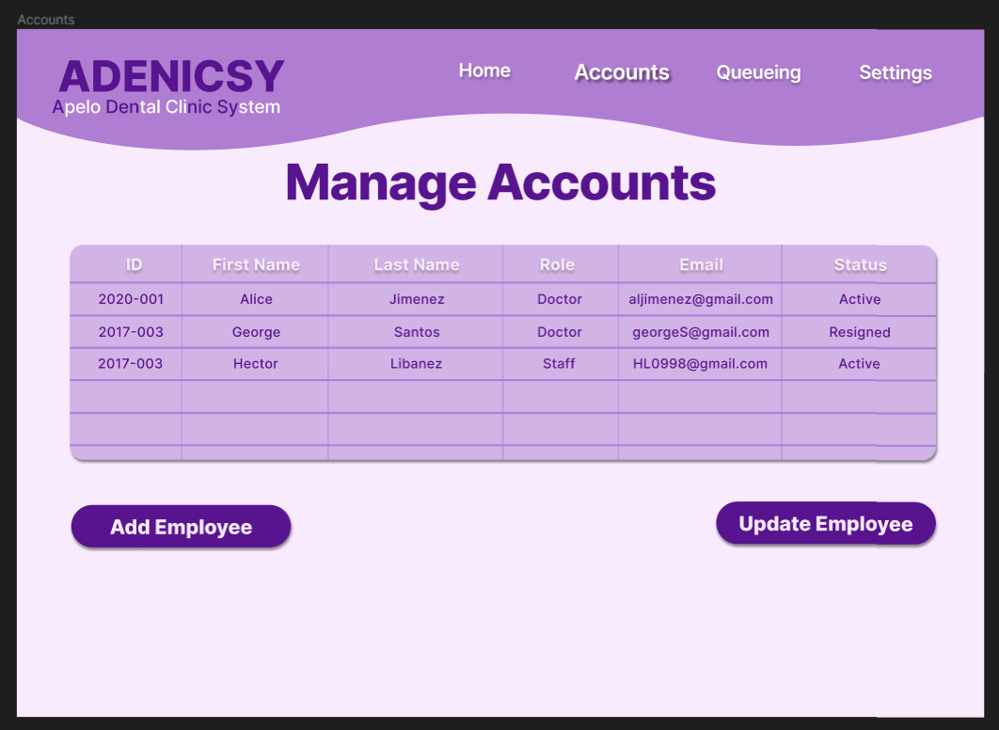

Figure 55 View of Employee List

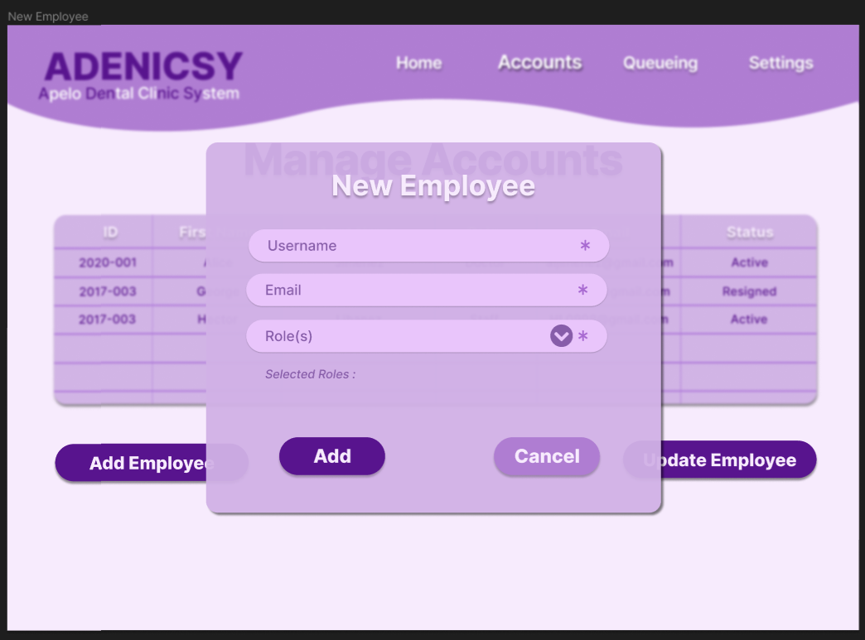

Figure 56 Adding New Employee

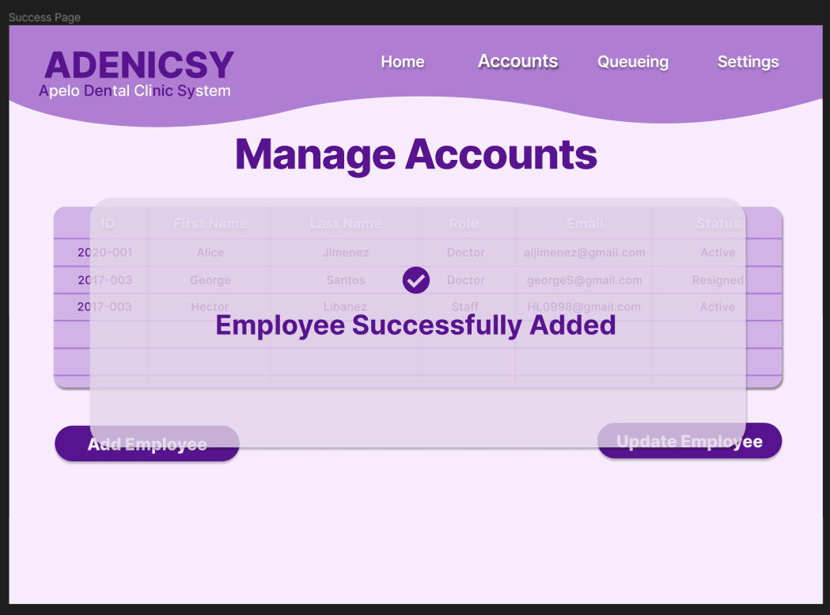

Figure 57 Confirmation of Successful Adding of Employee

## 5.3 Use Classes and Characteristics

Table 5 Users and their Description in ADENICSY

|  |  |
| --- | --- |
| **Roles** | **Description** |
| Admin | This user will have an administrative control to the system like adding new dentist users, staff users, modifying privileges to a specific user and has access to dashboard. |
| Patient | This user can get a number, see the current number in the clinic, modify profile, and access his/ her payment records at the clinic. |
| Dentist | This user can add medical information of a patient, upload pictures and other files and input payment details during a procedure. |
| Staff | This user can modify the dentist’s schedule, change the current number, view the queueing list, and add or update the payment records. |

# Conclusion

The development of web application for ADENICSY have been a long process from finding a client, going through design thinking process, developing prototype, making diagrams, and developing the actual software. Revisions in scope and proposed feature were encountered as the team reiterates on different process throughout the entire Project Based Learning (PBL) courses.

On the other hand, diagrams and prototypes have improved the understanding of the team in creating the software, vague concepts were clarified and some turns out to have some gap in the process.

The team have also learned that communication is one of the key aspects in achieving a progressive project. Setting a meeting with project adviser, stakeholders, consultant, and course adviser will make a big difference compared to a team that lacks it.

Having mentioned that, communication within the team itself is as important as communicating with other entities in the project. It is given that as student, there were still some technical gap especially on the knowledge of developing an application, hence, being able to address each one’s problem and giving solution to the barriers earlier will speed up the development process.

Currently, the team was able to provide the following functions and features:

* Landing Page
* Admin, Patient and Employee Login
* Search function for Dental Records
* Dental storage of information such as procedure history, teeth model, pictures and Xray.
* Updating the current number

The front end of the software was already completed but the backend were still on progress. The abovementioned features where the one with backend already while others will still be finished in the remaining days of Applied Project- System Prototype (SCSPROJ).

There were many tools that can be used in developing the software and many problems were encountered from the beginning. In the end, the course has instilled many learnings especially in experiencing a real-world scenario where the students have to interact with a client.

# References

|  |  |
| --- | --- |
| [1] | C. D. B. Nimes, L. B. Hidalgo and M. L. Sacramento, "Dental Clinic Management System," Nueva Ecija, 2019. |
| [2] | F. Masic, "Infomation Systems in Dentistry," ACTA INFORM MED, Faculty of Dental Medicine, Medical Universitry of Vienna, 2011. |
| [3] | My Dental Clinic, [Online]. Available: https://dentalclinicapp.com/#features. [Accessed 29 May 2022]. |
| [4] | Klinika.ph, "Simple Clinic Management System Designed for Doctors," [Online]. Available: https://klinika.ph/. [Accessed 30 April 2022]. |
| [5] | Plato, "Build a Collaborative Dental Practice," [Online]. Available: https://platomedical.com/whitepapers/collaborative-clinic-dental. [Accessed 2020]. |
| [6] | MYWAM SDN BHD, "Doctor Assist Practical Clinic Management Solution," [Online]. Available: https://wammap.com/doctor-assist-software/?gclid=Cj0KCQjwspKUBhCvARIsAB2IYuvJ0_B2gPyKj3wrDXUboltV8l54beFGjUrDe5iMH9Rik2AB2KJAheUaAi8AEALw_wcB. [Accessed 05 May 2022]. |
| [7] | Centaur Solutions Enabling, "Dental4Windows," [Online]. Available: https://www.centaursoftwareuae.ae/. [Accessed 05 May 2022]. |
| [8] | Plato Medical, "Plato Dental Clinic's Operating System," [Online]. Available: https://platomedical.com/dental-practice. [Accessed 05 May 2022]. |
| [9] | Topline, "Clinic / Medical Center Management Software ( E-claim & E-Prescription Ready)," [Online]. Available: https://www.toplineuae.com/products/clinic-software-dubai/. [Accessed 05 May 2022]. |
| [10] | R. H. S. A. Mohammed Ghazal, "An IoT Smart Queue Management System with Real-Time Queue Tracking," Electrical and Computer Engineering Department, Abu Dhabi University, Abu Dhabi, UAE, 2015. |

# Appendices

## Appendix A: Project Vision

Vision and Scope Document

**for**

Apelo Dental Clinic System (ADENICSY)

**Version 1.0 approved**

**Prepared by**

**De Vera, Alfonzo Louise**

**Dahinao, Earl Eufimeah**

**Meltran, Patricia Anne**

**Regalado, Guiler Marion**

**Pedrola, Janssen**

**Progmatiks**

**February 09, 2023**

***Vision and Scope for <Project> Page ii***

# Business Requirements

This chapter will discuss the background of the business, the challenges it faces, and the objectives laid out by the solutions proposed by the developer.

## Background

Apelo Dental Clinic (ADC) is the chosen client of the developers. It’s owned by Dr. Denroe Apelo, located in Dr Arcadio Santos Ave, Parañaque City, established since 2001. Their mission is to provide quality service with affordable price, so no one is deprived of good oral health care and their vision is to continuously upgrade to deliver highest dental care in safe environment for life-long. However, ADC’s current processes such as queueing of patients and recording patient information still relies on traditional or manual process.

The clinic allows minimal balances for patients with existing records. Having said that, if we can spread the number of patients throughout the day in a month since most of the procedures done in a day are still orthodontics which means that these patients will still come back and can be allowed to have a minimal balance, they can be assigned on weeks with a smaller number of patients instead of heaping on a certain week.

Aside from the concern on long waiting time, patient’s information such as personal information, medical history and payment records are manually written in an index card. This is prone to long time of retrieval or sometimes the index card gets lost because of too many records since 2001.

## Business Opportunity

The technique of patient’s queuing has been changed several times to find the best way to handle numerous patients. Their latest technique is a combination of listing names and time of arrival in a paper as early as 4 am in the morning and giving a numbered card to patients at 8:30 am before the clinic operates from 9 am – 5pm. This results in long waiting time for the patient because they will not know the current number being served so they might come back too early or too late that they might cut others in line. Aside from that, the patient’s duration of procedure is very indefinite as well, because the time will only be based on the doctor’s findings on what procedure should be done for a certain patient (which means, this factor that also cause the long waiting time is out of control by the clinic or the developers).

There were certain weeks in a month where patients are less and other weeks where the number of patients is overwhelming. One of the reasons for this is the salary period of the patients where they tend to visit the clinic more on the day that they have money.

Manual filing system also slows the day-to-day process of the business. When patients are about to be served, their index card will be retrieved by the front-desk staff, if the staff found it, she will prepare it with all the other files needed by the patient, but when it’s lost, the patient is required to fill another index card that cause problems like due to lost records. During the treatment, the index card will be handed to the doctor where he/she will put information like what he did, how the tooth looks like by putting marks on the teeth model, and putting the procedures done on that session with the total amount on a piece of paper that is clipped in the index card. The patient will then go to the accounting staff where they will pay the amount which sometimes incur some balance that is why the accounting staff should be the one to enter the total money paid by the patient in the index card.

The accounting staff will also need to write all the payment in piece of paper that she receives which at the end of the day she will forward to Dr. Denroe. While the index card will be put back to where it should be placed based on alphabetical order of names.

## Business Objectives and Success Criteria

This section enumerates the business objectives defined from the problem identified and its success criteria.

1. Aim to make the waiting time from 4 hours to 1 hour.

2. Provide a search function that will show the recent medical information of a certain patient.

3. Make queueing number online so that patients can get the number through their mobile phones and see the current number in the clinic as it updates.

## Customer or Market Needs

For Staff who need to arrange medical records, manage the queueing, and process the payment transactions of the patients. The software allows the staff to reduce procedures in managing medical records, manage queueing efficiently, and record the payment transactions of the patients easily. Unlike the previous system where they need to retrieve the medical records from physical file, give a card number for queueing, and write the payment information in the index card. Our product will provide a feature to search the medical information of the patient’s efficient management of queueing from finalizing doctor schedule, generating available number of slots, tracking queueing list, updating the current number, etc. an automated process from the doctor inputting the payment details, accessing capability for the staff and real time reflection of the payment on the patient’s end.

For Patients who need to get a card number and track the current number in the clinic. The software allows patients to get a number and track the current number wherever they are. Unlike the current manual system, that took too much time to get a card number and wait in the clinic for too long. Our product will provide online queuing numbers and tracking the current number with notification to the patient.

For Doctors who need to access their patients’ medical records easily. The software allows doctors to retrieve their patient’s information instantaneously. Unlike using index cards where retrieval, inputting, and navigating of information is slow. Our product will provide ease in managing patient’s information.

For Admin who Needs to manage his employee’s access. The software allows the admin to update and add employees to the system. Unlike the previous system where employees have access to various information. Our product will increase security in the clinic.

## Business Risks

The major business risk that the product brings is the error during the transition of the clinic from manual to using ADENICSY. Several processes can be very different from its current implementation so the developers will provide manuals and support to the clinic as they adapt to using the system. The migration of old data from their index card could also be an issue, hence it was discussed during the proposal of the project and the owner agreed that the system will be used on the new patients and the data migration will be discussed when the application is stable.

# Vision of the Solution

## Vision Statement

ADENICSY will be automating the process of queueing for patients within a day and the storage of patient information, and the process related to it such as inputting additional medical records, adding payment records, etc. This will result in increased efficiency, minimize the risk of data loss, and less physical storage consumed by the records. It will also provide analysis of key metric indicators so that the owner will be able to make data-driven decisions.

## Major Features

Queueing Management – This feature includes changing the doctor’s schedule where the available queueing numbers will be generated, updating the current number so that patients can estimate their time going to the clinic, and updating the queueing list.

Dental Records Management – The software will be a one repository of all the patient’s dental related files. Compared to their old method of storing files like dental procedure history, x ray, teeth pictures in separated storages, dentists can retrieve all the data and search for a patient instantaneously in the software.

Payment Records Management – Payment records will also be easy to access and update as patient’s payment information can be search in the software and the process from getting the payment information going to the staff for payment will be done through the software.

## Assumptions and Dependencies

One of the major dependencies of the software is the requirement of tablet per dentist to where the software will be installed. During the proposal of the project to the owner, the concern was settled as the owner is the one that suggested the tablet and he said that they are willing to invest in it if the software is stable and tested.

Other technological dependency is desktop in the admin side, hosting service, Wi-Fi connection and domain name.

# Scope and Limitations

This study aims to determine the problems in Apelo Dental Clinic’s (ADC) current system and provide possible solutions that will address it.

Scope:

The focus of this project is to lessen the waiting time of the patients of ADC and digitalize the manual processing of patient’s information. This will include features such as user login, inputting of patient information from different users, interactive teeth model, appointment system and SMS notification, search function, payment management, dashboard of key performances and developing a mobile version for patient users. Thus, providing solutions to make a better way of appointment and accessing patient information including how it will go from day-to-day process is the main concern that will be developed in this study.

Limitations:

In the software, inventory management of clinic supplies will not be included that is common in most dental clinic management software that has been developed. Data migration of the clinic’s patient information will also not be handled by the developer.

## Scope of Initial Release

The initial version of software should require the admin login where he can create credentials for his employee, patient login where they can register and login to their account, search button for patient’s dental and payment records. Patients should be able to get a queueing number in their end and see the current number in the clinic, hence, the staff should also be able to update the current number in the clinic so that the software can now help to reduce the waiting time. Notification is also supplemental in reducing the waiting time as it will tell the patient if their number is near so they can be on watch in the current number and estimate their time going to the clinic.

## Scope of Subsequent Releases

Maintenance and continuous improvement will be done through subsequent release. Features that will be included are various methods of uploading a file through the software and the dashboard that will provide insights to the owner regarding the clinic’s Key Performance Indicators KPI.

## Limitations and Exclusions

Inventory Management and tracking of business performance in terms of revenue and cost will not be included in the software.

# Business Context

Apelo Dental Clinic was established in 2001, they accumulate numerous patient because of quality and affordable service. However, their patient’s queueing system makes the waiting time so long and their manual storage of data causes problem like losing the index card where dental procedure and payment information are stored.

## Stakeholder Profiles

Stakeholders of Apelo Dental Clinic are the following:

|  |  |  |  |  |
| --- | --- | --- | --- | --- |
| **Stakeholder** | **Major Value** | **Attitudes** | **Major Interests** | **Constraints** |
| Clinic owner | Easier management of the clinic | Customer-centric, innovative and solution provider | The quality of service to be provided to its patient will provide welfare | Limited knowledge on tech innovation that can aid clinic’s problem. |
| Staff | Reduce workloads | Hardworking and attentive to patient’s concern | Less work by not having to retrieve records manually and answering queueing concerns | Needs to be oriented in using a new software system |
| Doctors | Well accessibility and accurate medical records of patient | Working continuously throughout the day, handles various customer | Medical records of patient can be accessed easily, and procedures done, and other doctors note should be legible. | Doctors varies from age so some should be trained on using the tablet-based software. |
| patients | Less waiting time in the clinic | On the go, busy people | Getting number would be easier and waiting in the queue line would be shorter than before. | Must adhere to new policy and be familiar with using an application of the clinic. |

## Operating Environment

ADENICSY will be implemented as a web-based application and the user can access the data that dynamically updates through the internet. When the software is implemented, the storage will also be on the hosting site. The number of patients that will access the current number will not be more than 20 at a time as per our estimation, hence it will still be tolerable in most cases.

When the hosting service will experience system failure, the clinic can still proceed with their day-to-day business as the data will be backed up in their local storage and data transfer will be handled through Wi-Fi even without internet connection and by doing the manual process on some other processes that can’t be bound in the Wi-Fi.

## Appendix B: Schedule

Project Schedule made using ProjectLibre.

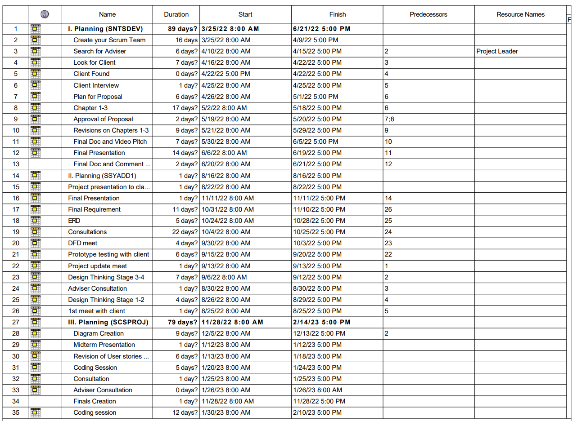

## Appendix C: Product Roadmap

Product roadmap for the entire PBL duration.

|  |  |  |
| --- | --- | --- |
| SNTSDEV SSYADD1 SCSPROJ | | |
| * Finding Client * Looking for resorts, restaurants, merchandising, and clinics. * Proposing initial idea. * Identifying Problems * User interview * Proposing idea * Performing Analysis * SWOT Analysis * Fishbone Diagram * Gap Analysis * Feasibility Study * Low-fidelity Prototype * Identifying Features * Application Flowchart | * High Fidelity Prototype * Pages to Pages Transitions * User Login * Registration page * Log in page * Verification * Home Page * Patient Information Storage * Personal Information * Dentist`s Note * Patient Records (admin side) * Payment Records * Visual teeth model * Teeth picture * X-Ray | * Queuing Management * Get a queuing number. * Update/View current number. * Update Dentists schedule * View queuing list * Notification * Notification to go or return to clinic.   • Payment Processing   * Dentist inputs procedure information and cost * Staff add the paid amount by the patient. * Patient can see the transaction reflected on his end |

## Appendix D: Team Meetings

(

The minutes of the meeting from SNTSDEV up to the meetings during SCSPROJ will be shown in the table below where dates, participants, duration, and meeting agenda are included. Pictures from random meetings, either face to face or online will be shown following the table with brief description of the meeting’s agenda. Please take note the table might only cover a few meetings. Nevertheless, the pictures with captioned data will be shown up to the most recent meeting in SCSPROJ.

|  |  |  |  |  |
| --- | --- | --- | --- | --- |
| Meeting ID | Date | Participants | Duration | Agenda |
| M001 | May 5, 2022 | Earl Eufimeah Dahinao  Patricia Anne Meltran  Janssen Pedrola  Guiler Marion Regalado | 1 hour and 2 minutes | * Comment Matrix * New Group name |
| M002 | May 12, 2022 | Earl Eufimeah Dahinao  Patricia Anne Meltran  Alfonzo Louise De Vera  Janssen Pedrola  Guiler Marion Regalado | 1 hour and 9 minutes | * Slide Deck for Apelo Appointment System * Additional RRLs |
| M003 | May 14, 2022 | Earl Eufimeah Dahinao  Patricia Anne Meltran  Alfonzo Louise De Vera  Janssen Pedrola  Guiler Marion Regalado | 43 minutes | * Statement of the Problem * RRLs * Task Delegation |
| M004 | May 16, 2022 | Earl Eufimeah Dahinao  Patricia Anne Meltran  Alfonzo Louise De Vera  Janssen Pedrola  Guiler Marion Regalado | 42 minutes | * Appointment System Proposal |
| M005 | May 17, 2022 | Earl Eufimeah Dahinao  Patricia Anne Meltran  Alfonzo Louise De Vera  Janssen Pedrola  Guiler Marion Regalado | 1 hour and 3 minutes | * Slide deck for appointment proposal |
| M006 | May 18, 2022  (Client Meeting) | Earl Eufimeah Dahinao  Patricia Anne Meltran  Alfonzo Louise De Vera  Janssen Pedrola  Guiler Marion Regalado | 20 minutes | * Current Progress of the project development * General Questions about the topic * Questions about the implemented appointment system before * Propose Appointment System |
| M007 | May 18, 2022 | Earl Eufimeah Dahinao  Patricia Anne Meltran  Alfonzo Louise De Vera  Janssen Pedrola  Guiler Marion Regalado | 20 minutes | * Meeting, Presentation, and Consultation with an adviser |
| M008 | May 18, 2022 | Earl Eufimeah Dahinao  Patricia Anne Meltran  Alfonzo Louise De Vera  Janssen Pedrola  Guiler Marion Regalado | 33 minutes | * Current Progress of the project development * General Questions about the topic * Questions about the implemented appointment system before * Propose Appointment System |
| M009 | May 19, 2022 | Earl Eufimeah Dahinao  Patricia Anne Meltran  Alfonzo Louise De Vera  Janssen Pedrola  Guiler Marion Regalado | 33 minutes | * Current Progress of the project development * General Questions about the topic * Questions about the implemented appointment system before * Propose Appointment System |
| M010 | May 23, 2022 | Earl Eufimeah Dahinao  Patricia Anne Meltran  Alfonzo Louise De Vera  Janssen Pedrola  Guiler Marion Regalado | 2 hours | * Task division for clinic staff and patient interview. * Creating appropriate questions for the specific interviewee * Listing all requirements for the final paper. * Setting deadline for previews task division. * Listing agendas for the next meeting on May 30. * Revision of SOP progression. |
| M011 | May 25, 2022 | Earl Eufimeah Dahinao  Patricia Anne Meltran  Alfonzo Louise De Vera  Janssen Pedrola  Guiler Marion Regalado | 26 minutes | * Reminders for the agenda for the meeting on May 30. * Finalization of minutes and division. |
| M012 | May 30, 2022 | Earl Eufimeah Dahinao  Patricia Anne Meltran  Alfonzo Louise De Vera  Janssen Pedrola  Guiler Marion Regalado | 33 minutes | * Planning to have onsite meetings, especially for paper prototypes. * Sending SOP progression to the adviser to check. * Brainstorming for the features for the prototype. * Parts division for the product backlog. |
| M013 | May 31, 2022 | Earl Eufimeah Dahinao  Patricia Anne Meltran  Alfonzo Louise De Vera  Janssen Pedrola  Guiler Marion Regalado | 40 minutes | * Discussion of the root cause of the problem. * Scaling the problems that the developers notice. * Discussion of the process of the appointment system. * Topic that must be included in the introduction of the paper. * General objectives. * Discussion about sop and objectives. |
| M014 | May 31, 2022 | Alfonzo Louise De Vera  Patricia Anne Meltran  Guiler Marion Regalado  Janssen Pedrola | 7 hours | * Revision of SOP progression. * Creating product vision, product backlog, product roadmap, and release plan. * Starting to build a prototype. |
| M015 | June 2, 2022 | Alfonzo Louise De Vera  Earl Eufimeah Dahinao  Patricia Anne Meltran  Guiler Marion Regalado  Janssen Pedrola | 7 hours | * Revision of SOP progression. * Finalizing features of the prototype. * Finishing prototype for patients and doctors. * Finalizing final paper. * Discussion for the video. * Discussion for the slide deck. |
| The meeting included in this table are group meeting, meeting with the adviser, and meeting with the clients. | | | | |

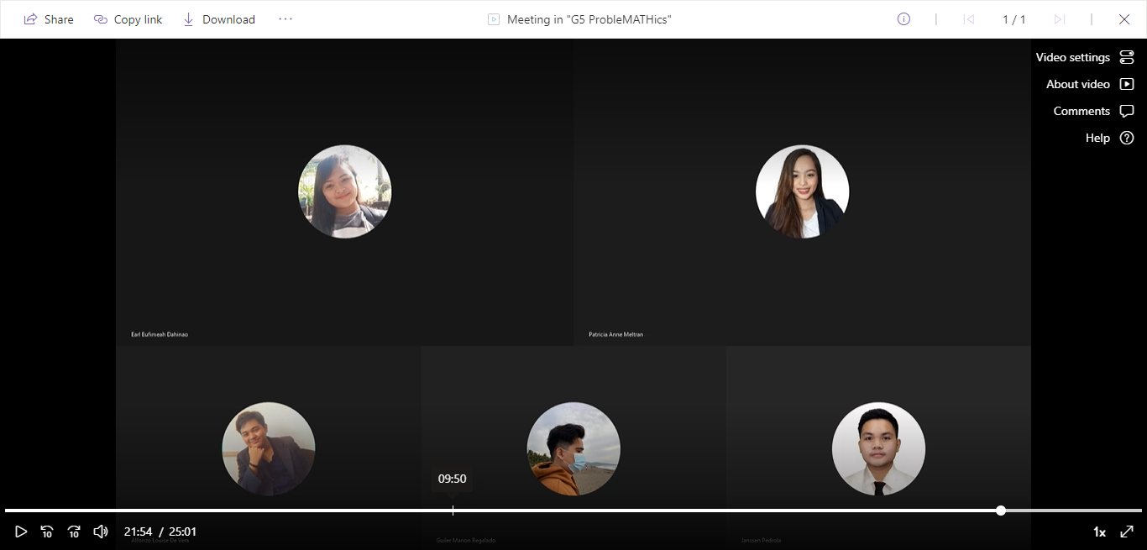

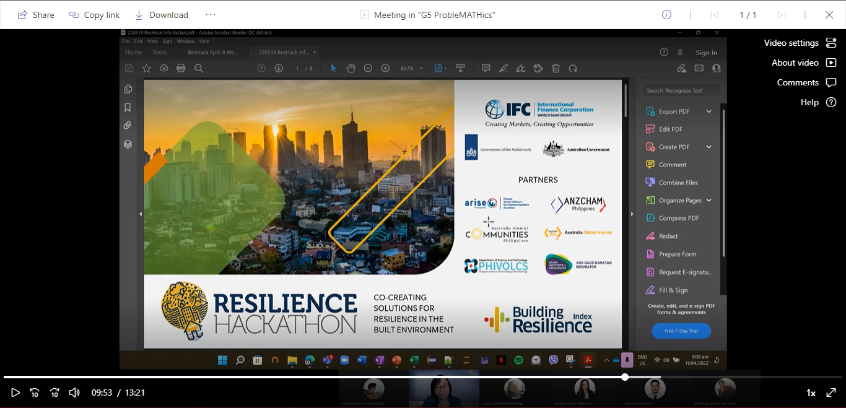

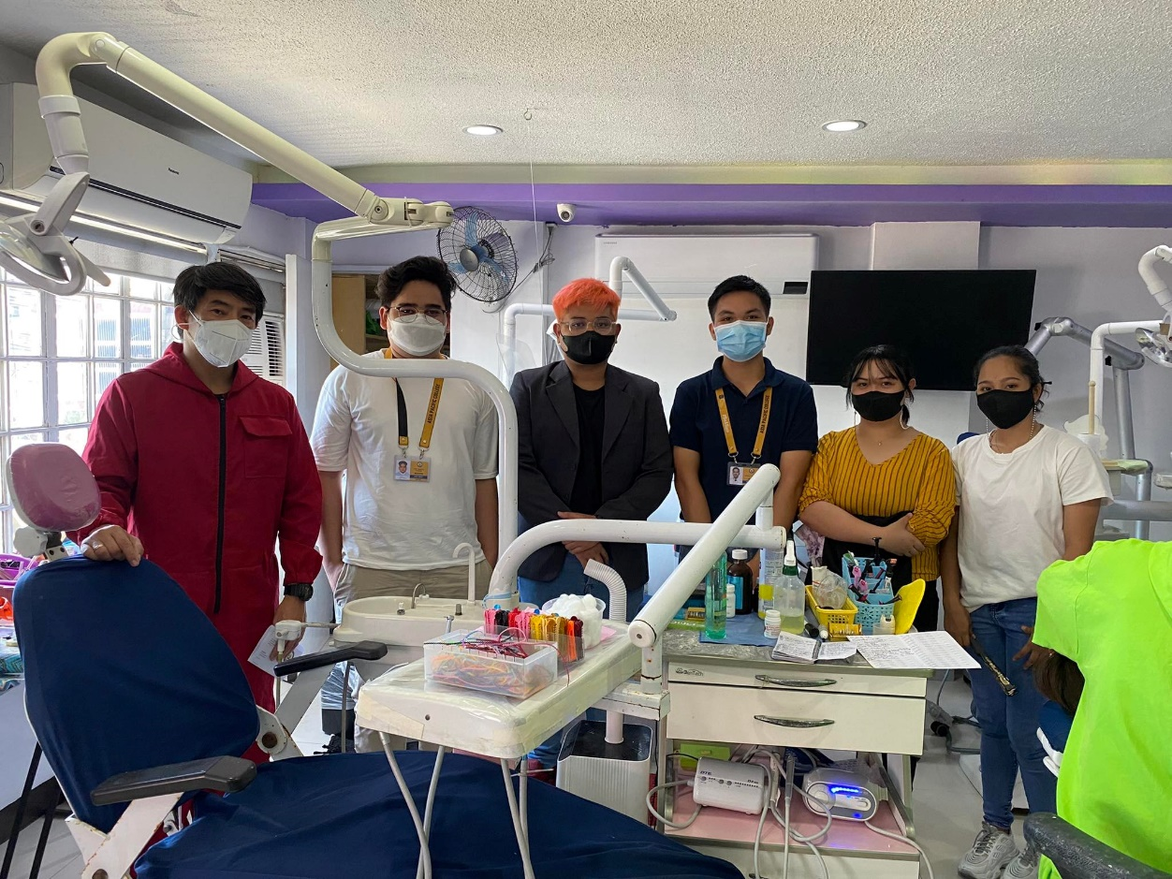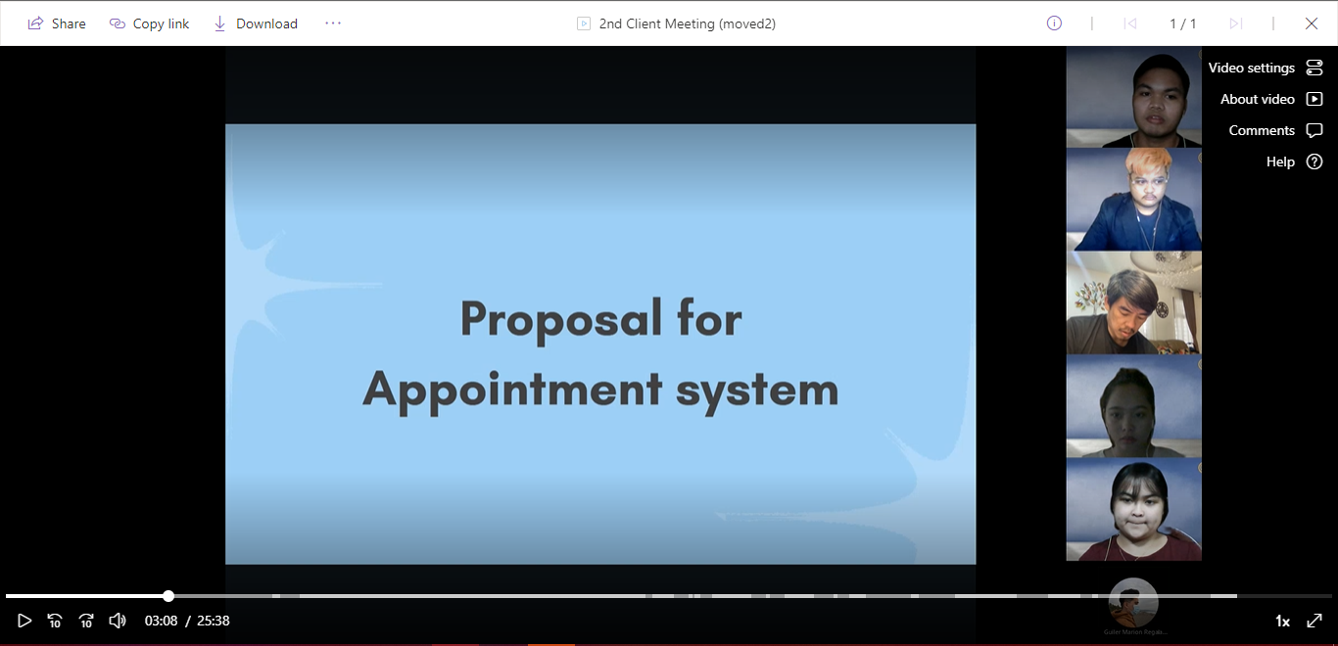

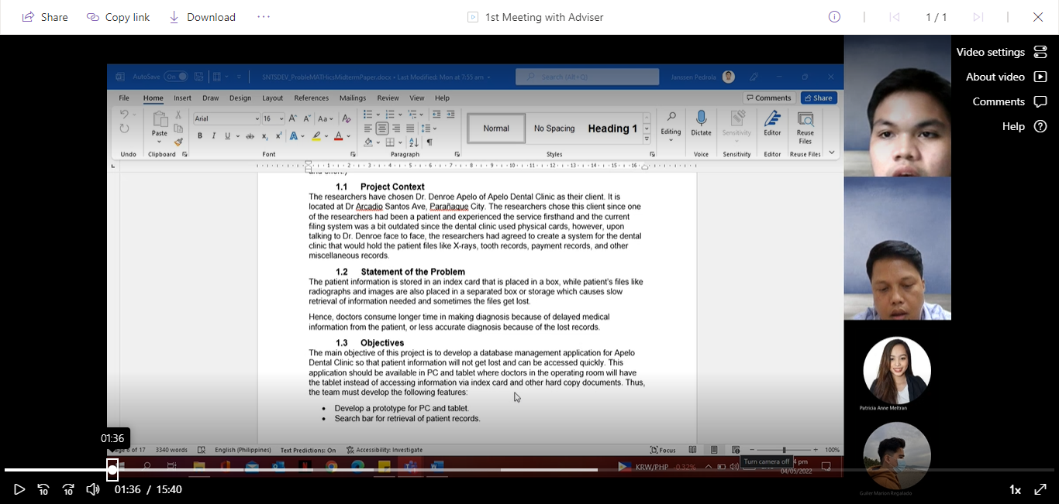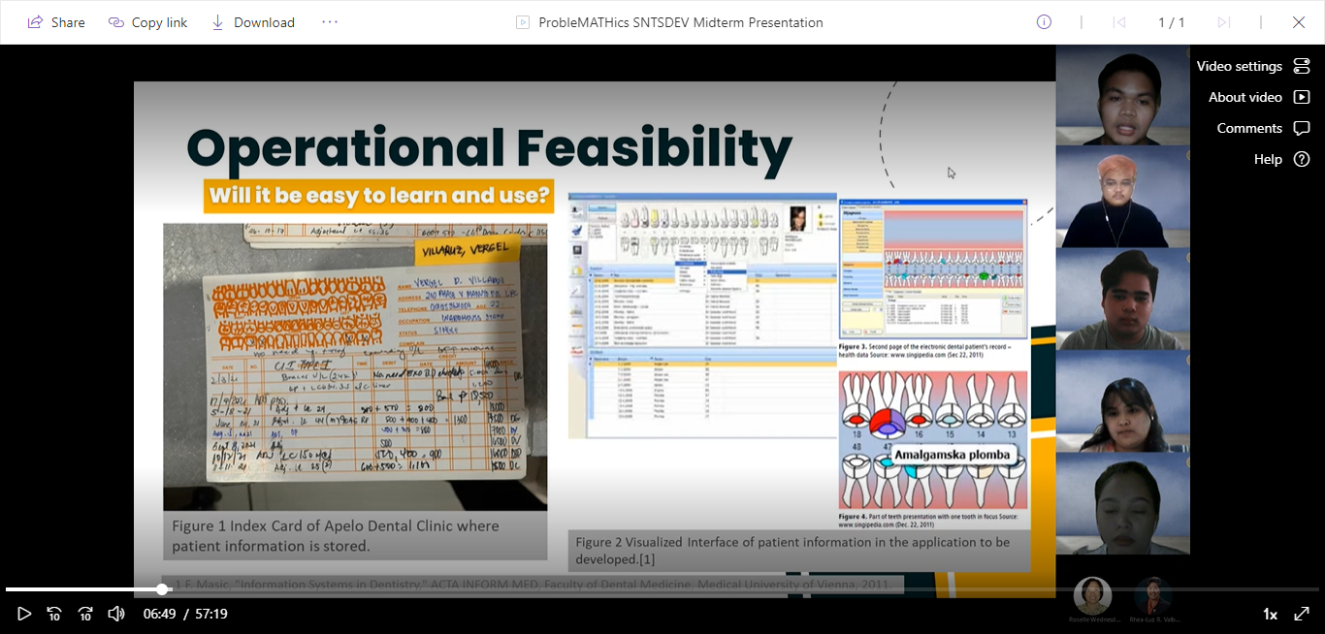

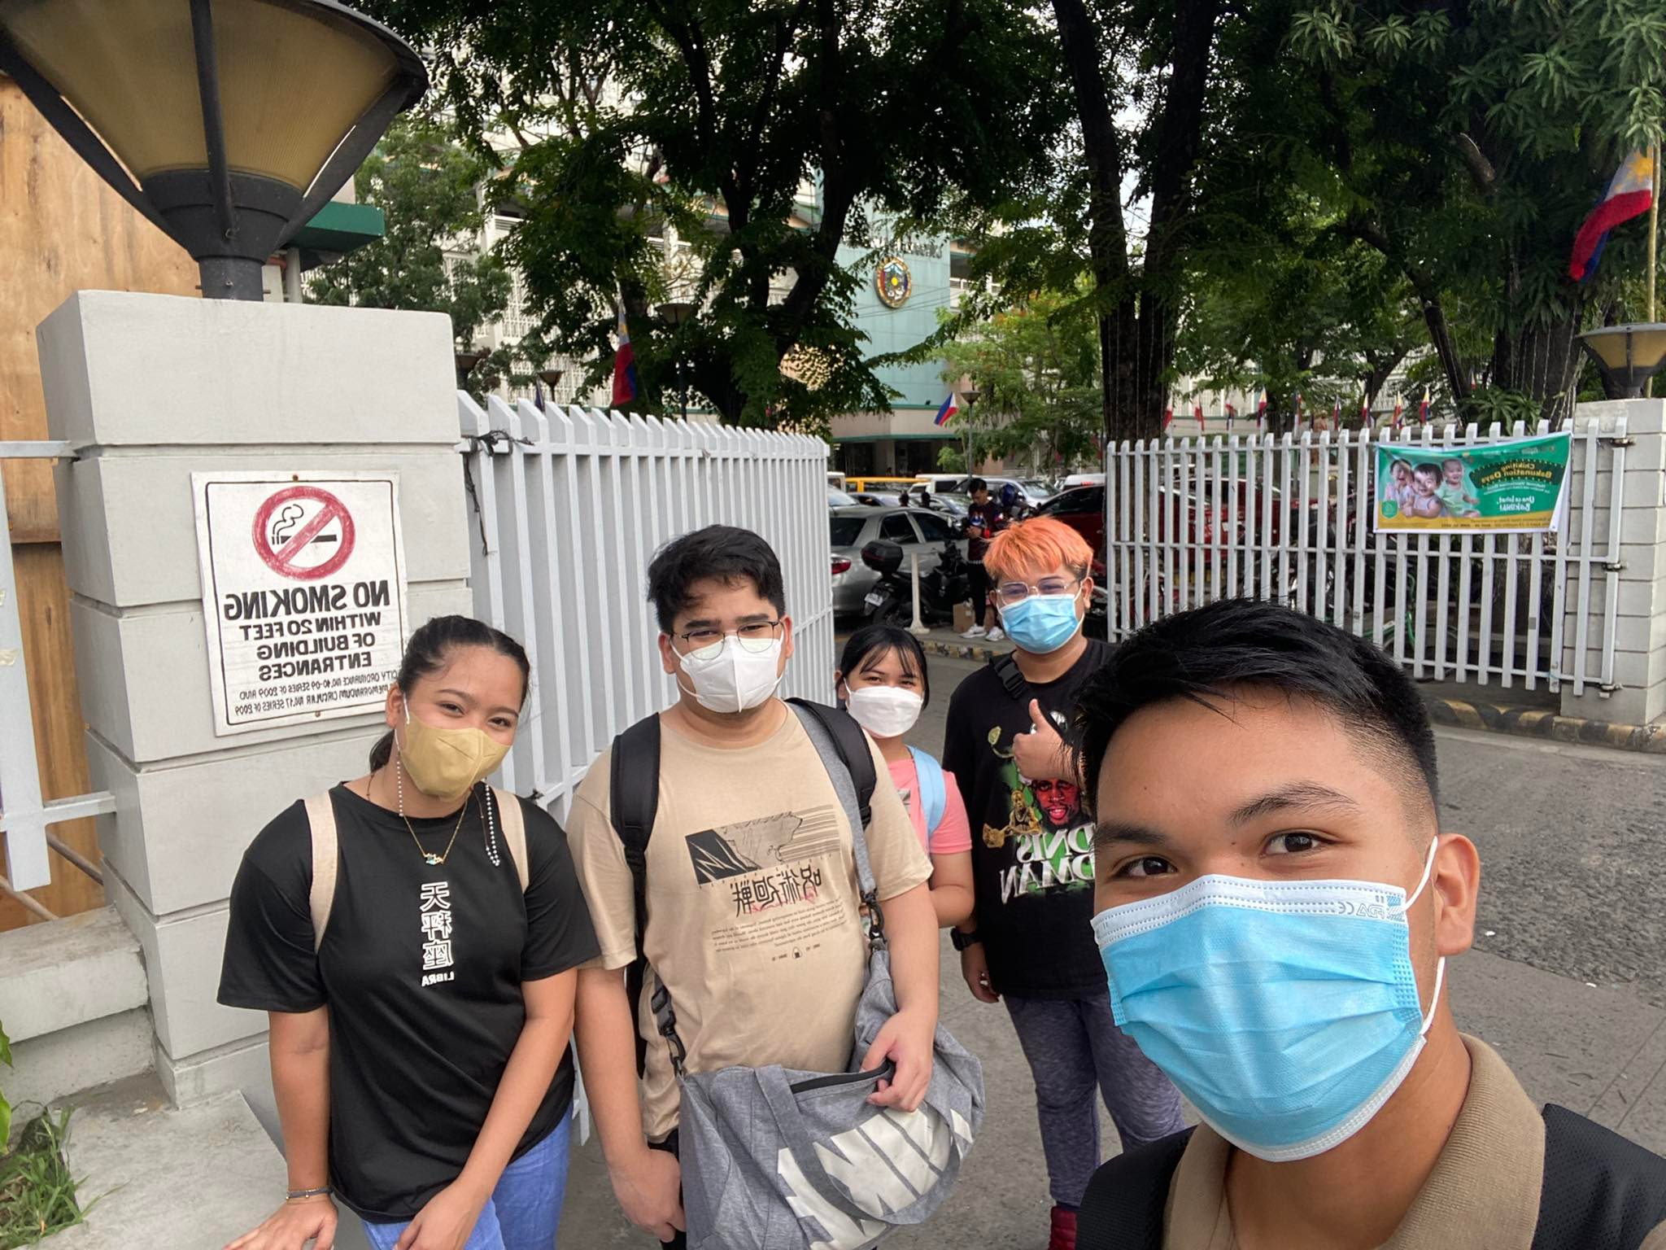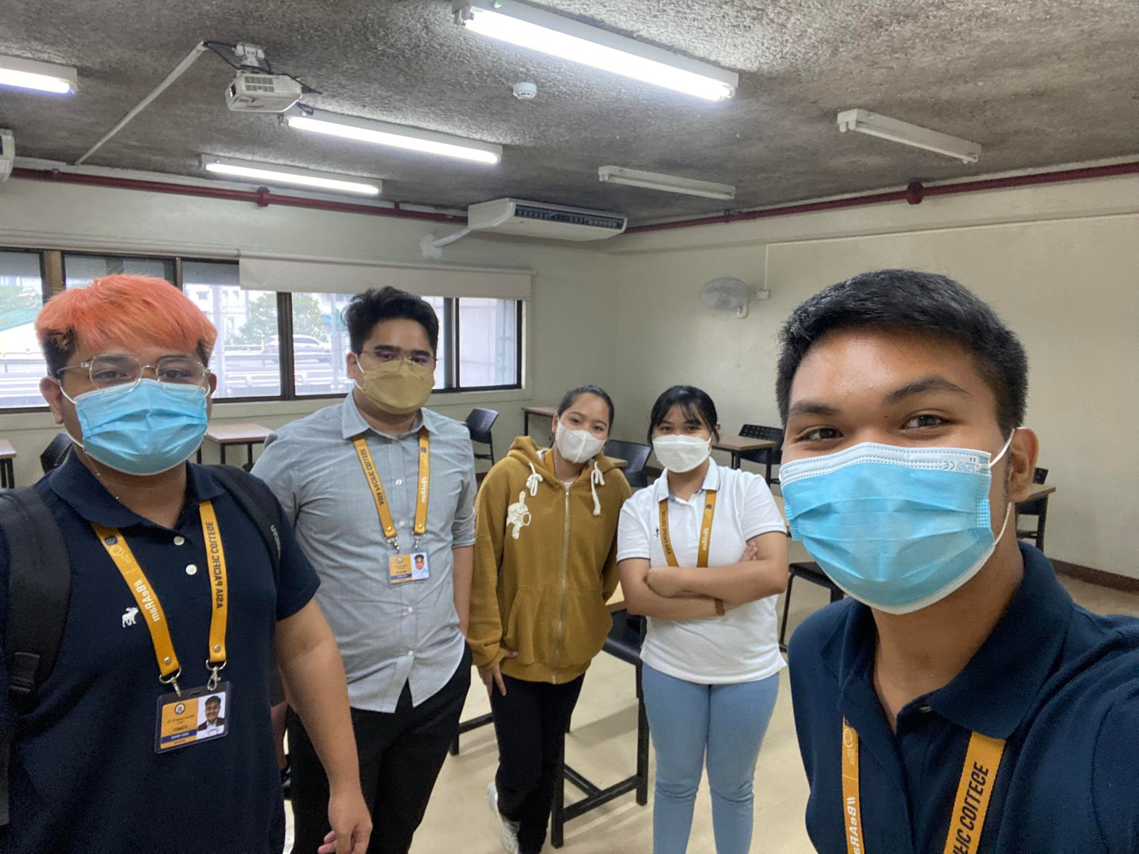

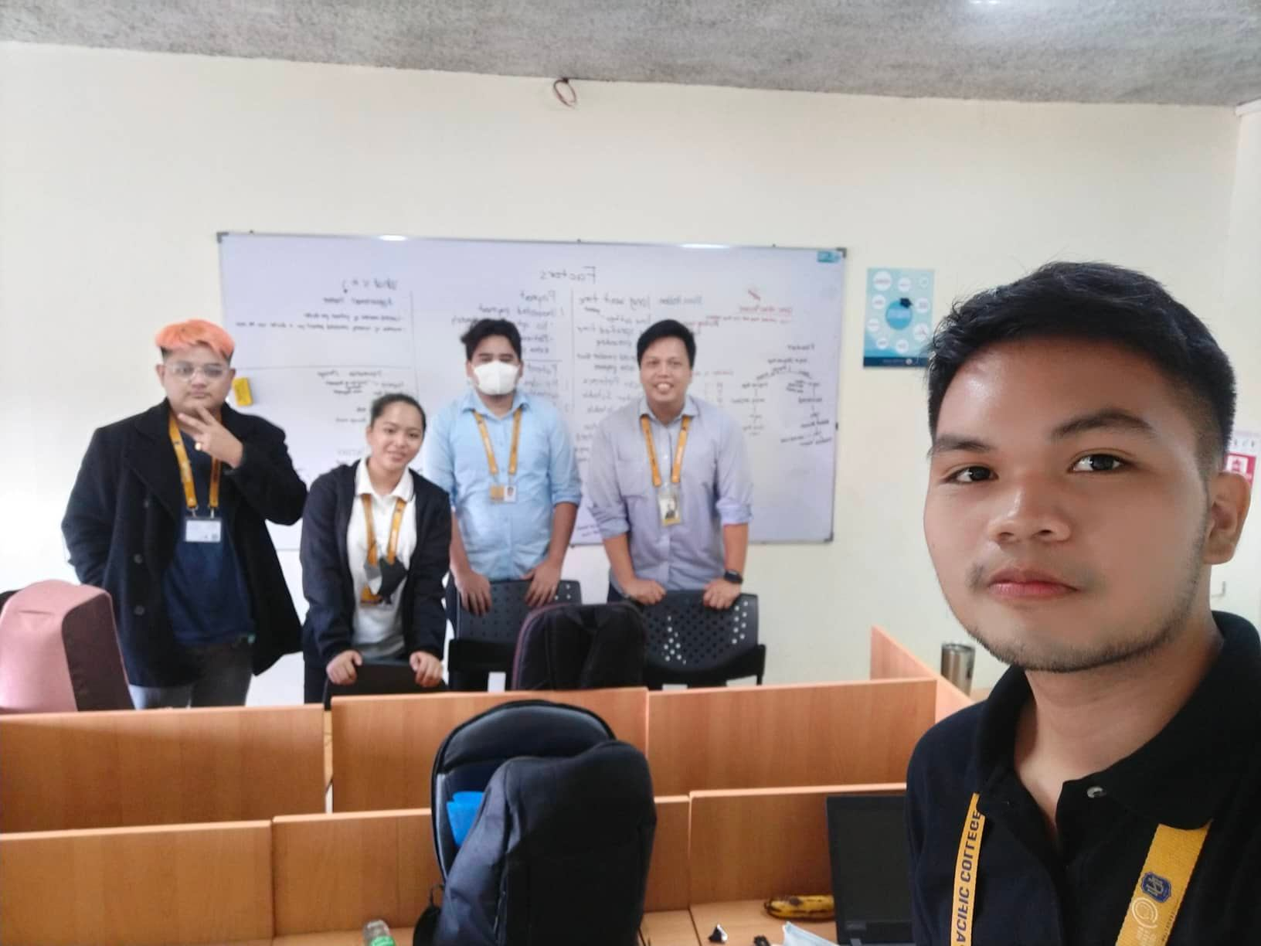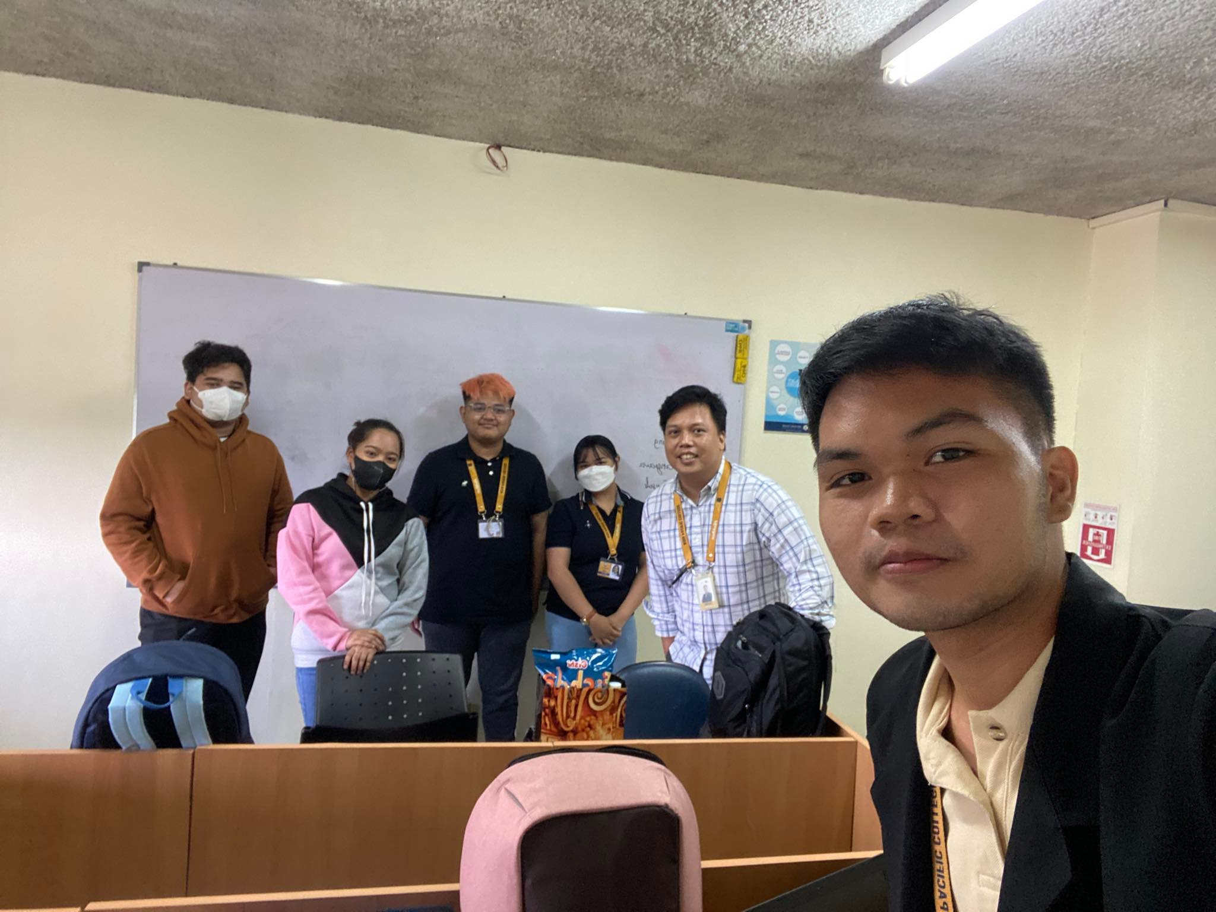

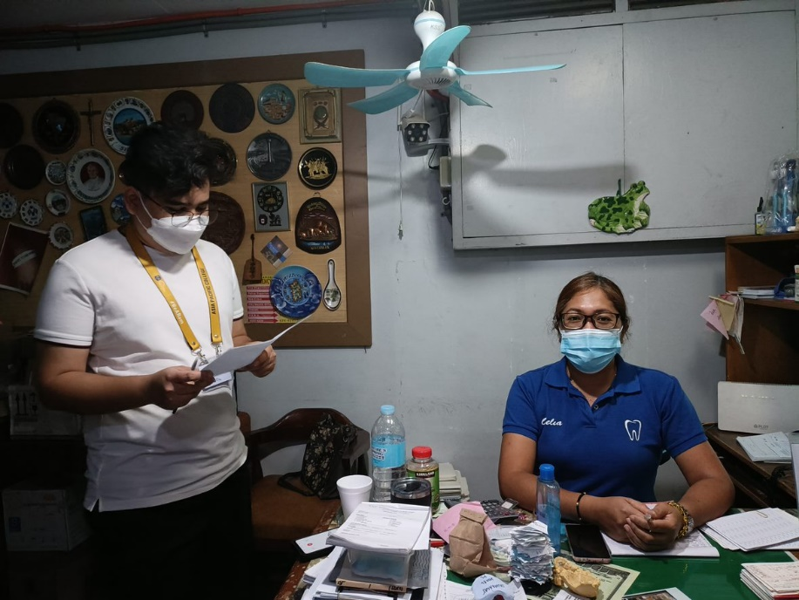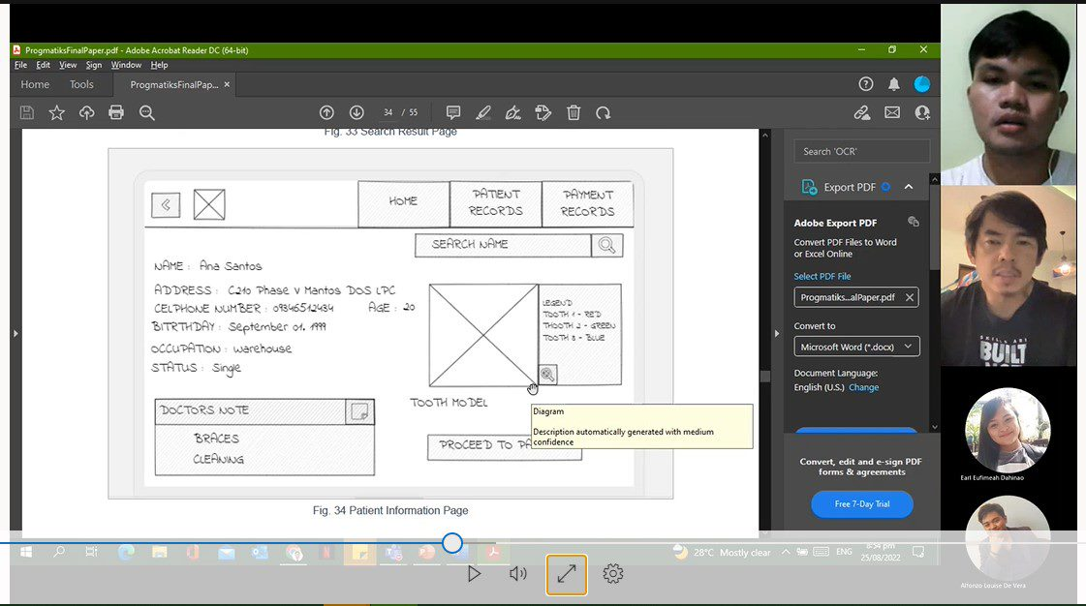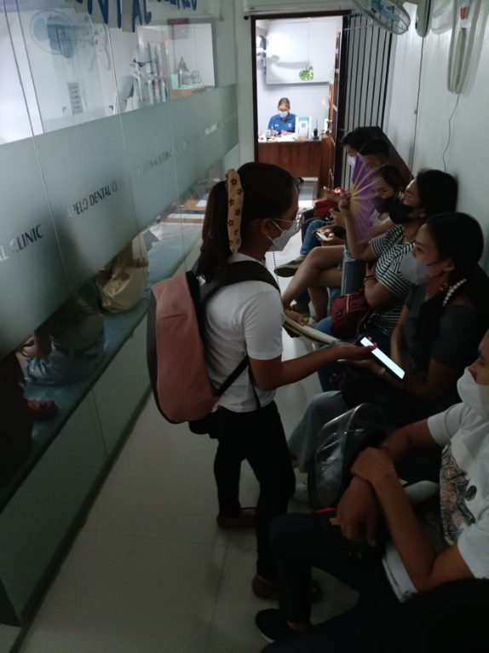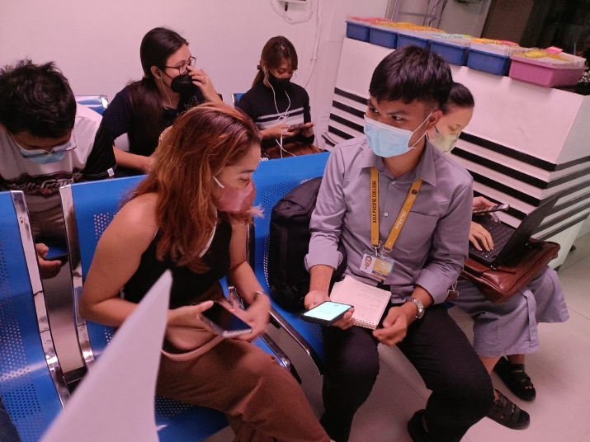

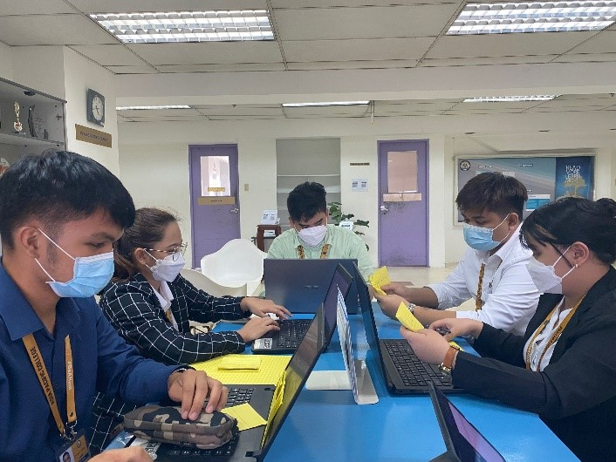

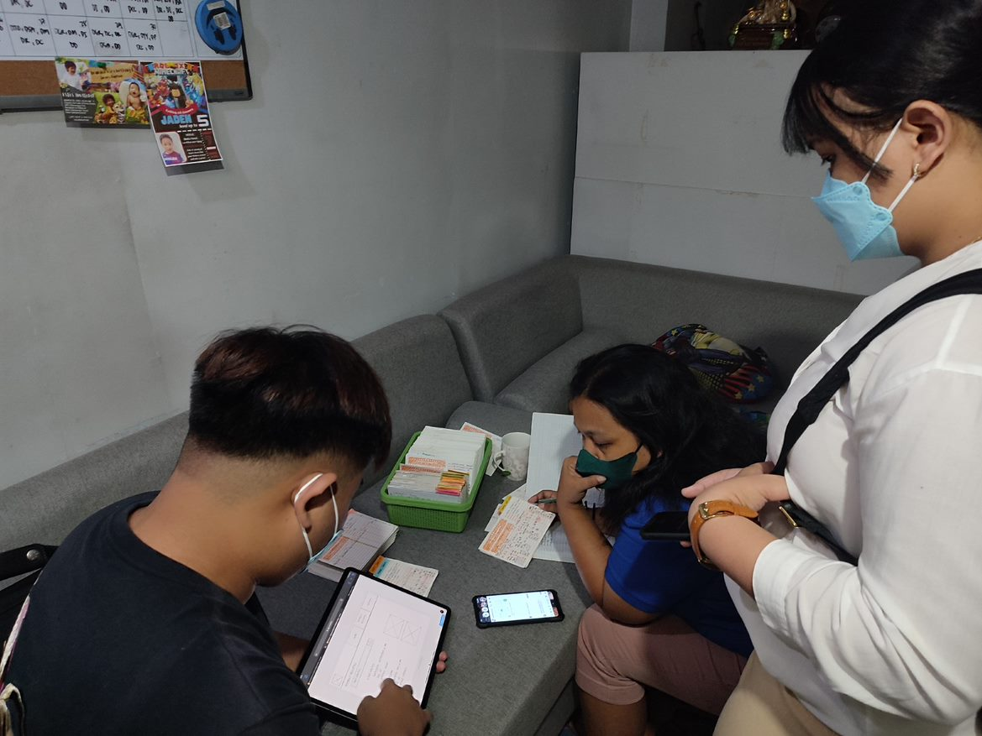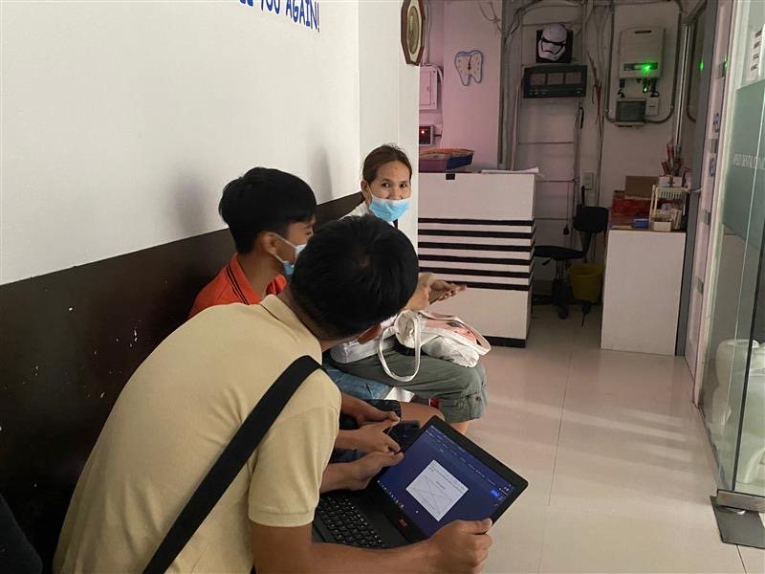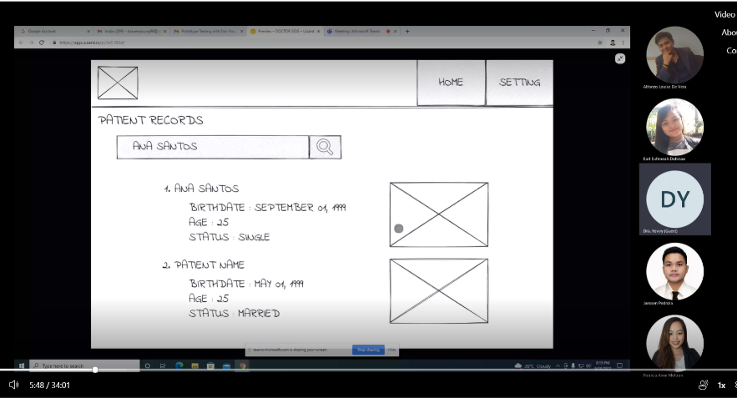

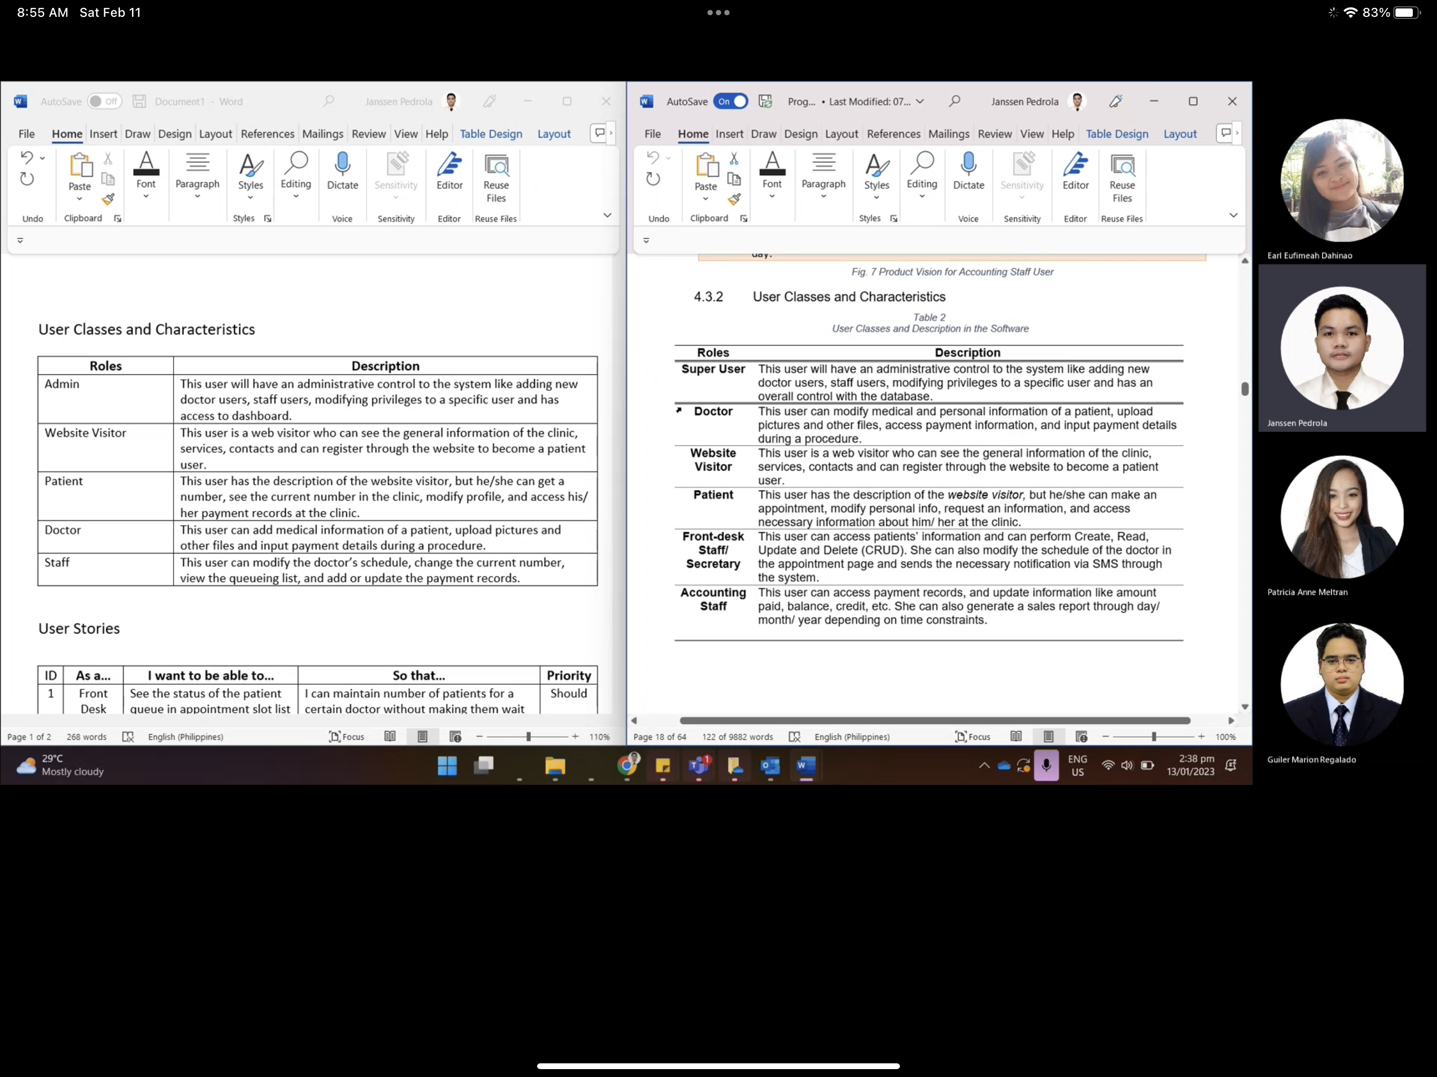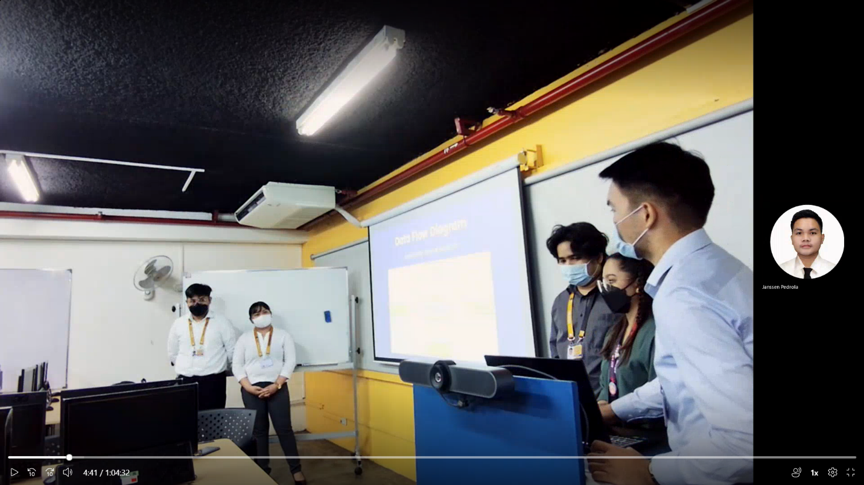

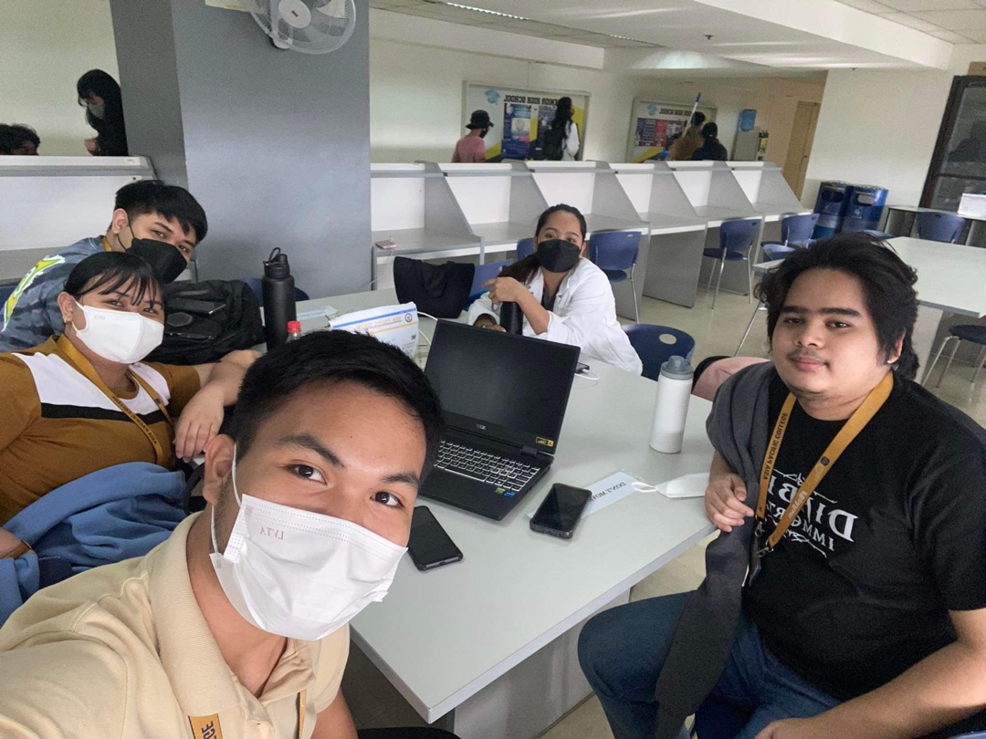

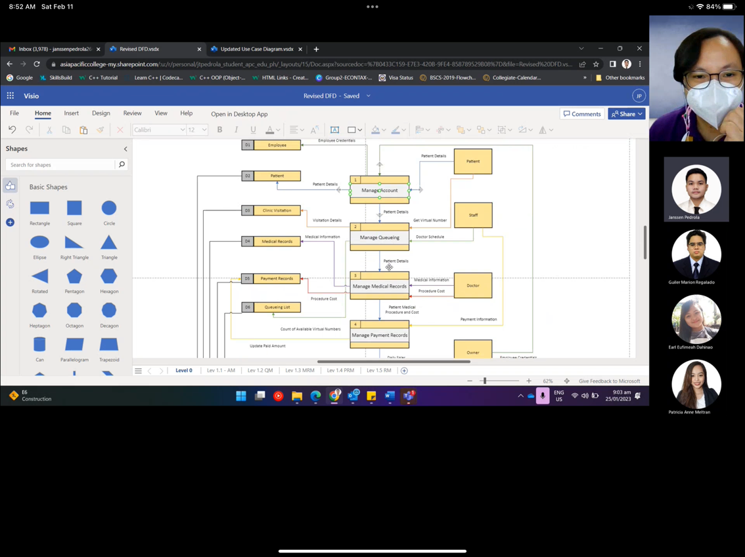

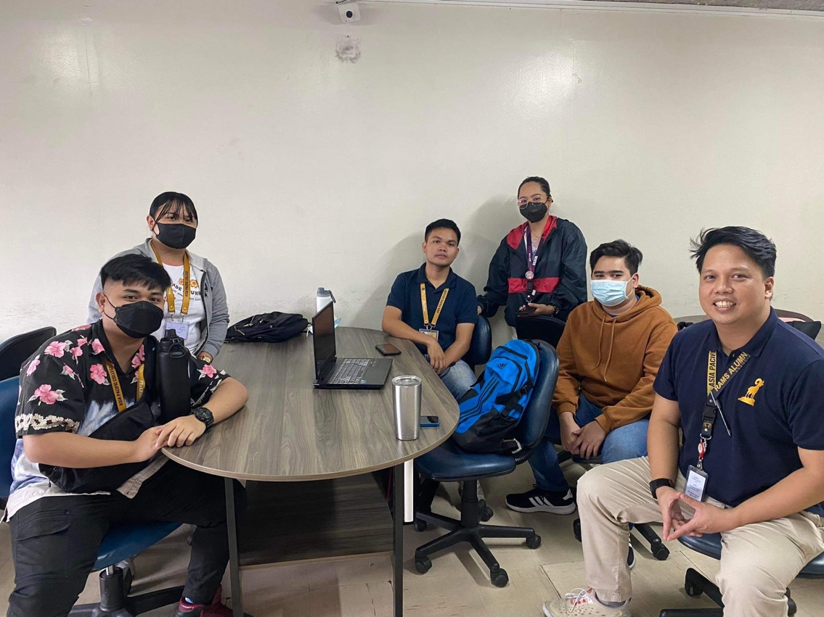

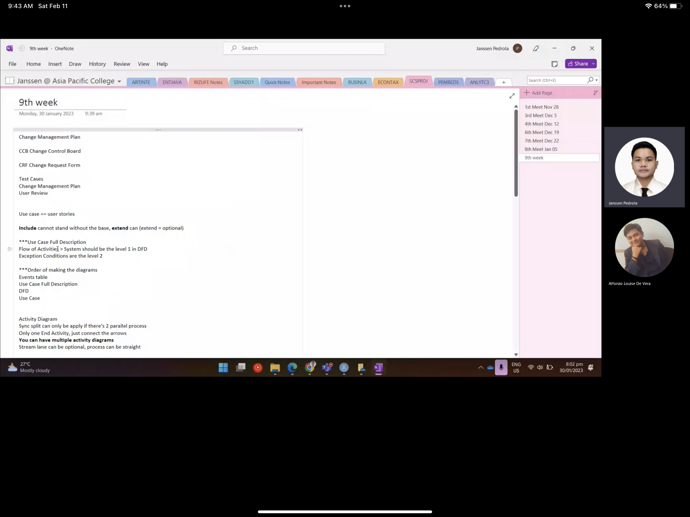

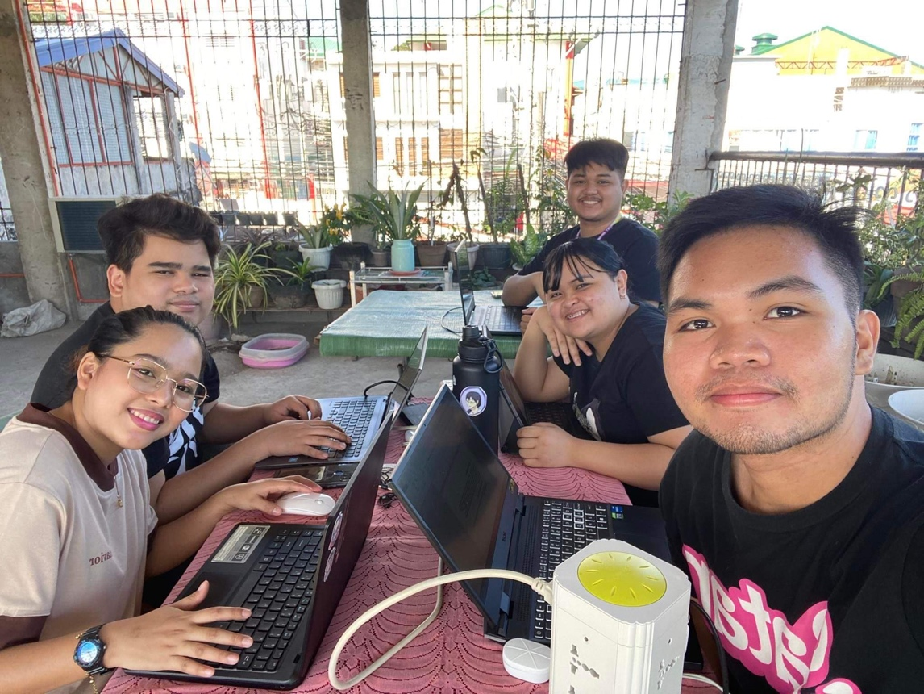

)

## Appendix E: Source Code

(

[ADENICSY Github Repository Link](https://github.com/jtpAPC2020/ADENICSY)

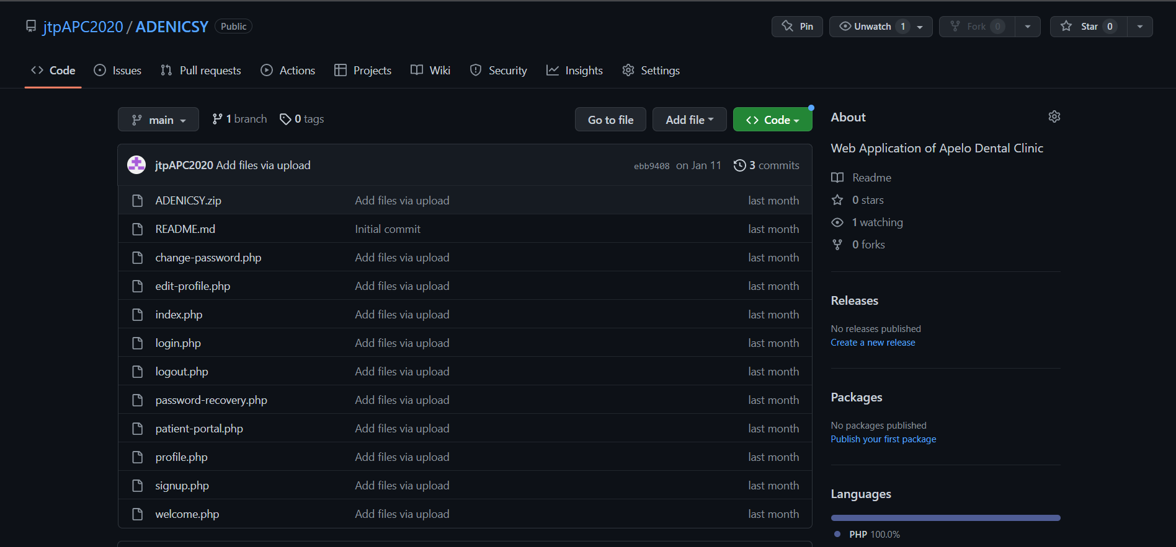)

## Appendix F: Team’s Curriculum Vitae



